Sanibel Congregational United Church of Christ
Worship Celebration
October 18, 2026, 10:00 a.m.


Welcome Everyone!
If you are visiting with us, and you are looking for a spiritual
community…

where you will be loved, accepted, supported and affirmed
regardless of your age, class, ability, race, ethnicity, gender
identification or sexual orientation…where you will be
encouraged and challenged to reflect on your beliefs,
acknowledge your doubts, ask your questions, and grow in
your faith…where God’s desire for compassion, healing,
reconciliation, justice and joy is preached…where you are
given the opportunity to put your faith in action through effective outreach ministries…then we hope to get to know you as a new friend.

No matter who you are, or where you are in your life journey…
You are welcome here!
An Open and Affirming / Creation Justice Congregation of the United Church of Christ

Seeking to love all people … growing in faith …
working toward God’s vision of justice, healing and joy.
Sanibel Congregational United Church of Christ
An Open and Affirming/Creation Justice Congregation
Worship Celebration
October 18, 2026, 10:00 a.m.

Welcome
Prelude Come, Christians, Join to Sing Hayes
Call to Worship
One: This is the day that God has blessed us with.
All: Let us rejoice and be grateful for it.
One: Let us honor God in thought, word and action.
All: Let us be a blessing to each other and to all of God’s people.
One: And when this day is done;
All: May we have given God and others our best.

Hymn Come, Thou Font of Every Blessing #68 (on p. 6)

Opening Prayer (together)
O God, we offer ourselves to You this day for the sake of Your will and ways.
Teach us and lead us to love as You do. Help us to bring healing to a society that is imperfect, fragmented, and broken in places. Lead us to worship You not just in this time and place, but in the totality of our lives.
Give us Your light to guide us ethically and morally, not in terms of narrow legalisms but through self-sacrifice and a commitment to the common good. Show us the way to being a just society without resorting to violence.
Holy One, change our hearts of indifference, apathy and anger to ones of decency, empathy and restraint.
Amen.

Music Meditation My Refuge Giamanco

A Time of Prayer with The Lord’s Prayer
2
(Please use the wording most meaningful to you.)
Invitation to Offering
Offertory Music Sweet Hour of Prayer King

*Presentation of Offering and Congregational Response
Praise God from whom all blessings flow
Praise God all creatures here below
Praise God for all that love has done
Creator, Christ and Spirit, One.
Amen.

Prayer of Dedication (together)
Accept these gifts, O God, that we offer back to You from all You have blessed us with. May they be used to help You lead us to a day and a world in which justice is tempered by mercy; vengeance is no more; and no one is seen as being beyond You grace and redemption.
Amen.
Ministry of the Word Matthew 5:21-26
(New Revised Standard Version Translation)

MINISTRY OF THE WORD

Matthew 5:21-26
You have heard that it was said to those of ancient times, ‘You shall not murder,’ and ‘whoever murders shall be liable to judgment.’ But I say to you that if you are angry with a brother or sister, you will be liable to judgment, and if you insult a brother or sister, you will be liable to the council, and if you say, ‘You fool,’ you will be liable to the hell of fire.
So when you are offering your gift at the altar, if you remember that your brother or sister has something against you, leave your gift there before the altar and go; first be reconciled to your brother or sister, and then come and offer your gift. Come to terms quickly with your accuser while you are on the way to court with him, or your accuser may hand you over to the judge and the judge to the guard, and you will be thrown into prison.
Truly I tell you, you will never get out until you have paid the last penny.

Message Rev. Dr. Mark Boyea
Hymn Love Divine, All Loves Excelling #358 (on p. 7)
Blessing
Postlude Improvisation on Love Divine, All Loves Excelling

*All who wish are welcome to stand.

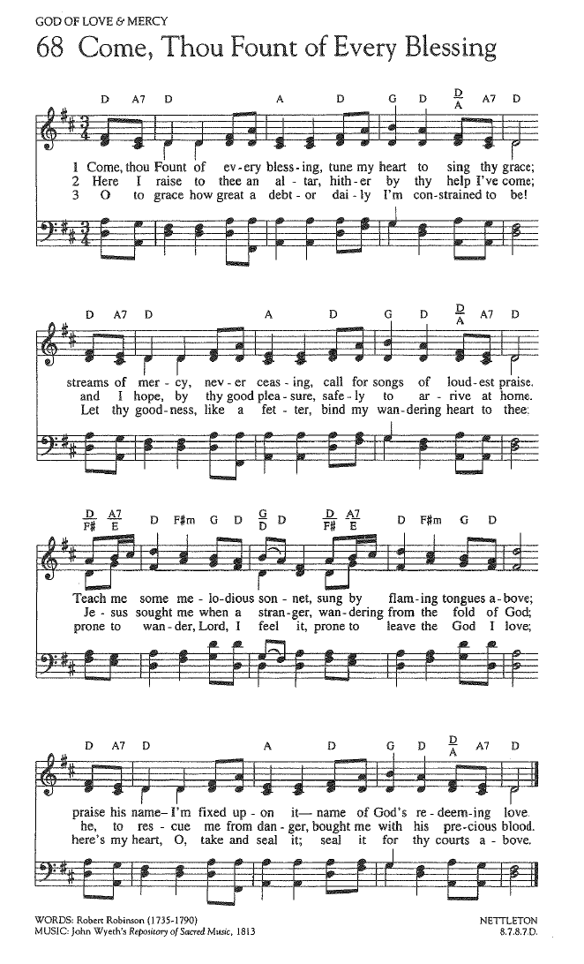
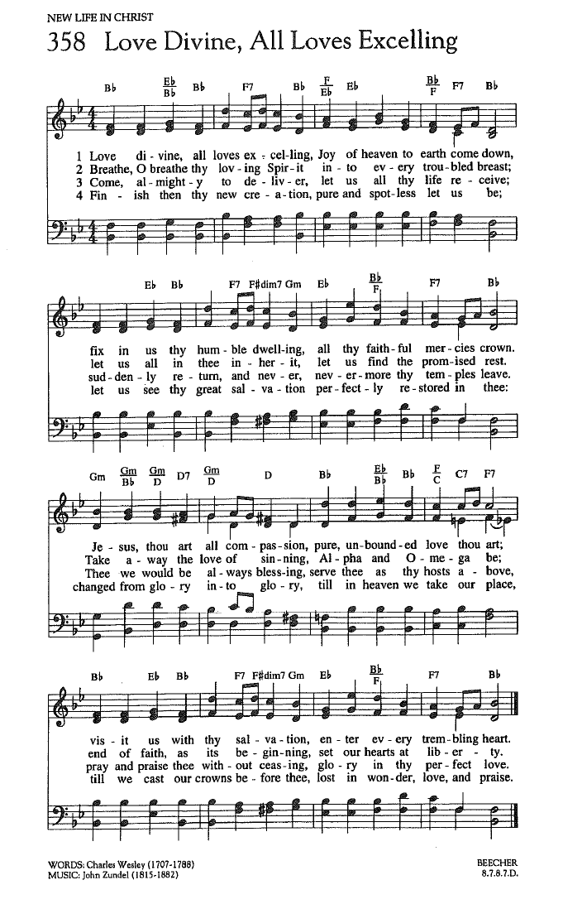

FOR YOUR CONSIDERATION

“Human nature is complex. While we have
inclinations to violence we also have inclinations to
empathy, cooperation and self-control.”
Steven Pinker, Canadian professor of Psychology and author

“There is no life to be found in violence. Every act
of violence brings us closer to death.”
bell hooks, American social theorist, author and activist

“Deliberate violence is more to be quenched than
a fire.”
Heraclitus, Greek philosopher

To Our Guests This Morning
If you are with us today for the first, or one of the first times, please let us know. Also, please take a moment to introduce yourself, or re-introduce yourself to Rev. Mark and to each other. Our hope is to provide you with the most graceful welcome possible.
TODAY’S FLORAL DEDICATION
The flowers for our Worship Celebration this morning
are in loving memory of Kermit Grener;
Jean Walker's father
October 14, 1918 – August 22, 2016


NEXT SUNDAY, OCTOBER 25 – Ask the Minister/Music Selection Day!
Our next Ask the Minister Sunday is next week!
Next Sunday, October 25, instead of offering a Message, Mark will once again attempt to address as many of your theological, biblical, spiritual and personal questions as time allows.
So get those questions in ahead of time to him by email at mark@sanibelucc.org, text them to 908-477-5426, or just come ready to ask them that morning.
These bi-monthly Sundays continue to be a welcome feature to our Worship times.
But that’s not all! Next Sunday is also Music Selection Day!
Not only will you choose what questions to have Mark address, but you will also select all the music for the day!
If you haven’t already, submit your requests for both hymns and special music pieces to Mackenzie or Mark by the end of Tuesday, October 20.
Mackenzie will then choose the Prelude, Music Meditation, Offertory and Postlude pieces from your submissions, while she and Mark will pick the two hymns.

SPIRITUAL EXPLORATION
Our Spiritual Exploration Unit for Fall 2026 continues THIS TUESDAY, OCTOBER 20 at 7PM on ZOOM.
A,B,C,D,E,F,G… : Faith By the Letter (Part 1)
Tuesdays: October 20 and 27; November 3 and 10
7:00-8:15PM on ZOOM
Based on the book, A Is For Alabaster by the renowned minister and theology professor Anna Carter Florence, this unit will be the first in a series that will occur intermittently over the next couple of years. Each week of this five-week unit will explore one story from the Hebrew Scriptures (Old Testament) and one from the New Testament that feature characters or themes that begin with a particular letter of the alphabet – beginning with the letter A and then proceeding in alphabetical order from there. As we do, we will discuss both our own and Carter Florence’s reflections on each story and its spiritual and theological themes.
BIBLE STUDY
As next Sunday is Ask the Minister Sunday, there will NO Bible Study this Thursday. Our next Bible Study session will take place on Thursday, October 29.
Each week, we explore the Scripture passage(s) being used in Worship that coming Sunday. The sessions are largely “guided discussion” in approach, focusing on your questions and insights from reading the text ahead of time, with Mark facilitating and adding relevant context and detail as needed or wanted.
This approach allows for participants to engage with the Bible creatively, and with an eye toward how the texts speak to us in our time and lives. In addition, the sessions are great preparation for getting more out of the Sunday Messages!

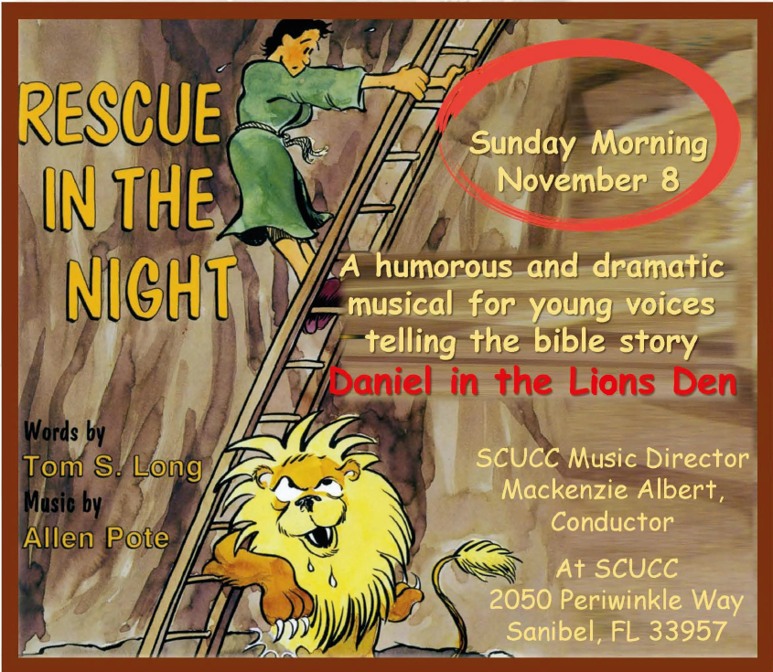
Assisting With Today’s Worship Celebration
Liturgist: Betsy Eidem
Ushers: Jerry and LaMoyne Ebner
Ministers: All Members and Friends of SCUCC
Moderator: Frank Palaia; Vice Moderator: Norm Boyd
Parish Nurse: Linda Convertine, R.N., B.S.N.
Music Director: Mackenzie Albert
Church Administrator: Tammy Flatley
Financial Manager: Terri Czeczotka
Tech Team: Dr. Renee Rawe, Kirsten Smith
Missionaries:
Alex Maldonado-Lizardi & Xiomara Cintron-Garcia in Colombia
Senior Minister: Rev. Dr. Mark Boyea
Pastors Emeriti: Rev. Dr. Ran Niehoff and Rev. Dr. John Danner

2050 Periwinkle Way, Sanibel, Florida 33957
Telephone: (239) 472-0497

Website: https://www.sanibelucc.org
Email: office@sanibelucc.org




You can scan a QR Code to make a donation through
PayPal or Venmo.

This Photo by Unknown Author is licensed under CC BY

