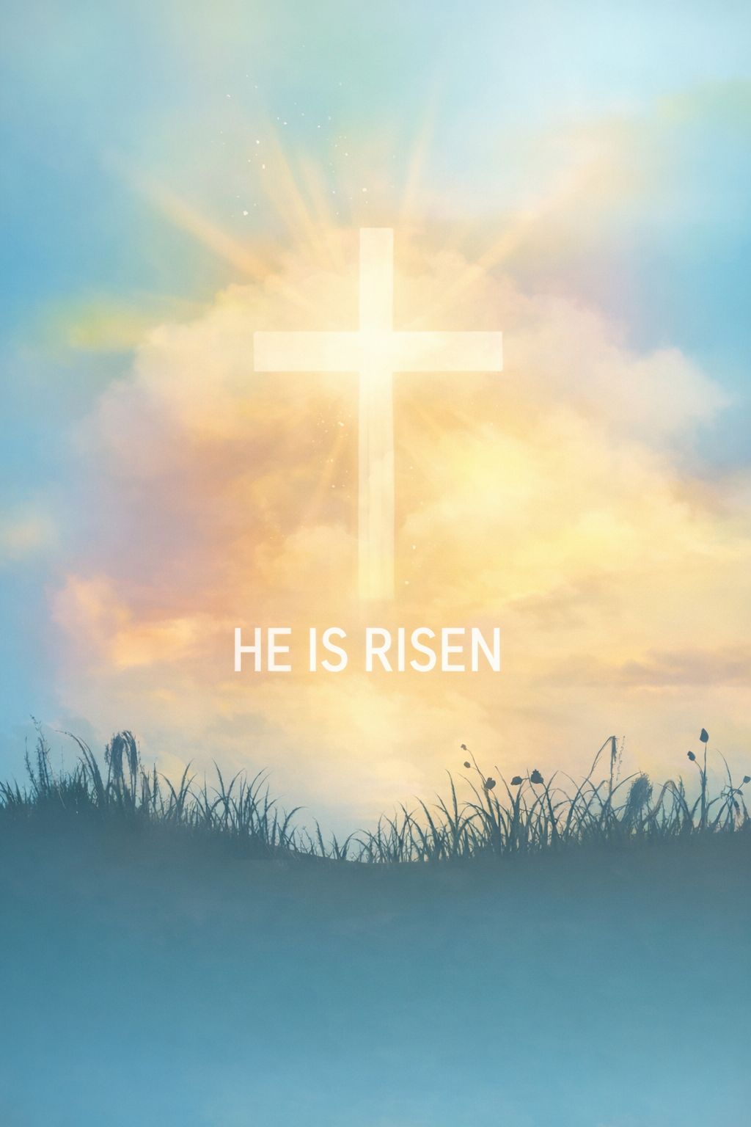
Sanibel Congregational United Church of Christ
Worship Celebration
EASTER SUNDAY
April 5, 2026, 10:00 a.m.
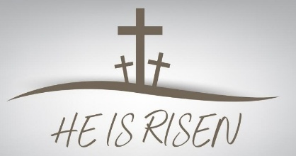

Welcome Everyone!
If you are visiting with us, and you are looking for a spiritual
community…

where you will be loved, accepted, supported and affirmed
regardless of your age, class, ability, race, ethnicity, gender
identification or sexual orientation…where you will be
encouraged and challenged to reflect on your beliefs,
acknowledge your doubts, ask your questions, and grow in
your faith…where God’s desire for compassion, healing,
reconciliation, justice and joy is preached…where you are
given the opportunity to put your faith in action through effective
outreach ministries…then we hope to get to know you as a new
friend.

No matter who you are, or where you are in your life journey…
You are welcome here!
An Open and Affirming / Creation Justice Congregation of the United Church of Christ
Seeking to love all people … growing in faith …
working toward God’s vision of justice, healing and joy.
Sanibel Congregational United Church of Christ
An Open and Affirming/Creation Justice Congregation
Worship Celebration
Easter Sunday
April 5, 2026, 10:00 a.m.

Welcome

Prelude Trumpet Concerto, Movement 1 Haydn
Diego Figueredo, trumpet

Easter Call to Worship
One: The tomb is empty.
All: Christ Is Risen.
One: Christ Is Risen.
All: Christ Is Risen Indeed.
One: Christ Is Risen Indeed!
All: Alleluia! Amen!

Hymn Christ the Lord Is Risen Today #288 (on p. 7)

Prayer of Resurrection (together)
God of endless new beginnings, through the power of Your Holy Spirit, Jesus has been raised.
Through that Resurrection, You showed us that not even death can separate us from You and the eternal life You created us for. May that free us to put our full trust in You and Your ways.
Through that Resurrection, You proclaimed that violence and injustice will not have the last word. May that free us to take risks for peace and justice on behalf of all Your people.
Through that Resurrection, You opened the door to the possibility of a new and better Creation for ourselves, our communities, our nation and this world. May that free us to serve Your vision with courage.
And now, once again inspired by that Resurrection, may we be the people of trust, justice, peace, courage, and new life You call and need us to be.
Amen.

Music Meditation Alleluia Round Boyce
The SCUCC Choir

A Time of Prayer with The Lord’s Prayer
2
(Please use the wording most meaningful to you.)
Invitation to Giving
Offertory Music Concertato on Thine Is the Glory arr. Powell
The SCUCC Choir
Diego Figueredo and Kleber Flores, trumpets

*Presentation of Offering and Congregational Response
Your name, we bless, O Risen Lord
And sing today with one accord
The life laid down, the life restored
Allelujah! Allelujah!

Amen.
*Prayer of Dedication (together)
Loving, restoring, renewing God, accept these gifts we offer on this Day of Resurrection. May they be used to help raise up those who hope and long for new life and a new world.
Amen.
Ministry of the Word Matthew 27:30-31
Luke 24:1-12
(New Revised Standard Version Translation)

MINISTRY OF THE WORD
Matthew 27:30-31
They spat on him and took the reed and struck him on the head. After mocking him, they stripped him of the robe and put his own clothes on him. Then they led him away to crucify him.
Luke 24:1-12
But on the first day of the week, at early dawn, they went to the tomb, taking the spices that they had prepared. They found the stone rolled away from the tomb, but when they went in they did not find the body.

While they were perplexed about this, suddenly two men in dazzling clothes stood beside them. The women were terrified and bowed their faces to the ground, but the men said to them, “Why do you look for the living among the dead? He is not here but has risen. Remember how he told you, while he was still in Galilee, that the Son of Man must be handed over to the hands of sinners and be crucified and on the third day rise again.”

Then they remembered his words, and returning from the tomb they told all this to the eleven and to all the rest. Now it was Mary Magdalene, Joanna, Mary the mother of James, and the other women with them who told this to the apostles. But these words seemed to them an idle tale, and they did not believe them. But Peter got up and ran to the tomb; stooping and looking in, he saw the linen cloths by themselves; then he went home, amazed at what had happened.

Message Rev. Dr. Mark Boyea

The Sacrament of Communion

Introduction

One: God is with us;
All: In every moment of our lives.
One: So let us lift up our hearts.
All: Let us lift them up to our God.
One: Let us present our lives to our God;
All: Through all we do and say.

The Words of Institution

The Consecration

Sharing God’s Gifts

The Community’s Prayer of Thanksgiving

We give You thanks, O God, for calling us to this table of nourishment and healing for body, mind and spirit. May the sharing of this Holy Meal strengthen our faith, increase our love for You and one another, and give us the courage we need to go out into the world as Christ’s disciples, inspired and supported by Your Holy Spirit.

Amen.

Hymn The Day of Resurrection! #298 (on p. 8)

Blessing
Postlude Concerto for Two Trumpets Telemann

*All who wish are welcome to stand.

**As usual on Easter Sunday, there will be no Fellowship Time after this
morning’s Worship Celebration.

***The entire SCUCC staff wishes you and yours a most Blessed Easter.

****Enormous gratitude to our guest musicians today for their
invaluable contribution to this morning’s Easter celebration:

Diego Figueredo and Kleber Flores

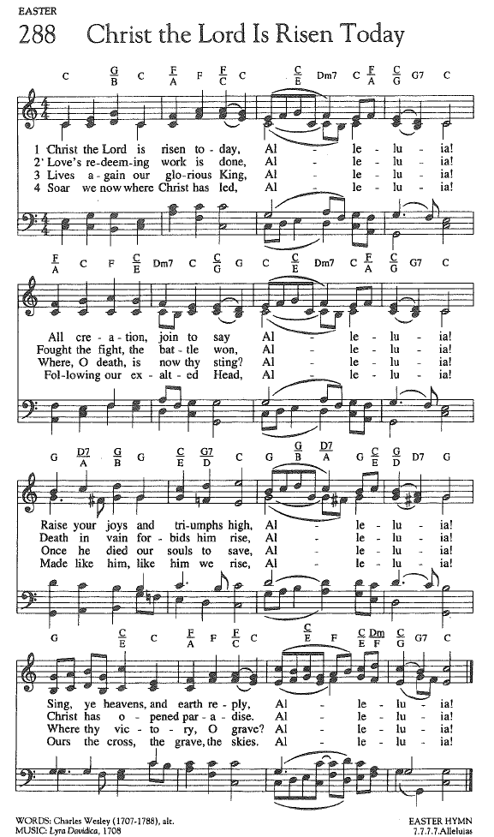
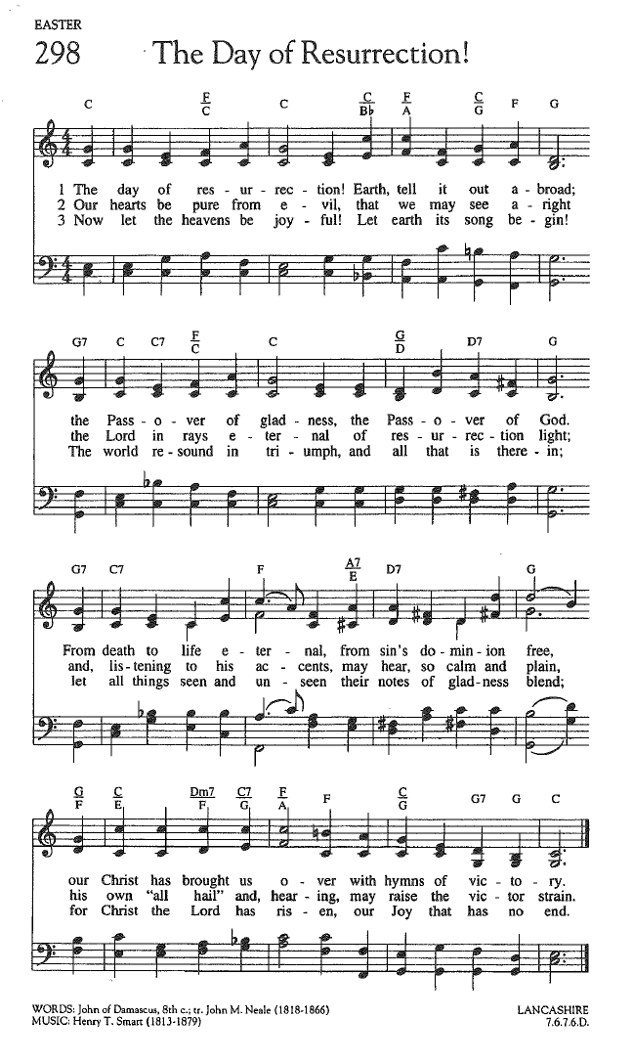

FOR YOUR CONSIDERATION

“Let us not merely say, ‘Christ is risen, but
also ‘I shall rise’.”
Phillips Brooks, American minister

“The very first Easter taught us this: that
life never ends and love never dies.”
Kate McGahan, American hospice grief counselor
and author

“The great gift of Easter is hope – hope
which makes us have confidence in God,
and in God’s ultimate triumph.”
Basil Hume, English minister


EASTER FLORAL DEDICATION

In Loving Memory of All Those
in the Boyea, Seeley, Benjamin and Clark Families
Who Have Returned to God
Mark & Cindy Boyea
With Gratitude To and For the SCUCC Community
Rev. Dr. Mark Boyea
In Loving Memory of Lynn Boynton
Jacquie, Mel, Becky, Jenny and Chuck
In Celebration of the life of the Rev. Don E. Creager
Gail Creager
In Memory of Our Precious Daughter, Sandy
Betty and Dennis Hayes




EASTER FLORAL DEDICATION

Remembering with Gratitude Our Loving Parents and Friends
Mary Anne and David Lougee
In Loving Memory of Our Parents
Judy and John McBroom
With Thanks for God’s Love and Blessings
Judy and Frank Palaia
In Memory of Our Parents:
J.C. and Dorothy McCormack &
Charles and Willa Ramseth
Jane and Chuck Ramseth
In Memory of Our Parents
Sarah Soule and Leigh Oliva

In Memory of Kevin Winn, Our Son
Linda and Jim Winn

To Our Guests This Morning
If you are with us today for the first, or one of the first times, please let us know. Also, please take a moment to introduce yourself, or re-introduce yourself to Rev. Mark and each other. Our hope is to provide you with the most graceful welcome possible.
NEXT SUNDAY, APRIL 12 – ASK THE MINISTER SUNDAY!
Next Sunday, April 12 will be our next Ask the Minister Sunday! Instead of a Message that morning, Mark will attempt to address as many of your biblical, theological, spiritual and personal questions as time allows.
So get those questions in ahead of time to Mark at mark@sanibelucc.org, text them to 908-477-5426, or just come ready to ask them that morning. These bi-monthly Sundays are always enthusiastically participated in.
Office Hours
*The Church Office WILL BE CLOSED on Monday, April 6.
The Office is regularly open from 9 am-3 pm on Monday through Friday.
Mark is generally on campus Tuesday-Thursday pending pastoral visits or off-site meetings. Please feel free to just “drop by” or make an appointment directly with him by email: mark@sanibelucc.org or text/phone at 908-477-5426.
Mackenzie Albert, our Director of Music, is normally on campus each Wednesday and some Fridays. Please make an appointment by phone or text at 203-517-5427.
SPIRITUAL EXPLORATION
Our most recent unit has concluded. The topic and schedule for our next unit are still being determined.

BIBLE STUDY
Bible Study WILL NOT meet this Thursday, April 9. It resumes on Thursday, APRIL 16 at 10:30 am on Zoom.

SAVE THE DATE!!!
SCUCC Turns 40!!!
Join us on Sunday, April 19 at 10 am
when we commemorate SCUCC’s 40th Anniversary!
That morning’s Worship time will serve as a celebration of that anniversary,
and will also include the conferring of Pastor Emeritus status on former
SCUCC Senior Minister, Rev. Dr. John Danner.
Afterwards, please plan to stay for a celebratory lunch, as well as other
activities, such as a historical tour of the SCUCC campus.


Assisting With Today’s Worship Celebration
Liturgist: Cindy Boyea
Ushers: Neal and Sherry Halleran
Ministers: All Members and Friends of SCUCC
Moderator: Frank Palaia; Vice Moderator: Norm Boyd
Parish Nurse: Linda Convertine, R.N., B.S.N.
Music Director: Mackenzie Albert
Church Administrator: Tammy Flatley
Financial Manager: Terri Czeczotka
Tech Team: Dr. Renee Rawe, Kirsten Smith, Maggie Voll
Missionaries:
Alex Maldonado-Lizardi & Xiomara Cintron-Garcia in Colombia
Senior Minister: Rev. Dr. Mark Boyea
Pastor Emeritus: Rev. Dr. Ran Niehoff
2050 Periwinkle Way, Sanibel, Florida 33957
Telephone: (239) 472-0497

Website: https://www.sanibelucc.org
Email: office@sanibelucc.org




You can scan a QR Code to make a donation through
PayPal or Venmo.

This Photo by Unknown Author is licensed under CC BY

