Sanibel Congregational United Church of Christ
Worship Celebration
September 6, 2026, 10:00 a.m.


Welcome Everyone!
If you are visiting with us, and you are looking for a spiritual
community…

where you will be loved, accepted, supported and affirmed
regardless of your age, class, ability, race, ethnicity, gender
identification or sexual orientation…where you will be
encouraged and challenged to reflect on your beliefs,
acknowledge your doubts, ask your questions, and grow in
your faith…where God’s desire for compassion, healing,
reconciliation, justice and joy is preached…where you are
given the opportunity to put your faith in action through effective outreach ministries…then we hope to get to know you as a new friend.

No matter who you are, or where you are in your life journey…
You are welcome here!
An Open and Affirming / Creation Justice Congregation of the United Church of Christ

Seeking to love all people … growing in faith …
working toward God’s vision of justice, healing and joy.
Sanibel Congregational United Church of Christ
An Open and Affirming/Creation Justice Congregation
Worship Celebration
September 6, 2026, 10:00 a.m.

Welcome
Prelude
Call to Worship
One: Grace and peace to you from the One who is, always was, and is still to come;
All: the Alpha and Omega - the Beginning and the End.
One: Our God has made us and loves us;
All: our God calls us to live out the love we have received.
One: May we find renewal and hope in this time together,
All: and may we leave this place committed once again to doing good
in this world.

Hymn Morning Has Broken #35 (on p. 6)

Opening Prayer (together)
Holy One, You call us together as Your people. You call us together to pray, sing, and listen to Your word, so that we may come closer to being who and what You created us to be - people who experience fullness of life individually and in community.
You have set before us the road to that life. It is a road on which the signs read: “Feed the Hungry”; “Offer Drink to the Thirsty”; “Welcome the Stranger”; “Clothe the Naked”; “Care for the Sick”; and “Remember the Prisoner”.
Help us to follow those signs. Help us to choose that life.
Amen.
Music Meditation

A Time of Prayer with The Lord’s Prayer
2
(Please use the wording most meaningful to you.)
Invitation to Offering

Offertory Music

*Presentation of Offering and Congregational Response
Praise God from whom all blessings flow
Praise God all creatures here below
Praise God for all that love has done
Creator, Christ and Spirit, One
Amen.
Prayer of Dedication (together)
O God who has fed us, offered us drink, clothed us, cared for us when we were sick and was present to us in our times of emotional and spiritual captivity, we offer back to You now these gifts. May they help do the same for others as You have done for us.
Amen.
Ministry of the Word Matthew 25:31-40
(New Revised Standard Version Translation)

MINISTRY OF THE WORD
Matthew 25:31-40
When the Son of Man comes in his glory and all the angels with him, then he will sit on the throne of his glory. All the nations will be gathered before him, and he will separate people one from another as a shepherd separates the sheep from the goats, and he will put the sheep at his right hand and the goats at the left.
Then the king will say to those at his right hand, ‘Come, you who are blessed by my Father, inherit the kingdom prepared for you from the foundation of the world; for I was hungry and you gave me food, I was thirsty and you gave me something to drink, I was a stranger and you welcomed me, I was naked and you gave me clothing, I was sick and you took care of me, I was in prison and you visited me.’
Then the righteous will answer him, ‘Lord, when was it that we saw you hungry and gave you food, or thirsty and gave you something to drink? And when was it that we saw you a stranger and welcomed you, or naked and gave you clothing? And when was it that we saw you sick or in prison and visited you?’
And the king will answer them, ‘Truly I tell you, just as you did it to one of the least of these who are members of my family, you did it to me.’

Message Do Good Rev. Dr. Sally Haynes
Hymn O Jesus, I Have Promised #458 (on p. 7)

Blessing
Postlude

*All who wish are welcome to stand.

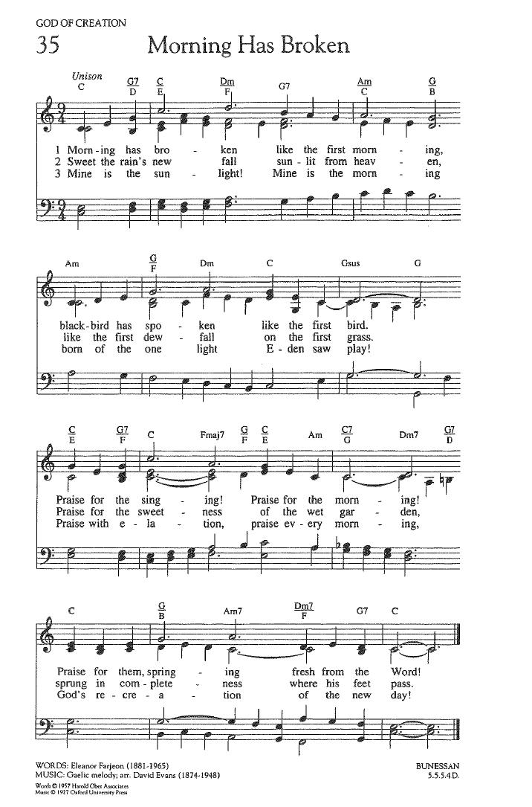
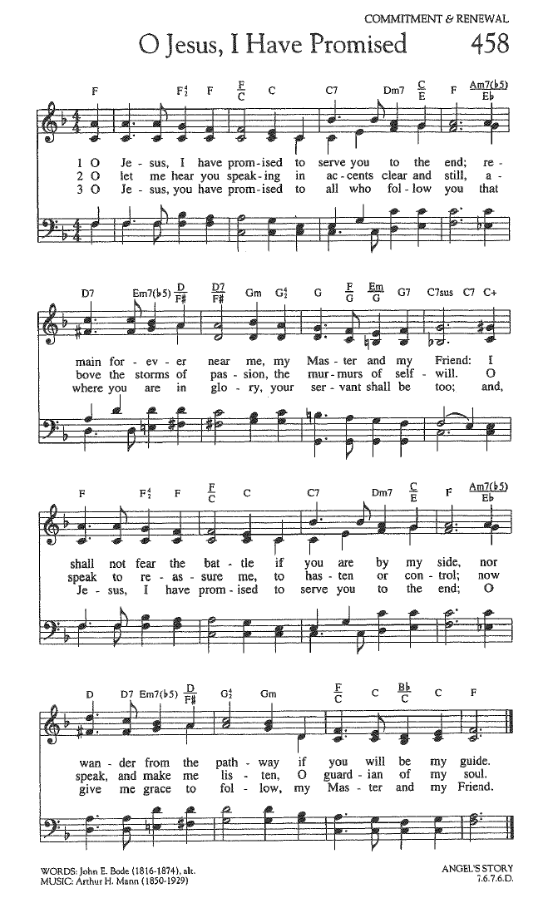

FOR YOUR CONSIDERATION

“The Gospel encompasses much more than
avoiding and overcoming sin. It also essentially
entails doing good.”
David A. Bednar, Mormon church leader and university
president

“Jesus did not spend a great deal of time talking
about the Trinity or Original Sin or the Incarnation.
He went around doing good and being
compassionate.”
Karen Armstrong, British religion scholar and author

“The best way to do ourselves good is to do good to
others. The best way to gather is to scatter.”
Thomas Brooks, English minister and author

To Our Guests This Morning
If you are with us today for the first, or one of the first times, please let us know. Also, please take a moment to introduce yourself, or re-introduce yourself to each other. Our hope is to provide you with the most graceful welcome possible.
TODAY, Sunday, September 6 – Rev. Dr. Sally Haynes
We once again welcome back our good friend, Rev. Dr. Sally Haynes, for her second of two consecutive Sundays as Worship leader while Mark in on his end of summer break.
While Mark is away, he remains available to be contacted for urgent church and pastoral care concerns throughout this time, but will not be returning other emails and messages until after.
SPIRITUAL EXPLORATION
Our latest Spiritual Exploration unit - and final one until the fall - has concluded.
Enormous gratitude to all those who participated throughout this past church year.
Stay tuned for announcements regarding our first unit for this coming Fall in the Sunday Bulletin and the Light newsletter, as well as on our website. It is expected to be some time in October.
BIBLE STUDY
Bible Study is now on break until some time in October.
Stay tuned for announcements regarding the start date in the Sunday Bulletin and the Light newsletter, as well as on our website.

Rescue in the Night

A Musical for Young Voices Telling the Story of Daniel in the Lion’s Den

On Sunday morning, _____________, SCUCC Music Director Mackenzie Albert will conduct Rescue in the Night, a 25-minute dramatization of the Bible story of Daniel in the Lion’s Den. This musical will be integrated into the 10 am Sunday Worship by Rev. Dr. Mark Boyea, Senior Minister at SCUCC.

Rescue In the Night tells Daniel’s story with nine lead characters, a group of lively towns people, and some hungry lions!
The cast consists of:
Daniel – the King’s wise advisor
King Darius – the King of ancient Babylon
Taxalot – the King’s accountant
Astrofar – the King’s astronomer
Crushafo- Captain of the King’s Guard
Herald #1, Herald #2, Herald #3, Herald #4 – the King’s announcers and narrators who give running commentary throughout the performance, sing solos, and make jokes
Townspeople – the chorus, some will have vocal solos, and many will have lines to speak
Lions – the lions roar, sing, and some have lines to speak

The rehearsals will be held in September and October; the rehearsal schedule will be crafted to meet the needs of the cast and musicians.

The musical will be performed during Worship on Sunday, ______________ at 10 am, with cast call at 9 am. The dress rehearsal is _________, __________at 10 am.

Rescue in the Night is written by Tom S. Long, an award-winning and prolific writer of gospel-based fables using humor to underpin serious messages, such as “The Complete History of the Old Testament in Twenty Minutes,” “Once Upon a Parable” (the story of the Good Samaritan and others), and “Malice in the Palace” (the story of Esther). The music is composed by Allen Pote, a nationally known award-winning composer of 300 religious works and 14 musicals. Mr. Pote is co-founder of the 300 voice Pensacola Children's Chorus, serving as Artistic Director for 26 years.

Assisting With Today’s Worship Celebration
Liturgist: Paul Roth
Ushers: Frank and Judy Palaia
Ministers: All Members and Friends of SCUCC
Moderator: Frank Palaia; Vice Moderator: Norm Boyd
Parish Nurse: Linda Convertine, R.N., B.S.N.
Music Director: Mackenzie Albert
Church Administrator: Tammy Flatley
Financial Manager: Terri Czeczotka
Tech Team: Dr. Renee Rawe, Kirsten Smith, Maggie Voll
Missionaries:
Alex Maldonado-Lizardi & Xiomara Cintron-Garcia in Colombia
Senior Minister: Rev. Dr. Mark Boyea
Pastors Emeriti: Rev. Dr. Ran Niehoff and Rev. Dr. John Danner

2050 Periwinkle Way, Sanibel, Florida 33957
Telephone: (239) 472-0497

Website: https://www.sanibelucc.org
Email: office@sanibelucc.org




You can scan a QR Code to make a donation through
PayPal or Venmo.

This Photo by Unknown Author is licensed under CC BY

