Sanibel Congregational United Church of Christ
Worship Celebration
September 20, 2026, 10:00 a.m.


Welcome Everyone!
If you are visiting with us, and you are looking for a spiritual
community…

where you will be loved, accepted, supported and affirmed
regardless of your age, class, ability, race, ethnicity, gender
identification or sexual orientation…where you will be
encouraged and challenged to reflect on your beliefs,
acknowledge your doubts, ask your questions, and grow in
your faith…where God’s desire for compassion, healing,
reconciliation, justice and joy is preached…where you are
given the opportunity to put your faith in action through effective outreach ministries…then we hope to get to know you as a new friend.

No matter who you are, or where you are in your life journey…
You are welcome here!
An Open and Affirming / Creation Justice Congregation of the United Church of Christ

Seeking to love all people … growing in faith …
working toward God’s vision of justice, healing and joy.
Sanibel Congregational United Church of Christ
An Open and Affirming/Creation Justice Congregation
Worship Celebration
September 20, 2026, 10:00 a.m.

Welcome
Prelude Wichtige Begenheit (An Important Event)
Janice Van Buskirk, piano
*Note: All of this morning’s special music was composed by
Robert Schumann, the first composer to write music for the modern grand piano.
Call to Worship
One: This is the day that God has blessed us with;
All: Let us open our hearts, hands, minds and spirits to God and each
other in Worship.

Hymn Arise,Your Light Is Come! #231 (on p. 6)

Opening Prayer (together)
O God, we gather together this day as a community of Your people. We gather together as brothers and sisters through You. And we also gather together as friends.
But not just friends to each other. For Jesus proclaims that we are His friends too. The One You sent to embody You and Your ways offers us true friendship and all that comes with it – to be present in our lives; to offer us care and comfort in our struggles; to understand, forgive and help us work with our shortcomings.
As Jesus offers us true friendship, may we offer it to others. Not just to those we agree with, those who are like us and those we like, but to all.
Just as Jesus does.
Amen.
Music Meditation Warum? (Why?)
Janice Van Buskirk, piano

A Time of Prayer with The Lord’s Prayer
2
(Please use the wording most meaningful to you.)

Invitation to Offering

Offertory Music Traumerie (Dreaming)
Mackenzie Albert, piano

*Presentation of Offering and Congregational Response
Praise God from whom all blessings flow
Praise God all creatures here below
Praise God for all that love has done
Creator, Christ and Spirit, One
Amen.
Prayer of Dedication (together)
God of all we have, do and are, we offer these gifts to You with gratitude for all You have blessed us with yesterday; all You will bless us with today; and all You will bless us with in the coming days. May they be used to help offer material, emotional, social and spiritual friendship to Your people who have been lost or forgotten.
Amen.
Ministry of the Word John 15:12-17
(New Revised Standard Version Translation)

MINISTRY OF THE WORD
John 15:12-17
This is my commandment, that you love one another as I have loved you.
No one has greater love than this, to lay down one’s life for one’s friends.
You are my friends if you do what I command you.
I do not call you servants any longer, because the servant does not know what the master is doing; but I have called you friends, because I have made known to you everything that I have heard from my Father.
You did not choose me, but I chose you. And I appointed you to go and bear fruit, fruit that will last, so that the Father will give you whatever you ask him in my name.
I am giving you these commands so that you may love one another.

Message Rev. Dr. Mark Boyea
Hymn What a Friend We Have in Jesus #473 (on p. 7)
Blessing
Postlude Improvisation on What a Friend We Have in Jesus

*All who wish are welcome to stand.

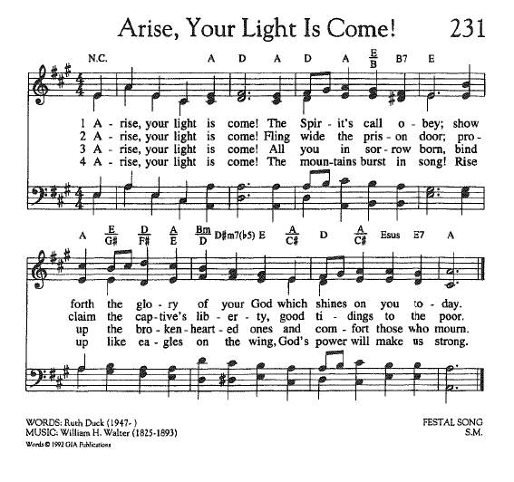
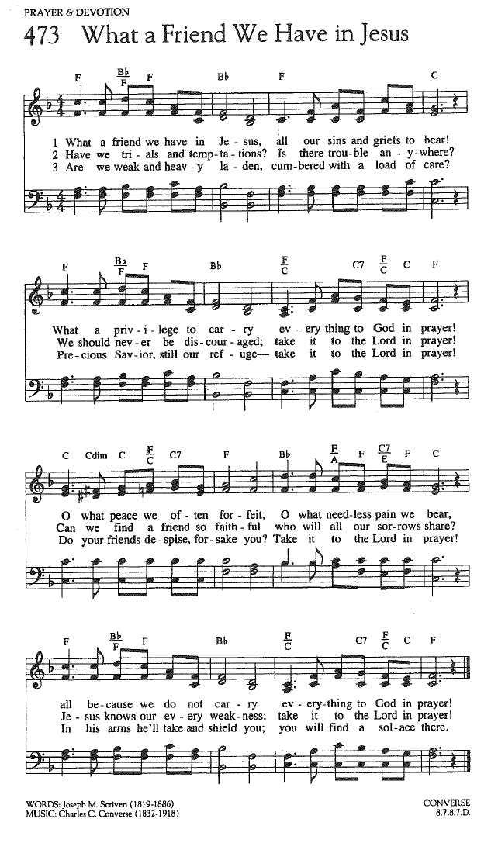

FOR YOUR CONSIDERATION

“A friend is someone who knows all about you and
still loves you.”
Elbert Hubbard, American writer, artist and philosopher

“We have to fully invest in not just romantic love,
but ‘friendship love’.”
Delilah Luke, American radio host and author

“Love demands infinitely less than friendship.”
George Jean Nathan, Drama critic and magazine editor

To Our Guests This Morning
If you are with us today for the first, or one of the first times, please let us know. Also, please take a moment to introduce yourself, or re-introduce yourself to each other. Our hope is to provide you with the most graceful welcome possible.
SPIRITUAL EXPLORATION
Our latest Spiritual Exploration unit - and final one until the fall - has concluded.
Enormous gratitude to all those who participated throughout this past church year.
Stay tuned for announcements regarding our first unit for this coming Fall in the Sunday Bulletin and the Light newsletter, as well as on our website. It is expected to be some time in October.
BIBLE STUDY
Bible Study is now on break until some time in October.
Stay tuned for announcements regarding the start date in the Sunday Bulletin and the Light newsletter, as well as on our website.

Assisting With Today’s Worship Celebration
Liturgist: Jane Ramseth
Ushers: Jerry and LaMoyne Ebner
Ministers: All Members and Friends of SCUCC
Moderator: Frank Palaia; Vice Moderator: Norm Boyd
Parish Nurse: Linda Convertine, R.N., B.S.N.
Music Director: Mackenzie Albert
Church Administrator: Tammy Flatley
Financial Manager: Terri Czeczotka
Tech Team: Bruce Findley, Dr. Renee Rawe, Kirsten Smith
Missionaries:
Alex Maldonado-Lizardi & Xiomara Cintron-Garcia in Colombia
Senior Minister: Rev. Dr. Mark Boyea
Pastors Emeriti: Rev. Dr. Ran Niehoff and Rev. Dr. John Danner

2050 Periwinkle Way, Sanibel, Florida 33957
Telephone: (239) 472-0497

Website: https://www.sanibelucc.org
Email: office@sanibelucc.org




You can scan a QR Code to make a donation through
PayPal or Venmo.

This Photo by Unknown Author is licensed under CC BY

