Sanibel Congregational United Church of Christ
Worship Celebration
November 16, 2025, 10:00 a.m.


Welcome Everyone!
If you are visiting with us, and you are looking for a spiritual
community…

where you will be loved, accepted, supported and affirmed
regardless of your age, class, ability, race, ethnicity, gender
identification or sexual orientation…where you will be
encouraged and challenged to reflect on your beliefs,
acknowledge your doubts, ask your questions, and grow in
your faith…where God’s desire for compassion, healing,
reconciliation, justice and joy is preached…where you are
given the opportunity to put your faith in action through effective
outreach ministries…then we hope to get to know you as a new
friend.

No matter who you are, or where you are in your life journey…
You are welcome here!
An Open and Affirming / Creation Justice Congregation of the United Church of Christ
Seeking to love all people … growing in faith …
working toward God’s vision of justice, healing and joy.
Sanibel Congregational United Church of Christ
An Open and Affirming/Creation Justice Congregation
Worship Celebration
Welcome Back Sunday
Stewardship Reflection – “What Shall We Bring?”
November 16, 2025, 10:00 a.m.

Welcome

Choral Introit Antiphonal Praise
The SCUCC Choir

Call to Worship

One: Blessed is the One who created us and all things;
All: The One who calls us together in covenant and community.
One: Blessed is the One who is the source of all we have.
All: May we use it to honor God by caring for others.
One: Blessed is the One who has given us all we need to rise to our higher
selves.
All: May we encourage and help each other do just that.

Hymn Come, Thou Font of Every Blessing #68 (on p. 6)
Opening Prayer (together)
O God, You have given us everything we need for us to help You create and sustain a world where all Your people’s basic needs are met; where all Your people may not just survive but thrive; where all Your people can be lifted up to become all You created them to be.
May we honor Your grace; Your generosity; Your endless blessing, by doing our best to help make Your vision for the world a reality. May we do that by lending others a hand in times of need; a word of encouragement in times of struggle; a truly understanding heart when they feel they have nowhere to turn.
And at the very least, O God, may we honor Your grace, blessing and generosity by refusing to be an obstacle to others on their path to having the life You want for them.
Amen.
A Stewardship Reflection Gail Hanny
Music Meditation River in Judea Feldman/Leavitt
Charlene Gulbrandsen, soloist

A Time of Prayer with The Lord’s Prayer
(Please use the wording most meaningful to you.)
Invitation to Giving
Offertory Music Just a Closer Walk With Thee
The SCUCC Choir

*Presentation of Offering and Congregational Response
Thank God from whom all blessings flow
Thank God, all creatures high and low
Thank God in Christ the Blessed Son
And for His call to be as One
Amen
*Prayer of Dedication (together)
Gracious, loving, giving God, we offer back to You now this part of all You have blessed us with. May it remind us that all we have comes from You, and is ultimately Yours. In our remembrance of that, may we also be more willing to share what we have with those in need, near and far.
Amen.

Ministry of the Word Luke 19:1-10
(New Revised Standard Version Translation)
Ministry of the Word

Luke 19:1-10

He entered Jericho and was passing through it. A man was there named Zacchaeus; he was a chief tax collector and was rich. He was trying to see who Jesus was, but on account of the crowd he could not, because he was short in stature. So he ran ahead and climbed a sycamore tree to see him, because he was going to pass that way.

When Jesus came to the place, he looked up and said to him, “Zacchaeus, hurry and come down, for I must stay at your house today.” So he hurried down and was happy to welcome him.

All who saw it began to grumble and said, “He has gone to be the guest of one who is a sinner.” Zacchaeus stood there and said to the Lord, “Look, half of my possessions, Lord, I will give to the poor, and if I have defrauded anyone of anything, I will pay back four times as much.”

Then Jesus said to him, “Today salvation has come to this house, because he, too, is a son of Abraham. For the Son of Man came to seek out and to save the lost.”

Message Dr. Mark Boyea

Hymn Called as Partners in Christ’s Service #581 (on p. 7)
Blessing
Postlude Improv on Called as Partners in Christ’s Service

*All who wish are welcome to stand.

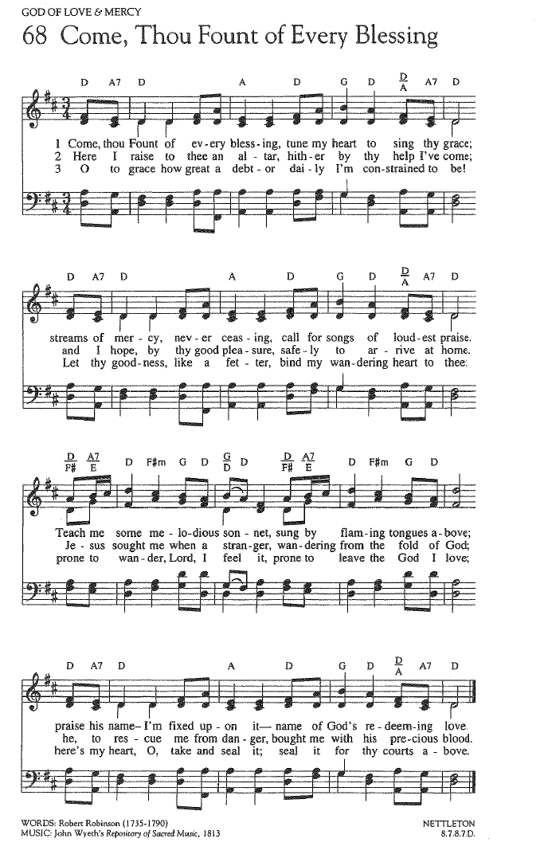

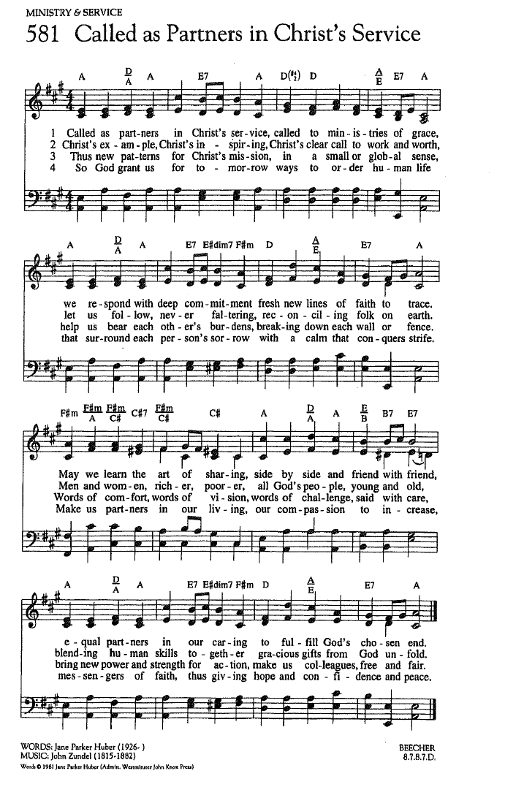

FOR YOUR CONSIDERATION

“If you want to lift yourself up, lift up someone else.”
Booker T. Washington, American educator, author and speaker

“What are you afraid of losing, when nothing in the world actually belongs to you?”
Marcus Aurelius, Roman emperor and Stoic philosopher

“We rise by being eyes for the blind, strength for the
weak, and a shield for the defenseless.”
Robert Green Ingersoll, American lawyer and politician


ANNOUNCEMENTS

To Our Guests This Morning
If you are with us today for the first, or one of the first times, please let us know. Also, please take a moment to introduce yourself, or re-introduce yourself to Rev. Mark and others, as we will do with you. Our hope is to provide you with the most graceful welcome possible.
TODAY, SUNDAY, NOVEMBER 16 – WELCOME BACK SUNDAY LUNCH!
Please join us after Worship TODAY Sunday, November 16 for a special Fellowship Time to meet, greet and catch up with each other, as many of us continue to return to Sanibel. Lunch will be served, including sandwiches and desserts.
In addition, we continue our three weeks long Stewardship Reflection period which ushers in our annual Stewardship season. This year’s theme is What Shall We Bring?, based upon Exodus 25:1-8, when God invites the Israelites to bring gifts of time, talent and treasure for the purpose of building a Sanctuary - and a community - where God can dwell among them.
During these Sundays, members of our spiritual community will bless us with their stories of how they came to be here and what SCUCC means to them. This Sunday we will hear from Gail Hanny.
Office Hours
The Office is regularly open from 9am-3pm, Monday through Friday. Mackenzie Albert, our Director of Music, is normally on campus each Wednesday and some Fridays. Please make an appointment by phone or text at 203-517-5427.
SPIRITUAL EXPLORATION CONCLUDES THIS WEEK!
Our current Spiritual Exploration unit concludes this Tuesday,
November 18 at 7:00pm on Zoom.
“Questioning God”
The companion unit to “Questioning Jesus” from Summer of 2024, the word “Questioning” in the title once again refers not to the idea of challenging or doubting God, or our asking God questions, but instead God’s frequent habit in the Bible of asking questions of others.
During these weeks, we are exploring some of those questions, what they were meant to move the people God asks to do or consider, the answers God receives, and what God’s questions ask us to do or consider now.
Stay tuned for information on our coming Advent in early December.

BIBLE STUDY MEETS THIS THURSDAY!
SCUCC Bible Study will meet this Thursday, November 20 at 10:30am on Zoom.
Each week, we explore the Scripture passage(s) being used in Worship that coming Sunday. The sessions are largely “guided discussion” in approach, focusing on your questions and insights from reading the text ahead of time, with Mark facilitating and adding relevant context and detail as needed or wanted.
This approach allows for participants to engage with the Bible creatively, and with an eye toward how the texts speak to us in our time and lives. In addition, they are great preparation for getting more out of the Sunday Messages!

SCUCC T-Shirts
Please check out our new SCUCC t-shirts. They will be available for sale in Fellowship Hall on Sundays after Worship. A $10 donation is suggested.

Christmas Eve Beach Service Volunteers
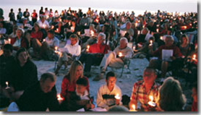
As previously announced, the Christmas Eve Beach service we sponsor will return this year after several year’s absence on December 24 at 5pm! Please help us make it as warm and welcoming as possible for the Sanibel community and its holiday guests. If you can give some time to volunteer in one of several ways, please check out the opportunities on the sign-up sheets in Fellowship Hall.

Art Group on Tuesdays in Fellowship Hall
Calling all artists and all skill levels! Please join Carol Good and friends on Tuesday mornings, from 11:00 am to 2:00 pm in Fellowship Hall. Take time to paint, pick up some pointers and catch up with friends!
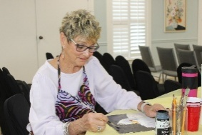
A Note from Mission & Benevolence
The Sanibel UCC and Bat Yam Temple of the Islands collaborative monthly Food and Paper Products Drive will begin this month, starting on Wednesday, November 19th.
When: Every Third Wednesday, 11:00 AM to 1:00 PM
Where: Church Parking Driveway

Each organization will supply 2–3 members to accept drive-in donations of:

- Non-perishable food items
- Bath and kitchen paper products

Collected donations will benefit local neighbors in need through F.I.S.H. and the Gladiolus Food Pantry. Just drive up to the covered part of the driveway, and our volunteers will gladly take your donations.
If you are interested in assisting with this effort, please contact: Ed Hannon, Mission and Benevolence Committee Member, (239) 240-7524
Calling all Shell Point Members
If you would like to have shuttle service to and from Shell Point for Worship on Sundays, please add your name to the sign-up sheet that can be found in Fellowship Hall. The office needs to know how many people would be interested in this service before it can be arranged. Please add your contact information no later than Friday, December 5th.
Shell Point Men’s Group DECEMBER Luncheon
The Sanibel Congregational UCC Shell Point Men’s Group will meet this coming Tuesday, December 9 at 11:45am at the Palm Grill in the Woodlands Common. Please make reservations with Bruce Findley at bruce.findley@gmail.com.

Shell Point Women’s Group DECEMBER Luncheon
The Sanibel Congregational UCC Shell Point Women’s Group will meet this coming Friday, December 12 at 11:30am at the Palm Grill in the Woodlands Common. Please make reservations with Susan Schmitt at sudischmitt@gmail.com.
Liturgists Needed
Please reach out to Sharon Hannon if you would like more information on being a liturgist for our Sunday Worship, or to be added to the contact list. Please send an email to skbhannon@aol.com and include any and all dates you are available.
Ushers Needed
Please contact Inky Meng if you would like more information, or to be added to the contact list to be an Usher during our Worship Celebrations. Send an email to inkymeng@hotmail.com.
Like A Ride To Worship?
If you would like a ride to our Sunday Worship Celebration from Shell Point or Cypress Cove, please contact the Church Office at office@sanibelucc.org by noon on Thursday.
.
INTERESTED IN JOINING SCUCC???
If you are considering becoming a member of SCUCC, or would simply like to find out more about us, please let Rev. Mark know. After you and he discuss the expectations and, as the old commercial says, “the benefits of membership,” you and he can schedule a Sunday that works best for you to become an official part of the SCUCC community.

Floral Dedication Reminder
If you would like to honor a loved one by dedicating flowers to a Worship Celebration, please fill out a Flower Donation Form and your dedication will appear in the bulletin for that Celebration. Donation forms can be found in the Narthex. Christmas Eve flower donation forms are also available.

Drop off your request to the office or place it in the appropriately marked basket. If you prefer, you may call, visit or email the office to make a request.

Assisting With Today’s Worship Celebration
Liturgist: Jonathan Helmreich
Ushers: Barry and Cheryl Tice
Ministers: All Members and Friends of SCUCC
Moderator: Kathy Y. Carter; Vice Moderator: Frank Palaia
Parish Nurse: Linda Convertine, R.N., B.S.N.
Music Director: Mackenzie Albert
Assistant Church Administrator: Tammy Flatley
Financial Manager: Terri Czeczotka
Tech Team: Dr. Renee Rawe, Kirsten Smith, Maggie Voll
Missionaries:
Alex Maldonado-Lizardi & Xiomara Cintron-Garcia in Colombia
Senior Minister: Rev. Dr. Mark Boyea
Pastor Emeritus: Rev. Dr. Ran Niehoff
2050 Periwinkle Way, Sanibel, Florida 33957
Telephone: (239) 472-0497
Website: https://www.sanibelucc.org
Email: office@sanibelucc.org

Scan QR Code to make a donation through PayPal.




This Photo by Unknown Author is licensed under CC BY

