ANNOUNCEMENTS
FOR
SUNDAY, July 12, 2026

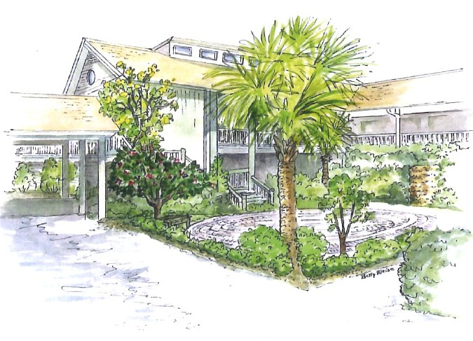



﻿Church Office Hours
The Office is regularly open from 9am-3pm, Monday through Friday.
Mark is normally on campus Tuesday-Thursday pending pastoral visits or off-site meetings. Please feel ﻿free to just “drop by” or make an appointment directly with him by email: mark@sanibelucc.org or text/phone at 908-477-5426.
﻿Mackenzie Albert, our Director of Music, is normally on campus each Wednesday and some Fridays. ﻿Please make an appointment by phone or text at 203-517-5427.

MUSIC
The Church is very proud of the music programs we are able to present which are always free and open to all. However, many of these programs do involve expense to pay guest soloists and musicians. If you would be interested in sponsoring any or part of these programs and providing underwriting for them, please contact Music Director, Mackenzie Albert at 203-517-5427 about programs and costs.
SCUCC T-Shirts
Please check out our SCUCC t-shirts. They are available for sale in Fellowship Hall on Sundays after Worship. A $10 donation is suggested.
The Green Team is Growing!
Are you interested in the stewardship of our natural world? Want to meet new friends? The Green Team invites you to join us! Simply put, the Green Team seeks to fulfill our SCUCC mission in nurturing God’s Creation. We share resources and help sponsor programs and speakers to raise awareness on how we are all intimately connected with our environment. Periodic planning meetings are online. For more information contact Linda Graf at 708-415-7020 or lgrafcnm@aol.com.
Like A Ride To Worship?
If you would like a ride to our Sunday Worship Celebration from Shell Point or Cypress Cove, please contact the Church Office at office@sanibelucc.org no later than noon on Thursday.
INTERESTED IN JOINING SCUCC???
If you are considering becoming a member of SCUCC, or would simply like to find out more about us, please let Rev. Mark know. After you and he discuss the expectations and, as the old commercial says, “the benefits of membership,” you and he can schedule a Sunday that works best for you to become an official part of the SCUCC community.
Shell Point Men’s Group JULY Luncheon
The Sanibel Congregational UCC Shell Point Men’s Group’s next meeting is THIS Tuesday, July 14th at 11:45 am at the Palm Grill in the Woodlands Common. The monthly Men’s Lunch is now open to ALL SCUCC men, regardless of where they live. Please make reservations with Bruce Findley at bruce.findley@gmail.com.
Shell Point Women’s Group
The Shell Point Women’s Group Luncheons are finished until the fall. Please stay tuned for information regarding the next gathering.
The Santiva Islanders Cardio & Strength Classes
Please join Mahnaz Bassiri at SCUCC for exercise. Get fit this summer from 9:30-10:30; Monday, Wednesday and Friday in Fellowship Hall.
From the Hurricane Preparedness Committee
Please check out the F.I.S.H of SanCap website for useful hurricane season information. Their preparedness packet includes a list of the Fort Myers area local motels and hotels, with their local numbers.
2026-FISH-of-SanCap-Hurr icane-Preparedness-Packet.pdf
Copies are also available in the Narthex.

Just a reminder, donations made to the Gladiolus Food Pantry
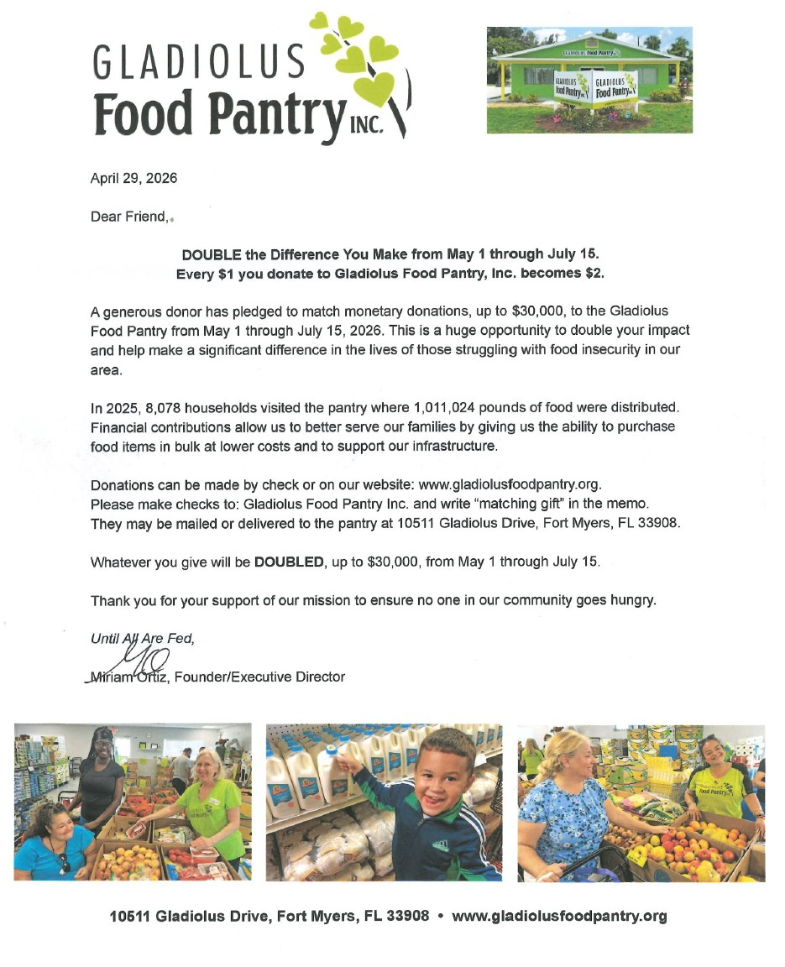
will be doubled, through July 15th.

