Sanibel Congregational United Church of Christ
Worship Celebration
November 9, 2025, 10:00 a.m.


Welcome Everyone!
If you are visiting with us, and you are looking for a spiritual
community…

where you will be loved, accepted, supported and affirmed
regardless of your age, class, ability, race, ethnicity, gender
identification or sexual orientation…where you will be
encouraged and challenged to reflect on your beliefs,
acknowledge your doubts, ask your questions, and grow in
your faith…where God’s desire for compassion, healing,
reconciliation, justice and joy is preached…where you are
given the opportunity to put your faith in action through effective
outreach ministries…then we hope to get to know you as a new
friend.

No matter who you are, or where you are in your life journey…
You are welcome here!
An Open and Affirming / Creation Justice Congregation of the United Church of Christ
Seeking to love all people … growing in faith …
working toward God’s vision of justice, healing and joy.
Sanibel Congregational United Church of Christ
An Open and Affirming/Creation Justice Congregation
Worship Celebration
Stewardship Reflection – “What Shall We Bring?”
Reception of New Members
November 9, 2025, 10:00 a.m.

Welcome

Choral Introit A Jubilant Song Pote
The SCUCC Choir and The Suncoast Brass Quintet

Call to Worship

One: This is the day that God has blessed us with.
All: Let us open our hearts, minds, hands and spirits to God and each
other.

Hymn Joyful, Joyful, We Adore Thee #59 (on p. 6)

Opening Prayer (together)
Holy One, You call us to be Your people. You call us to be Christ’s disciples, living out Your ways of kindness, forgiveness, justice, and mercy. You look to us to carry out Your call to serve the lost, the forgotten, the weak and the powerless.
Help us to answer that call, and care for others who also answer it. Help us to refuse to take them for granted; assist them when they are in need; stand up for them as they have stood up for others; and repay their service with service of our own.
Amen.

Reception of New Members Dianne Higgins and Vicki Morrison
Invitation
Covenant of the New Members
Covenant of the Congregation
Minister: And now, I ask you, the members of the Sanibel Congregational United Church of Christ, to affirm your welcome and covenant with Dianne and Vicki.
All: We welcome you with great joy as members of this spiritual community. We promise you our friendship and prayers as we share in the ways and work of Jesus. By the power of the Holy Spirit, may we continually seek together to understand and live out God’s will and ways, and be examples of the good news of God’s love for all people.
Music Meditation Ye Servants of God Lyons, arr Holcombe
The SCUCC Choir and The Suncoast Brass Quintet

A Time of Prayer with The Lord’s Prayer
(Please use the wording most meaningful to you.)
Invitation to Giving
Offertory Music God Bless the USA Greenwood
The Suncoast Brass Quintet

*Presentation of Offering and Congregational Response
Praise God from whom all blessings flow
Praise God, all creatures here below
Praise God for all that love has done
Creator, Christ, and Spirit, One
Amen
*Prayer of Dedication (together)
God of all we have, do and are, we offer back to You now this part of all You have blessed us with. May it be used to serve Your people and purposes, near and far. May it be used to serve those who seek to rise up from their troubles, as You help us rise up from ours.
Amen.

Ministry of the Word Luke 18:1-8
(New Revised Standard Version Translation)
Ministry of the Word

Luke 18:1-8

Then Jesus told them a parable about their need to pray always and not to lose heart.

He said, “In a certain city there was a judge who neither feared God nor had respect for people. In that city there was a widow who kept coming to him and saying, ‘Grant me justice against my accuser.’ For a while he refused, but later he said to himself, ‘Though I have no fear of God and no respect for anyone, yet because this widow keeps bothering me, I will grant her justice, so that she may not wear me out by continually coming.’ ”

And the Lord said, “Listen to what the unjust judge says. And will not God grant justice to his chosen ones who cry to him day and night? Will he delay long in helping them? I tell you, he will quickly grant justice to them. And yet, when the Son of Man comes, will he find faith on earth?””

Message Dr. Mark Boyea

Hymn America, the Beautiful #727 (on p.7)
A Stewardship Reflection Barb and Renny Challoner
Blessing
Postlude Washington Post March Sousa
The Suncoast Brass Quintet

*All who wish are welcome to stand.

** Our deepest thanks to our friends from the Suncoast Brass for blessing
us this morning with their musical gifts:

Cindy Scaruffi-Klispie, Alan R. Klispie, Dana Williams, Matthew Murrell and Tom Kracmer

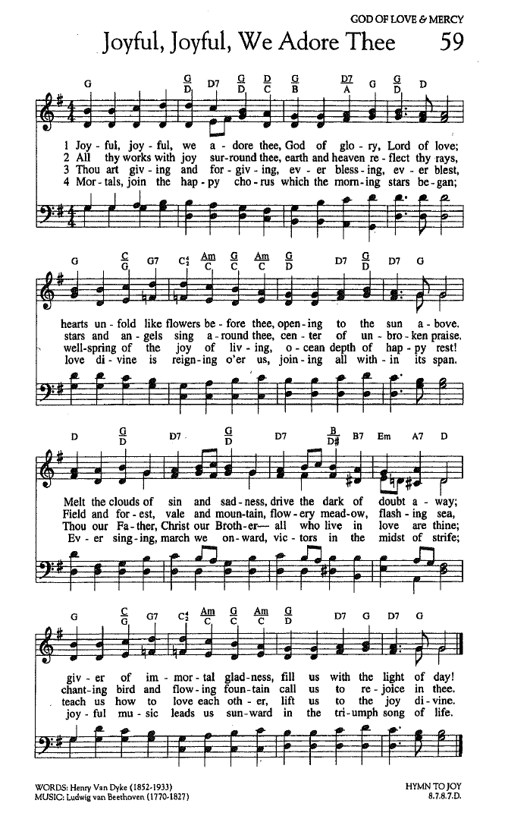

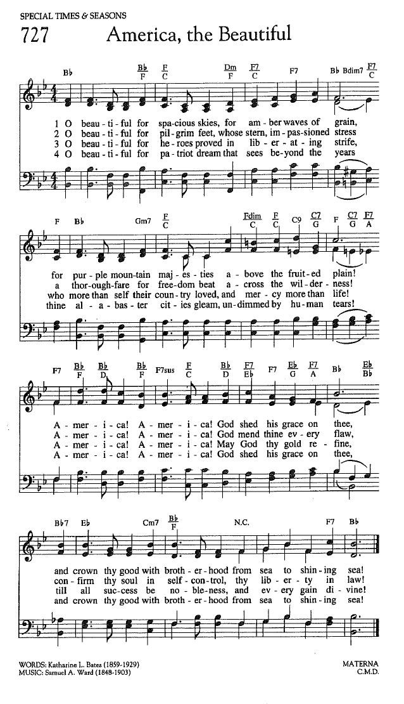

FOR YOUR CONSIDERATION

“I have long believed that sacrifice is the pinnacle of
patriotism.”
Bob Riley, former Governor of Alabama

“True heroism is remarkably sober, very undramatic. It is not the urge to surpass all others at whatever cost, but the urge to serve others at whatever cost.”
Arthur Ashe, tennis great and civil rights advocate

“There is no moral authority like that of sacrifice.”
Nadine Gordimer, South African novelist


ANNOUNCEMENTS

To Our Guests This Morning
If you are with us today for the first, or one of the first times, please let us know. Also, please take a moment to introduce yourself, or re-introduce yourself to Rev. Mark and others, as we will do with you. Our hope is to provide you with the most graceful welcome possible.
TODAY, SUNDAY, NOVEMBER 9
What a Sunday here at SCUCC!
This morning we welcome our great friends from The Suncoast Brass Quintet for their annual Veterans’ Day Sunday contribution to our Worship time.
In addition, we begin our three weeks long Stewardship Reflection period which begins our annual Stewardship season. This year’s theme is What Shall We Bring?, based upon Exodus 25:1-8, when God invites the Israelites to bring gifts of time, talent and treasure for the purpose of building a Sanctuary - and a community - where God can dwell among them.
During these Sundays, members of our spiritual community will bless us with their stories of how they came to be here and what SCUCC means to them. This Sunday we will hear from Barb and Renny Challoner.
We are also blessed today to formally welcome Dianne Higgins and Vicki Morrison into membership.
And finally, please join us after Worship in Fellowship Hall for a special Fellowship Time in honor of Veterans’ Day.
MISSING MAN TABLE TODAY!
This morning, as part of our Veterans’ Day remembrance, you will see what is known as the Missing Man Table. This poignant display serves as a powerful reminder of those who are not with us - our fallen, missing, and imprisoned service members.
This display consists of a single red rose, which symbolizes the blood of service members; a slice of lemon, which represents the bitter fate of the missing; salt, which represents the tears shed by waiting families; an inverted glass representing the fact that the missing and fallen cannot be with us; and a lit candle, symbolizing the light of hope.

NEXT SUNDAY, NOVEMBER 16th - WELCOME BACK LUNCHEON,

Please join us after Worship NEXT Sunday, November 16 for a special Fellowship Time to meet, greet and catch up with each other, as many of us continue to return to Sanibel. A lunch will be served, including sandwiches and desserts.
We look forward to seeing you there!

Office Hours
The Office is regularly open from 9am-3pm, Monday through Friday.
Please note, the office will be closed on Tuesday, November 11th in commemoration of Veteran’s Day.
Mackenzie Albert, our Director of Music, is normally on campus each Wednesday and some Fridays. Please make an appointment by phone or text at 203-517-5427.
SPIRITUAL EXPLORATION DOES NOT MEET THIS WEEK!
SCUCC Spiritual Exploration WILL NOT meet this Tuesday. It continues NEXT Tuesday, November 18 at 7:00pm on Zoom.
“Questioning God”
The companion unit to “Questioning Jesus” from Summer of 2024, the word “Questioning” in the title once again refers not to the idea of challenging or doubting God, or our asking God questions, but instead God’s frequent habit in the Bible of asking questions of others.
During these weeks, we are exploring some of those questions, what they were meant to move the people God asks to do or consider, the answers God receives, and what God’s questions ask us to do or consider now.
BIBLE STUDY MEETS THIS THURSDAY!
SCUCC Bible Study will meet this Thursday, November 13 at 10:30am on Zoom.
Each week, we explore the Scripture passage(s) being used in Worship that coming Sunday. The sessions are largely “guided discussion” in approach, focusing on your questions and insights from reading the text ahead of time, with Mark facilitating and adding relevant context and detail as needed or wanted.
This approach allows for participants to engage with the Bible creatively, and with an eye toward how the texts speak to us in our time and lives. In addition, they are great preparation for getting more out of the Sunday Messages!

SCUCC T-Shirts
Please check out our new SCUCC t-shirts. They will be available for sale in Fellowship Hall on Sundays after Worship. A $10 donation is suggested.

Christmas Eve Beach Service Volunteers
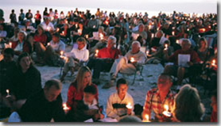
As previously announced, the Christmas Eve Beach service we sponsor will return this year after several year’s absence on December 24 at 5pm! Please help us make it as warm and welcoming as possible for the Sanibel community and its holiday guests. If you can give some time to volunteer in one of several ways, please check out the opportunities on the sign-up sheets in Fellowship Hall.

A Note from Mission & Benevolence
The Sanibel UCC and Bat Yam Temple of the Islands collaborative monthly Food and Paper Products Drive will begin this month, starting on Wednesday, November 19th.
When: Every Third Wednesday, 11:00 AM to 1:00 PM
Where: Church Parking Driveway
Each organization will supply 2–3 members to accept drive-in donations of:


- Non-perishable food items
- Bath and kitchen paper products
Collected donations will benefit local neighbors in need through F.I.S.H. and the Gladiolus Food Pantry. Just drive up to the covered part of the driveway, and our volunteers will gladly take your donations.
If you are interested in assisting with this effort, please contact: Ed Hannon, Mission and Benevolence Committee Member, (239) 240-7524
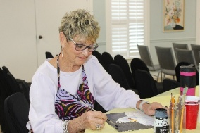
Art Group on Tuesdays in Fellowship Hall
Calling all artists and all skill levels! Please join Carol Good and friends on Tuesday mornings, from 11:00 am to 2:00 pm in Fellowship Hall. Take time to paint, pick up some pointers and catch up with friends!
Shell Point Men’s Group NOVEMBER Luncheon
The Sanibel Congregational UCC Shell Point Men’s Group will meet this coming Tuesday, November 11 at noon at the Palm Grill in the Woodlands Common. Please make reservations with Bruce Findley at bruce.findley@gmail.com.
Shell Point Women’s Group NOVEMBER Luncheon
The Sanibel Congregational UCC Shell Point Women’s Group will meet this coming Friday, November 14 at 11:30am at the Palm Grill in the Woodlands Common. Please make reservations with Susan Schmitt at sudischmitt@gmail.com.
Liturgists Needed
Please reach out to Sharon Hannon if you would like more information on being a liturgist for our Sunday Worship, or to be added to the contact list. Please send an email to skbhannon@aol.com and include any and all dates you are available.
Ushers Needed
Please contact Inky Meng if you would like more information, or to be added to the contact list to be an Usher during our Worship Celebrations. Send an email to inkymeng@hotmail.com.

Like A Ride To Worship?
If you would like a ride to our Sunday Worship Celebration from Shell Point or Cypress Cove, please contact the Church Office at office@sanibelucc.org by noon on Thursday.
Calling all Shell Point Members
If you would like to have shuttle service to and from Shell Point for Worship on Sundays, please add your name to the sign-up sheet that can be found in Fellowship Hall. The office needs to know how many people would be interested in this service before it can be arranged. Please add your contact information no later than Friday, December 5th.
INTERESTED IN JOINING SCUCC???
If you are considering becoming a member of SCUCC, or would simply like to find out more about us, please let Rev. Mark know. After you and he discuss the expectations and, as the old commercial says, “the benefits of membership,” you and he can schedule a Sunday that works best for you to become an official part of the SCUCC community.

Floral Dedication Reminder
If you would like to honor a loved one by dedicating flowers to a Worship Celebration, please fill out a Flower Donation Form and your dedication will appear in the bulletin for that Celebration. Donation forms can be found in the Narthex. Christmas Eve flower donation forms are also available.

Drop off your request to the office or place it in the appropriately marked basket. If you prefer, you may call, visit or email the office to make a request.

Assisting With Today’s Worship Celebration
Liturgist: Sharon Hannon
Ushers: Neal and Sherri Halleran
Ministers: All Members and Friends of SCUCC
Moderator: Kathy Y. Carter; Vice Moderator: Frank Palaia
Parish Nurse: Linda Convertine, R.N., B.S.N.
Music Director: Mackenzie Albert
Assistant Church Administrator: Tammy Flatley
Financial Manager: Terri Czeczotka
Tech Team: Dr. Renee Rawe, Kirsten Smith, Maggie Voll
Missionaries:
Alex Maldonado-Lizardi & Xiomara Cintron-Garcia in Colombia
Senior Minister: Rev. Dr. Mark Boyea
Pastor Emeritus: Rev. Dr. Ran Niehoff
2050 Periwinkle Way, Sanibel, Florida 33957
Telephone: (239) 472-0497
Website: https://www.sanibelucc.org
Question or concerns, please contact the office: office@sanibelucc.org

Scan QR Code to make a donation through PayPal.




This Photo by Unknown Author is licensed under CC BY

