Sanibel Congregational United Church of Christ
Worship Celebration
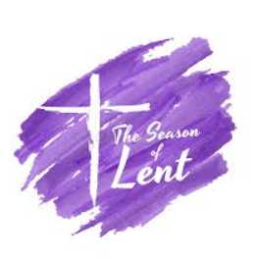
March 15, 2026, 10:00 a.m.

Welcome Everyone!
If you are visiting with us, and you are looking for a spiritual
community…

where you will be loved, accepted, supported and affirmed
regardless of your age, class, ability, race, ethnicity, gender
identification or sexual orientation…where you will be
encouraged and challenged to reflect on your beliefs,
acknowledge your doubts, ask your questions, and grow in
your faith…where God’s desire for compassion, healing,
reconciliation, justice and joy is preached…where you are
given the opportunity to put your faith in action through effective
outreach ministries…then we hope to get to know you as a new
friend.

No matter who you are, or where you are in your life journey…
You are welcome here!
An Open and Affirming / Creation Justice Congregation of the United Church of Christ
Seeking to love all people … growing in faith …
working toward God’s vision of justice, healing and joy.
Sanibel Congregational United Church of Christ
An Open and Affirming/Creation Justice Congregation
Worship Celebration
Fourth Sunday in Lent
“He Said What???!!!”
March 15, 2026, 10:00 a.m.

Welcome
Choral Introit Gentle Shepherd
The SCUCC Choir

Lenten Call to Worship

One: As we continue the journey of Lent;
All: We trust that the Lord will lead the way.
One: When the path is dark;
All: We trust that the Lord will light the way.
One: When the path is hard;
All: We trust the Lord to give us the strength to keep going on the way.
One: And when the path is unclear;
All: We trust the Lord to help us see the way.
All: We go, trusting the Lord to take us where we need to be.
Hymn All Creatures of Our God and King #23, v.1,4&5 (on p. 6)
Prayer of Confession (together)
Holy One, we continue the journey with Jesus and each other through the sacred season of Lent. We continue to examine our lives for the ways in which we have wandered from how Jesus lived and calls us to live.
Forgive us for the times when we have not made the most of the divine spark You have placed in us, and that Jesus calls us to honor. Forgive us for the times when we have not seen, or refused to see, that divine spark in others. Forgive us for when we have not answered Your call to turn that spark into the light of the world.
Help us, in this season and all seasons, to be more faithful to that spark, to that light, and to You – more compassionate, just and merciful.
Amen.
Words of Forgiveness
Know that the One who calls us also forgives us when we turn away and wander off. Know that if we choose, the One who calls us always welcomes us back, again and again.
Music Meditation Pavane Faure

A Time of Prayer with The Lord’s Prayer
2
(Please use the wording most meaningful to you.)

Invitation to Giving
Offertory Music Lamb of God, What Wondrous Love Faure/Petker
The SCUCC Choir

*Presentation of Offering and Congregational Response
(Adapted, Mary Luti, to the Tune of Praise God from Whom All Blessings Flow)
Praise God, the source of breath and birth
The One who formed us from the Earth
To live as one humanity
To love and set each other free
Amen

*Prayer of Dedication (together)
We have received Your many blessings with gratitude, O God. And with gratitude, we now return a part of those blessings back to You. May it be used to help move Your story in the world forward in some way. And may we do the same.

Amen.

Ministry of the Word Matthew 5:38-48
(New Living Bible Translation)

MINISTRY OF THE WORD

Matthew 5:38-48

“You have heard the law that says the punishment must match the injury: ‘An eye for an eye, and a tooth for a tooth.’ But I say, do not resist an evil person! If someone slaps you on the right cheek, offer the other cheek also.

If you are sued in court and your shirt is taken from you, give your coat, too. If a soldier demands that you carry his gear for a mile, carry it two miles. Give to those who ask, and don’t turn away from those who want to borrow.

You have heard the law that says, ‘Love your neighbor’ and hate your enemy. But I say, love your enemies! Pray for those who persecute you! In that way, you will be acting as true children of your Father in heaven. For he gives his sunlight to both the evil and the good, and he sends rain on the just and the unjust alike.

If you love only those who love you, what reward is there for that? Even corrupt tax collectors do that much. If you are kind only to your friends, how are you different from anyone else? Even pagans do that.

But you are to be perfect, even as your Father in heaven is perfect.”

Message Rev. Dr. Mark Boyea

Hymn We Yearn, O Christ for Wholeness (on p. 7)
(from Hymns of Faith and Light)
Blessing
Postlude

*All who wish are welcome to stand.

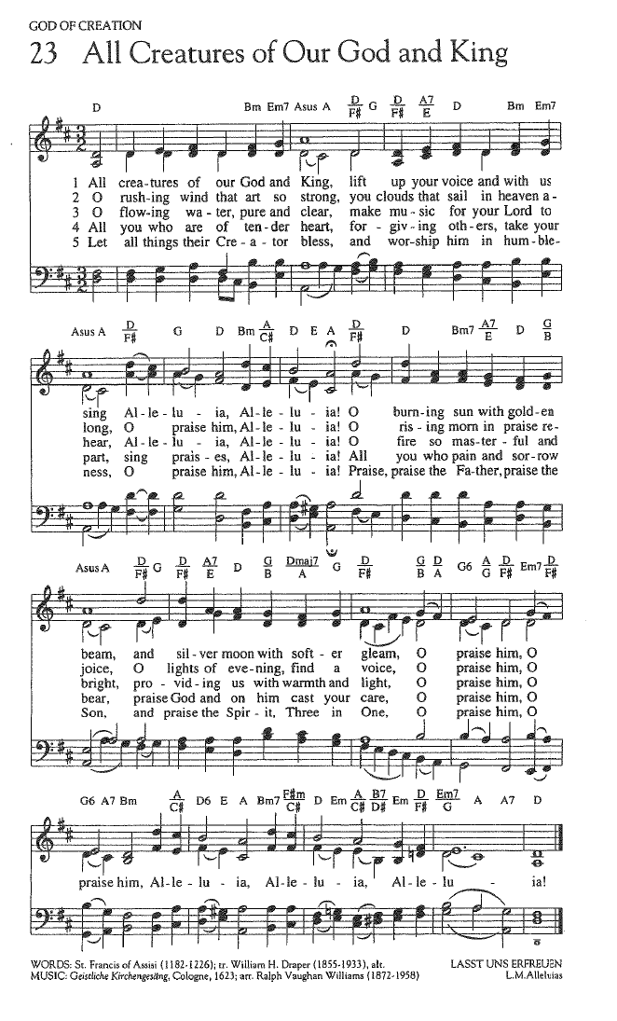
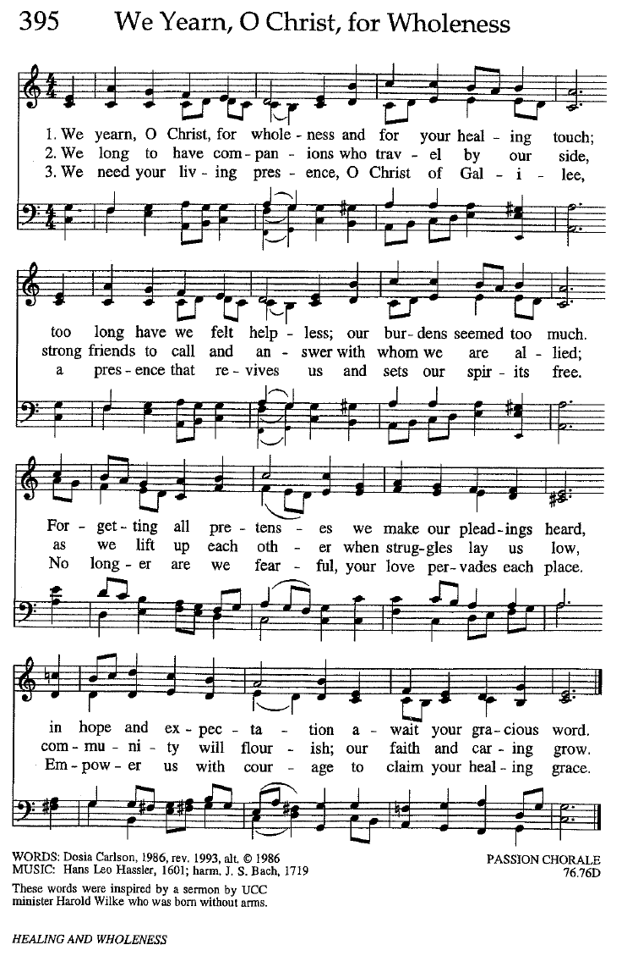

FOR YOUR CONSIDERATION

“It is easy enough to be friendly to one’s friends. But to befriend the one who regards himself as your enemy is the quintessence of true religion. The other is mere business.”
Mahatma Gandhi, Indian spiritual leader and ethicist

“While seeking revenge, dig two graves – one for
yourself.”
Douglas Horton, American minister and ecumenical leader

“Moral certainty can defend people from any truth
other than their own.”
Geraldine Brooks, Australian journalist

To Our Guests This Morning
If you are with us today for the first, or one of the first times, please let us know. Also, please take a moment to introduce yourself, or re-introduce yourself to Rev. Mark. Our hope is to provide you with the most graceful welcome possible.
TODAY, Sunday, March 15 – Fourth Sunday in Lent and Academy Awards Sunday!
Today we continue our Lenten Message theme, He Said What???!!! In which we are focusing on some of the more confusing, difficult or troubling things which Jesus says in the Gospels.
It is also Academy Awards Sunday! On a number of occasions over the years, Mark has used an Academy Award nominated film as one of the foundations of his Message on the morning leading to that night’s Academy Awards ceremony. This Sunday is one of those times!
NEXT Sunday, March 22 – Rev. Dr. Sally Haynes Returns!
As Mark will be away, we will be blessed next Sunday, March 22 by the return of our friend Rev. Dr. Sally Haynes as Worship leader and preacher.
Lenten Devotionals Available
In conjunction with the season of Lent, copies of the Lenten Devotional The Sanctuary for Lent are available at the back of the Sanctuary. Please help yourself to one.

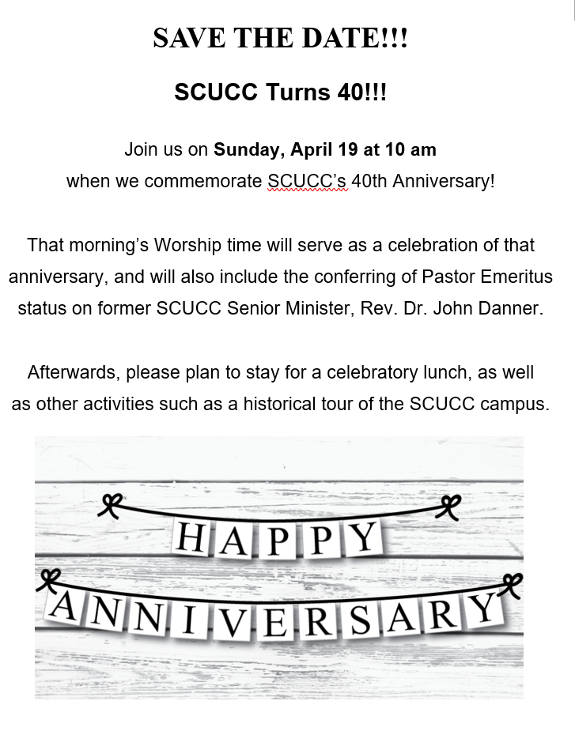
Assisting With Today’s Worship Celebration
Liturgist: Barbara Cecala
Ushers: Ed and Sharon Hannon
Ministers: All Members and Friends of SCUCC
Moderator: Frank Palaia; Vice Moderator: Norm Boyd
Parish Nurse: Linda Convertine, R.N., B.S.N.
Music Director: Mackenzie Albert
Church Administrator: Tammy Flatley
Financial Manager: Terri Czeczotka
Tech Team: Dr. Renee Rawe, Kirsten Smith, Maggie Voll
Missionaries:
Alex Maldonado-Lizardi & Xiomara Cintron-Garcia in Colombia
Senior Minister: Rev. Dr. Mark Boyea
Pastor Emeritus: Rev. Dr. Ran Niehoff
2050 Periwinkle Way, Sanibel, Florida 33957
Telephone: (239) 472-0497

Website: https://www.sanibelucc.org
Email: office@sanibelucc.org




You can scan a QR Code to make a donation through
PayPal or Venmo.

This Photo by Unknown Author is licensed under CC BY

