Sanibel Congregational United Church of Christ
Worship Celebration
January 11, 2026, 10:00 a.m.


Welcome Everyone!
If you are visiting with us, and you are looking for a spiritual
community…

where you will be loved, accepted, supported and affirmed
regardless of your age, class, ability, race, ethnicity, gender
identification or sexual orientation…where you will be
encouraged and challenged to reflect on your beliefs,
acknowledge your doubts, ask your questions, and grow in
your faith…where God’s desire for compassion, healing,
reconciliation, justice and joy is preached…where you are
given the opportunity to put your faith action through effective
outreach ministries…then we hope to get to know you as a new
friend.

No matter who you are, or where you are in your life journey…
You are welcome here!
An Open and Affirming / Creation Justice Congregation of the United Church of Christ
Seeking to love all people … growing in faith …
working toward God’s vision of justice, healing and joy.
Sanibel Congregational United Church of Christ
An Open and Affirming/Creation Justice Congregation
Worship Celebration
January 11, 2026, 10:00 a.m.

Welcome

Choral Introit Seek Ye First the Kingdom of God
The SCUCC Choir

Call to Worship

One: This is the day that God has blessed us with.
All: Let us rejoice and be grateful for it.
One: Let us sing, listen, pray and be in community;
All: Knowing that where two or more are gathered, God is present.
One: Let us come before God with open hearts and minds;
All: Ready to be a place of God’s hospitality for all.

*Hymn Joyful, Joyful, We Adore Thee #59 (on p. 6)

Opening Prayer (together)
Gracious God, we thank You for this place of such beauty and comfort as we Worship this morning. But we also ask that You stir us from our comfort. Give us eyes to see those whom we do not yet know, and hearts to care for those who are strangers to us. May our love for each other be a springboard for us to invite the world into Your ever-widening circle of welcome. Fill us with Your love, that we may love others well.

Amen.

Music Meditation Jesu, Joy of Man’s Desiring J. S. Bach

A Time of Prayer with Our Lord’s Prayer
(please use the wording most meaningful to you)

Invitation to Giving

Offertory Music Sweet Hour of Prayer King

*Presentation of Offering and Congregational Response
(To the tune of Praise God from Whom All Blessings Flow)
To God, all glorious heavenly light
To Christ, revealed in earthly sight
To God the Spirit, now we raise
Our joyful songs of thankful praise
Amen
*Prayer of Dedication (together)
We offer You now, O God, this part of all You have blessed us with. We offer it not because we have to, but because we want to. And we want to because You have not just blessed us, but call us to be a place of blessing and hospitality for others.

Amen.

Ministry of the Word Acts 8:26-39
(New Revised Standard Version Translation)

MINISTRY OF THE WORD
Acts 8:26-39
Then an angel of the Lord said to Philip, “Get up and go toward the south to the road that goes down from Jerusalem to Gaza.” (This is a wilderness road.) So he got up and went. Now there was an Ethiopian eunuch, a court official of the Candace, the queen of the Ethiopians, in charge of her entire treasury. He had come to Jerusalem to worship and was returning home; seated in his chariot, he was reading the prophet Isaiah. Then the Spirit said to Philip, “Go over to this chariot and join it.” So Philip ran up to it and heard him reading the prophet Isaiah. He asked, “Do you understand what you are reading?” He replied, “How can I, unless someone guides me?” And he invited Philip to get in and sit beside him. Now the passage of the scripture that he was reading was this:
“Like a sheep he was led to the slaughter, and like a lamb silent before its shearer, so he does not open his mouth. In his humiliation justice was denied him. Who can describe his generation? For his life is taken away from the earth.”
The eunuch asked Philip, “About whom, may I ask you, does the prophet say this, about himself or about someone else?” Then Philip began to speak, and starting with this scripture he proclaimed to him the good news about Jesus. As they were going along the road, they came to some water, and the eunuch said, “Look, here is water! What is to prevent me from being baptized?” He commanded the chariot to stop, and both of them, Philip and the eunuch, went down into the water, and Philip baptized him. When they came up out of the water, the Spirit of the Lord snatched Philip away; the eunuch saw him no more and went on his way rejoicing.

Message Will You Walk Across the Room?
Rev. Dr. Sally Haynes

Hymn Called as Partners in Christ’s Service # 581 (p. 7)
Blessing

Postlude Called as Partners in Christ’s Service (improvisation)

*All who wish are welcome to stand.

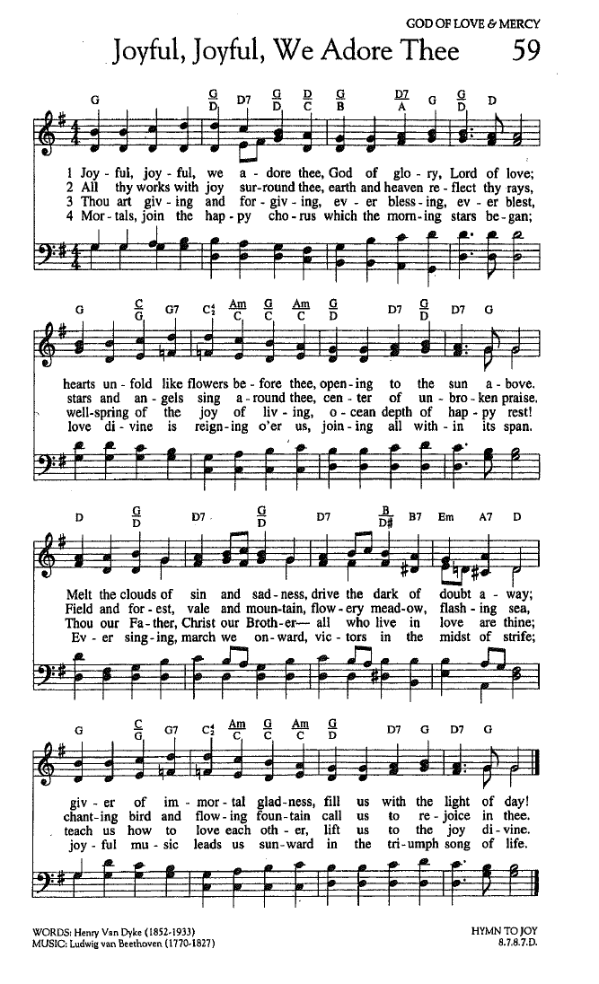
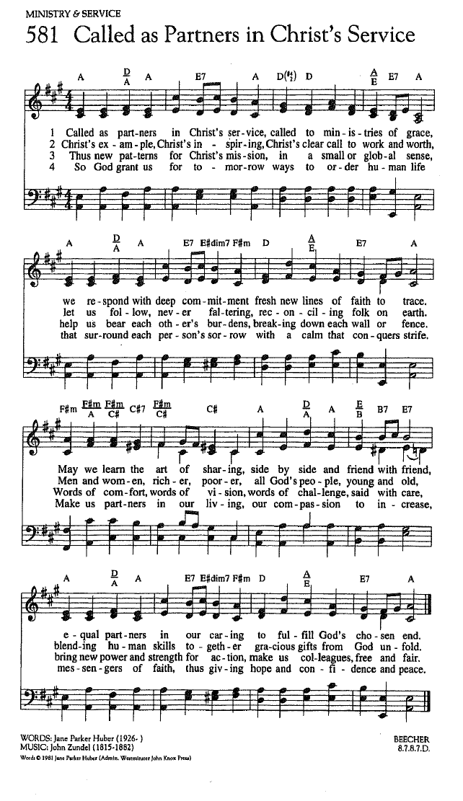

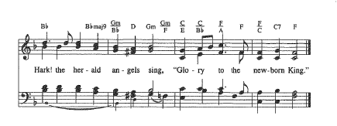

FOR YOUR CONSIDERATION

“I think the vast majority of us in this country hunger
for more unity and hospitality, and we all share and shoulder the burden of the hard work necessary to build that.”
Lee Isaac Chung, American filmmaker

“Hospitality knows no gender or race.”
Danny Meyer, American restaurant owner

“The transition from stranger, to neighbor, to family that hospitality makes possible does not happen naturally, but only with intent, and grit, and sacrifice, and God’s blessing.”
Rosaria Butterfield, American author and theologian

ANNOUNCEMENTS
To Our Guests This Morning
If you are with us today for the first, or one of the first times, please let us know. Also, please take a moment to introduce yourself, or re-introduce yourself to Rev. Mark and others. Our hope is to provide you with the most graceful welcome and experience possible.
TODAY, Sunday, January 11, 2026 – Rev. Dr. Sally Haynes
As previously announced, Rev. Dr. Sally Haynes returns to lead Worship this morning as Mark is away.
Church Office Hours
The Church Office is regularly open from 9 am-3 pm, Monday through Friday.
Mark is normally on campus Tuesday-Thursday pending pastoral visits or off-site meetings. Please feel free to just “drop by” or make an appointment directly with him by email: mark@sanibelucc.org or text/phone at 908-477-5426.
Mackenzie Albert, our Director of Music, is normally on campus each Wednesday and some Fridays. Please make an appointment by phone or text at 203-517-5427.
SPIRITUAL EXPLORATION
This year’s “Advent Unit” has concluded.
Our next unit will begin in late January or early February. The topic and schedule will be announced soon.

BIBLE STUDY
Bible Study will meet this Thursday, January 15 at 10:30am on Zoom.
Each week, we explore the passages which will be part of that coming Sunday’s Worship. These sessions are discussion based, with Mark guiding a structured conversation based on participants’ questions, concerns and considerations of the text. The passage(s) to be looked at each week, as well as the necessary information for joining in, will be sent by email the day before.

Don’t Miss This! A Council of All Beings
TOMORROW, Monday, January 12, from 1-4:30, SCUCC will host a workshop called A Council of All Beings. Please see the January Sanibel Light for more details. In this creative ritual participants temporarily step aside from their human identity and speak on behalf of another life-form. Sitting in council together, the beings speak of their concerns, describe the challenges they face, and offer their unique gifts to the humans. The experience will be enhanced by a guided meditation, songs, easy mask-making with natural objects and simple craft supplies, and teachings from the Work That Reconnects.
Invite your friends for this unusual opportunity. Donations are on a sliding scale from $10-35. After paying for snacks and the materials we need, we will donate the rest to buy native plants for the church’s butterfly garden. Questions, call Linda Graf at 708-415-7020. To register, see sign-up in Fellowship Hall or go to the website of our facilitator https://www.annegoodwin.com/events before Friday, January 9.
Anne will be present after Worship, TODAY, Sunday, January 11 to answer questions.

The Green Team is Growing!
Are you interested in the stewardship of our natural world? Want to meet new friends? The Green Team invites you to join us! Simply put, the Green Team seeks to fulfill our SCUCC mission in nurturing God’s Creation. We share resources and help sponsor programs and speakers to raise awareness on how we are all intimately connected with our environment. Periodic planning meetings are online. For more information contact Linda Graf at 708-415-7020 or lgrafcnm@aol.com.
“Knowing what’s right doesn’t mean much unless you do what’s right”
~ Theodore Roosevelt
Art Group on Tuesdays in Fellowship Hall
Calling all artists and all skill levels! Please join Carol Good and friends on Tuesday mornings, from 11:00 am to 2:00 pm in Fellowship Hall. Take time to paint, pick up some pointers and catch up with friends! You can also check the art displayed around Fellowship Hall, from our newest artist, Arlene Stigum.
Shell Point Men’s Group JANUARY Luncheon
The Sanibel Congregational UCC Shell Point Men’s Group will next meet this Tuesday, January 13 at 11:45 am at the Palm Grill in the Woodlands Common. Please make reservations with Bruce Findley at bruce.findley@gmail.com.
Shell Point Women’s Group FEBRUARY Luncheon
The Sanibel Congregational UCC Shell Point Women’s Group will next meet on Friday, February 13 at 11:30 am at the Palm Grill in the Woodlands Common. Please make reservations with Susan Schmitt at sudischmitt@gmail.com.

Like A Ride To Worship?
If you would like a ride to our Sunday Worship Celebration from Shell Point or Cypress Cove, please contact the Church Office at office@sanibelucc.org by noon on Thursday.
Ushers Needed
Please contact Inky Meng if you would like more information, or to be added to the contact list to be an Usher during our Worship Celebrations. Send an email to inkymeng@hotmail.com.
INTERESTED IN JOINING SCUCC???
If you are considering becoming a member of SCUCC, or would simply like to find out more about us, please let Rev. Mark know. After you and he discuss the expectations and, as the old commercial says, “the benefits of membership,” you and he can schedule a Sunday that works best for you to become an official part of the SCUCC community.

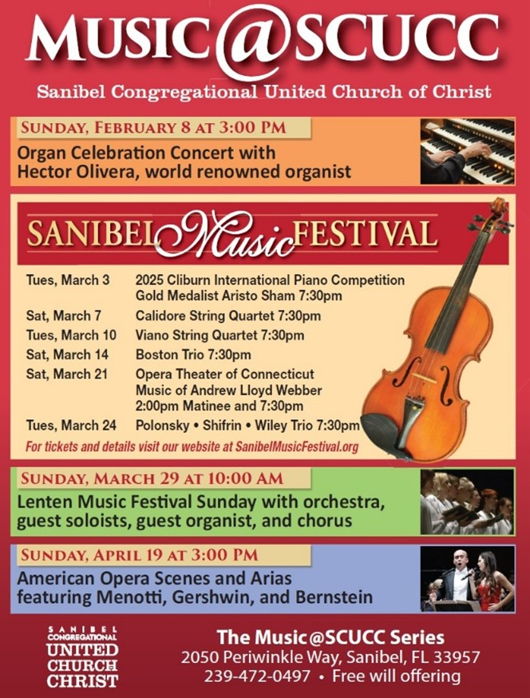
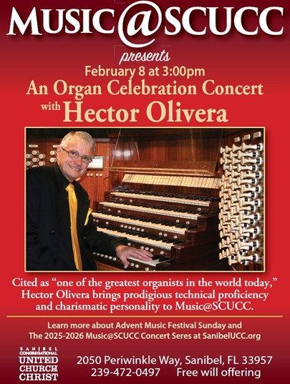
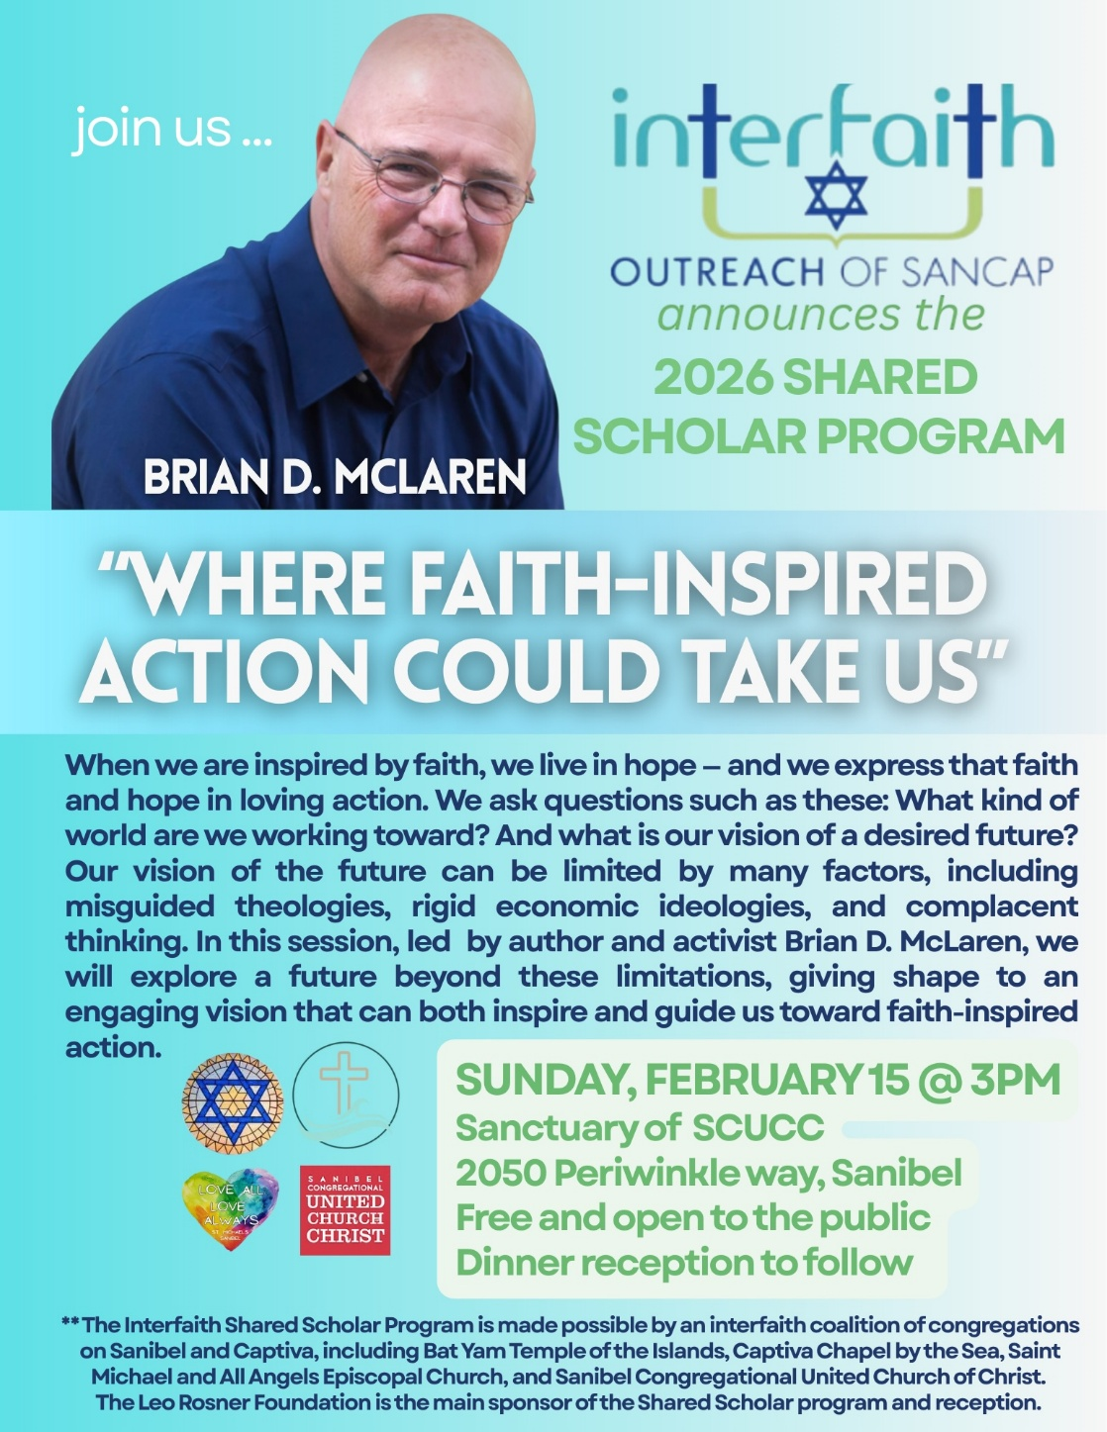
Assisting With Today’s Worship Celebration
Liturgist: Sharon Hannon
Ushers: Jim and Linda Winn
Ministers: All Members and Friends of SCUCC
Moderator: Kathy Y. Carter; Vice Moderator: Frank Palaia
Parish Nurse: Linda Convertine, R.N., B.S.N.
Music Director: Mackenzie Albert
Church Administrator: Tammy Flatley
Financial Manager: Terri Czeczotka
Tech Team: Dr. Renee Rawe, Kirsten Smith, Maggie Voll
Missionaries:
Alex Maldonado-Lizardi & Xiomara Cintron-Garcia in Colombia
Senior Minister: Rev. Dr. Mark Boyea
Pastor Emeritus: Rev. Dr. Ran Niehoff
2050 Periwinkle Way, Sanibel, Florida 33957
Telephone: (239) 472-0497

Website: https://www.sanibelucc.org


Email: office@sanibelucc.org
You can scan a QR Code to make a donation through
PayPal or Venmo.



This Photo by Unknown Author is licensed under CC BY


