Seeking to love all people … growing in faith …
working toward God’s vision of justice, healing and joy.
Sanibel Congregational United Church of Christ
An Open and Affirming/Creation Justice Congregation
Worship Celebration
May 5, 2024 10:00 a.m.

Welcome

Prelude He Is Lord Vogt

Call to Worship

One: This is the day that God has blessed us with.
All: Let us open our hearts, minds and spirits to God and each other in Worship.

Hymn God of Grace and God of Glory #477 (on p. 2)

Opening Prayer (together)

Holy One, we thank You for creating us in Your image and likeness. We thank You for creating us to experience full, spirit-filled lives. We thank You for the call to be Your hands, feet, head, heart and voice in this world.

Help us to do this wisely and well; generously and joyfully. Help us to leave behind everything and anything that keeps us from heading to the places and people You are trying to lead us to – to the new and different paths You are calling us to travel and the new and different people You are calling us to serve. Help us to care more about Your ways and glory than our own, and be willing and grateful to play whatever part You need us to.

Amen.

A Time of Prayer with The Lord’s Prayer
(Please use the wording most meaningful to you.)

1
Invitation to Giving

Offertory Music Quiet Medley Lau

*Presentation of Offering and Congregational Response
(Praise God from Whom All Blessings Flow #46)

Praise God from whom all blessings flow
Praise God, all creatures here below
Praise God for all that love has done
Creator, Christ and Spirit, One. Amen.

*Prayer of Dedication (together)

God of all we have, do and are, we offer back to You now this part of all You have blessed us with. May it be used to help make Your vision for the world a reality. And may those served by it know Your presence in their lives, giving them strength, courage, and hope in the midst of their struggles.

Amen.

Ministry of the Word John 5:1-15 (on p. 4)
(New Revised Standard Version Translation)

Message Brian Culbertson

Hymn We Yearn, O Christ, for Wholeness #395 (on p. 5)

Blessing

Postlude A Joyous Acclamation Smith

*All who wish are welcome to stand.

3

For Your Consideration
“Hope lies in having more faith in the power of God to heal us than the power of anything to hurt or destroy us.”
Marianne Williamson, American author
“Healing does not always mean going back to the way things were before, but rather allowing what is to move us closer to God.”
Ram Dass, American psychologist and writer

ANNOUNCEMENTS
TODAY, Sunday, May 5
This morning, with both Mark and Mackenzie away, we are blessed by the gifts of our four leaders for the day. Kathy Carter will serve as the day’s Worship Leader, offering the Welcome and Final Blessing, as well as presiding over the Time of Prayer and Invitation to the Offering. Jan VanBuskirk will serve as Liturgist. Pastor Brian Culbertson, our friend from Refuge Church, which was our home from October 2022-October 2023, will deliver the morning’s Message, and Shirley Witte, Chair of our Music Committee, will serve as our musical leader.
Next Sunday, May 12
Next Sunday, May 12, we will celebrate the Sacrament of Communion as a spiritual community in honor of all those women who have blessed us as mothers, grandmothers and mother figures throughout our lives.
Church Office Hours
The Church Office is open Monday-Friday, from 9am-3pm.
Mark is normally on the campus Tuesday-Thursday pending pastoral visits or off-site meetings. Please feel free to just “drop by” or make an appointment directly with him by email: mark@sanibelucc.org or text/phone at 908-477-5426.

60
Spiritual Exploration
Our current unit continues:

“Blessed Are Who???: The Beatitudes Then and Now”
Tuesdays: May 7, 21 and 28
7:00-8:15pm on Zoom
The “Beatitudes” are among the most influential spiritual teachings in human history. They have appeared in and influenced literature, politics, and moral and ethical philosophy.
In this unit, we are exploring the Beatitudes as they are presented to us by both Matthew’s and Luke’s Gospels, how they would have been understood in Jesus’ time and the time those gospels were written, and how they might speak to us in this time.
You do not need to be able to attend all sessions to participate, as each one begins with a brief review of the previous week’s discussion.
You will receive the information you need to join these sessions, as well as any advanced reading you should do in advance, on Monday afternoons.

Bible Study
Bible Study will meet this Thursday, May 9 at 10:30am on Zoom.

Each week, we explore the Scripture passage(s) being used in Worship that coming Sunday. These sessions are largely “guided discussion” in approach, focusing on your questions and insights from reading the text(s) ahead of time, with Mark facilitating and adding relevant context and detail as needed or wanted.

This approach allows for participants to engage with the Bible creatively, and with an eye toward how the text speaks to us in our time and lives. In addition, they are great prep for getting more out of the Sunday messages!

You will receive the information you need to join in on these sessions, as well as the passages you need to read in advance, on Wednesday afternoons.

7
New Chat Feature Added to Our YouTube Stream!
We are now able to “chat” with each other on Sunday mornings during the livestream our Worship celebrations on YouTube. All you need do is log into YouTube using just your email address and name. You will be asked to follow YouTube’s guidelines and check the box stating you are over 18 years of age. YouTube will not ask for any personally identifiable information other than your email address and name. Then open our service broadcast and the “chat window” will be available on the right side of your screen, just like in Zoom. You can then communicate with others who are also watching live if you wish to say hello or comment on the day’s proceedings.
Dinners for 6, 7 or 8
One of our most loved offerings are the social gatherings known as “Dinner for 6, 7 or 8”. If you would like to participate, please send your names, email addresses and phone numbers to Shirley Akins at akinsteach@gmail.com. Dinners have mostly ended for this past season, but will resume with new groups in the fall.
Shell Point Women’s Group May Luncheon
The Sanibel Congregational UCC, Shell Point Women’s Group will have its next monthly luncheon meeting this Friday, May 10 at 11:30am at the Palm Grill in the Woodlands Common. Please make reservations with Emily Kletzien at emily.kletzien@gmail.com.
Shell Point Men’s Group May Luncheon
The Sanibel Congregational UCC Shell Point Men’s Group will have its next monthly luncheon meeting on Tuesday, May 14 at noon at the Palm Grill in the Woodlands Common. Please make reservations with Candy Atchison at JimAtch@aol.com or 561-714-4655.
Fellowship Time Volunteers Needed
If you would like to help prepare and serve refreshments for Fellowship Time after Worship on Sundays, please sign up on the sheet found on the table in the back of Fellowship Hall. It is easy, and assistance will be available if needed. Donations of light fare and/or help with serving or cleanup will be greatly appreciated.
Ushers Needed
If you are interested in ushering for Sunday Worship, please contact Frank Palaia at flpalaiajr@cs.com for more information.
8
An Update from the Mission & Benevolence Committee
Thank you for your continuing support of the Gladiolus Food Pantry. The food box in the narthex runneth over! They are now in need of canned corn and canned peas, so please include these with your other items. A can for cash has also been added to the food box if you desire to make monetary contributions.
Donations can be placed in the collection chest inside the entrance to the Sanctuary.
Be An Artist
Anyone interested in painting in any medium is welcome to join our returning Art Class. Classes are held on Tuesdays from Noon to 3:00pm in Fellowship Hall.
Carol Good will be teaching a beginner’s watercolor class at the same time for anyone who would like to learn. Please contact her at 618-201-6252 for more information.
Yoga Classes
Please note, both the Wednesday and Thursday Yoga Classes are currently on hold. An update will be provided when the classes are to resume.
INTERESTED IN JOINING SCUCC???
If you are considering becoming a member of SCUCC, or would simply like to find out more about us, please let Rev. Mark know. After you and he discuss the expectations and, as the old commercial says, “the benefits of membership”, you and he can schedule a Sunday that works best for you to become an official part of the SCUCC community.
Like A Ride To Worship?
If you would like a ride to Sunday Worship from Shell Point or Cypress Cove, please contact the Church Office at office@sanibelucc.org by noon on Thursdays.

9

MINISTRY OF THE WORD

JOHN 5: 1-15
After this there was a festival of the Jews, and Jesus went up to Jerusalem.
Now in Jerusalem by the Sheep Gate there is a pool, called in Hebrew
Beth-zatha, which has five porticoes. In these lay many invalids - blind, lame, and paralyzed. One man was there who had been ill for thirty-eight years. When Jesus saw him lying there and knew that he had been there a long time, he said to him, ‘Do you want to be made well?’ The sick man answered him, ‘Sir, I have no one to put me into the pool when the water is stirred up; and while I am making my way, someone else steps down ahead of me.’

Jesus said to him, ‘Stand up, take your mat and walk.’ At once the man was made well, and he took up his mat and began to walk.
Now that day was a sabbath. So the Jews said to the man who had been cured, ‘It is the sabbath; it is not lawful for you to carry your mat.’ But he answered them, ‘The man who made me well said to me, “Take up your mat and walk.” ’ They asked him, ‘Who is the man who said to you, “Take it up and walk”?’ Now the man who had been healed did not know who it was, for Jesus had disappeared in the crowd that was there.
Later Jesus found him in the temple and said to him, ‘See, you have been made well! Do not sin anymore, so that nothing worse happens to you.’ The man went away and told the Jews that it was Jesus who had made him well.

4
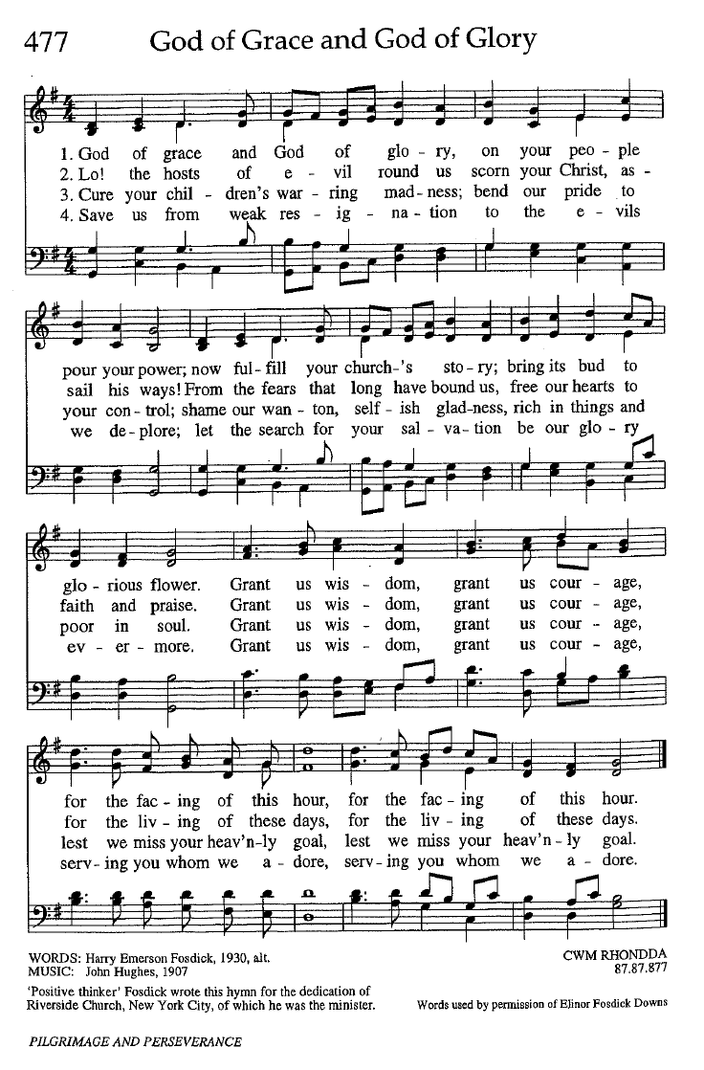
2
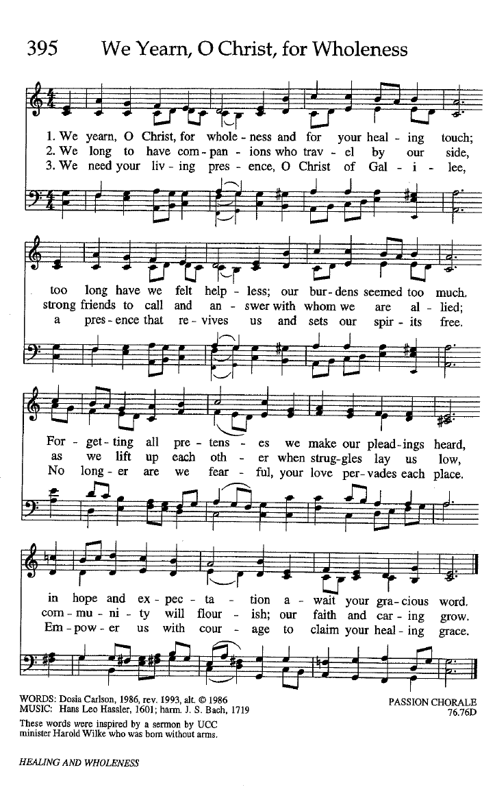
5

