Sanibel Congregational United Church of Christ
Worship Celebration

April 26, 2026, 10:00 a.m.

Welcome Everyone!
If you are visiting with us, and you are looking for a spiritual
community…

where you will be loved, accepted, supported and affirmed
regardless of your age, class, ability, race, ethnicity, gender
identification or sexual orientation…where you will be
encouraged and challenged to reflect on your beliefs,
acknowledge your doubts, ask your questions, and grow in
your faith…where God’s desire for compassion, healing,
reconciliation, justice and joy is preached…where you are
given the opportunity to put your faith in action through effective
outreach ministries…then we hope to get to know you as a new
friend.

No matter who you are, or where you are in your life journey…
You are welcome here!
An Open and Affirming / Creation Justice Congregation of the United Church of Christ
Seeking to love all people … growing in faith …
working toward God’s vision of justice, healing and joy.
Sanibel Congregational United Church of Christ
An Open and Affirming/Creation Justice Congregation
Worship Celebration
Fourth Sunday of Easter
April 26, 2026, 10:00 a.m.

Welcome

Choral Introit Glory to God Vitale
The SCUCC Choir

Call to Worship
One: As we continue to gather together in this Easter Season;
All: Let us offer our minds, hearts and spirits to God and each other in
Worship.

Hymn Morning Has Broken #35 (on p. 6)

Opening Prayer (together)
O God, we gather together this day to thank You; to praise You; to seek to better understand You and Your ways. We gather together as people who You love and constantly offer grace to.
But we can be so set in our ways; so stubborn; so sure we are right; so certain that others are at fault that we resist offering that same love and grace to them.
Help us to recognize when we have fallen short of Your hopes and call for our lives. Give us the strength and courage we need to openly acknowledge it. And lead us to the humility we need to be willing to express our regret to You and those we have failed to do right by.
Amen.
Music Meditation Honor and Majesty Lanier
The SCUCC Choir

A Time of Prayer with The Lord’s Prayer
2
(Please use the wording most meaningful to you.)
Invitation to Giving
Offertory Music Gavotte Bach
Shirley Witte, piano; Jane Saghir, flute

*Presentation of Offering and Congregational Response
Your name, we bless, O Risen Lord
And sing today with one accord
The life laid down, the life restored
Allelujah! Allelujah!

Amen.
*Prayer of Dedication (together)
Spirit-giving, strengthening and restoring God, we offer back to You now this part of all You have blessed us with. May it be used to help instill strength and restore Your spirit in those who cannot feel its presence in their lives and in this world.

Amen.
Ministry of the Word John 15:4-11
(New Revised Standard Version Translation)

MINISTRY OF THE WORD

John 15:4-11

Abide in me as I abide in you. Just as the branch cannot bear fruit by itself unless it abides in the vine, neither can you unless you abide in me.

I am the vine; you are the branches. Those who abide in me and I in them bear much fruit, because apart from me you can do nothing. Whoever does not abide in me is thrown away like a branch and withers; such branches are gathered, thrown into the fire, and burned. If you abide in me and my words abide in you, ask for whatever you wish, and it will be done for you.

My Father is glorified by this, that you bear much fruit and become my disciples. As the Father has loved me, so I have loved you; abide in my love. If you keep my commandments, you will abide in my love, just as I have kept my Father’s commandments and abide in his love.

I have said these things to you so that my joy may be in you and that your joy may be complete.

Message Rev. Evan Farrar

Hymn The Gift of Love #397 (on p. 7)
Blessing
Postlude Dona Nobis (Give Us Peace) Lantz
The SCUCC Choir

*All who wish are welcome to stand.

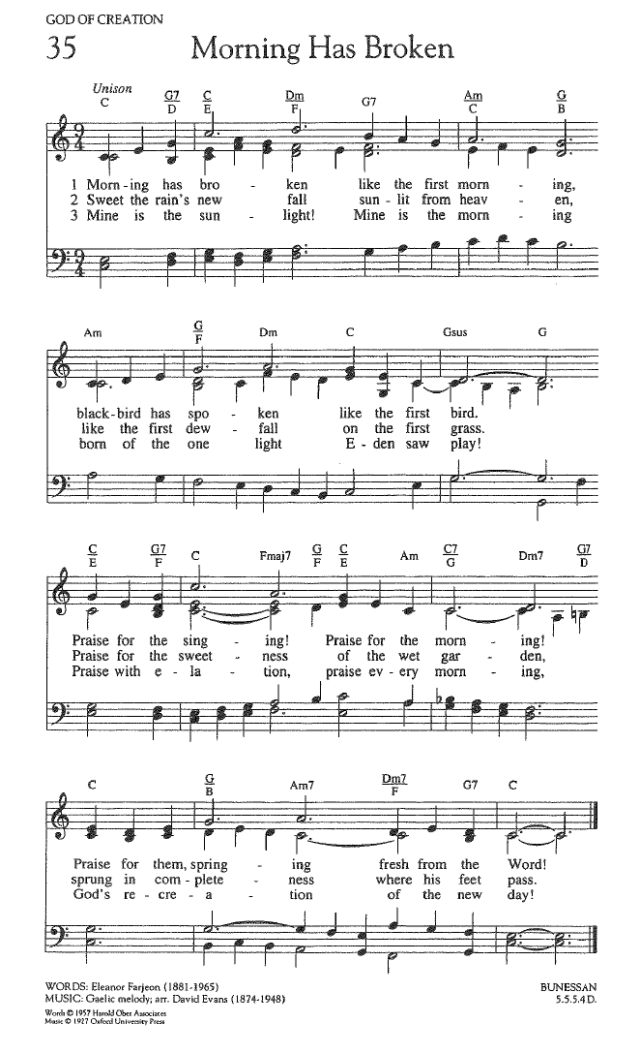
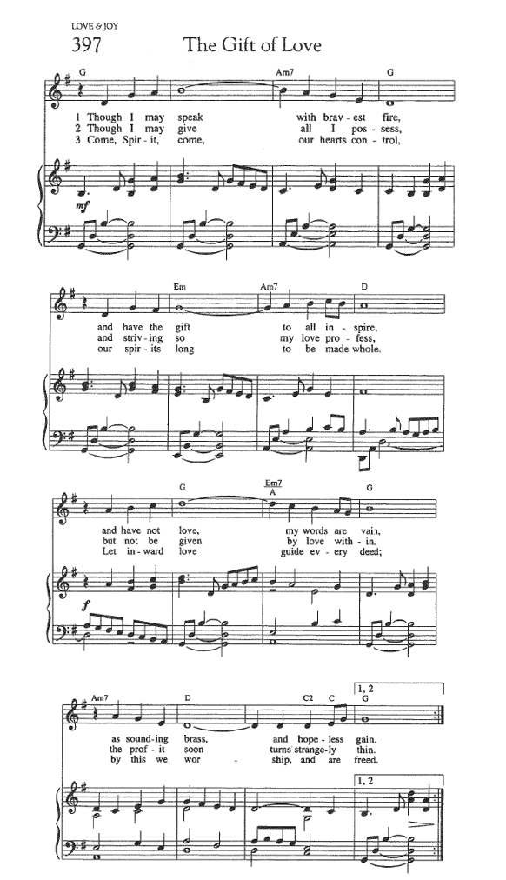

FOR YOUR CONSIDERATION

“Nothing in or of this world measures up to the simple pleasure of experiencing the presence of God.”
Aiden Wilson Tozer, American minister and author

“I realized I had been so focused on asking
why a good God allows bad things to happen
that I was missing out on the nearness of God
all along. In becoming preoccupied with the
why, I was missing the who.”
Margaret Feinberg, American author

“Joy is the infallible sign of the presence of God.”
Pierre Teilhard de Chardin, French priest and scientist

To Our Guests This Morning
If you are with us today for the first, or one of the first times, please let us know. Also, please take a moment to introduce yourself, or re-introduce yourself to each other. Our hope is to provide you with the most graceful welcome possible.
TODAY, SUNDAY, APRIL 26 – Rev. Evan Farrar
Today we welcome Rev. Evan Farrar as guest preacher while Mark recovers from his surgery this past Wednesday.
Rev. Farrar holds a Master of Divinity from Union Theological Seminary in New York City and an M.A. in mental health counseling. He is an ordained minister in the United Church of Christ and has served congregations in New York, Ohio and Florida. Most recently, he served as Minister of Congregational United Church of Christ in Sarasota.
Earlier in his career, Rev. Farrar worked at the national level of the United Church of Christ with Global Ministries and has extensive experience working in the nonprofit sector serving people with addictions, homelessness, disabilities and mental health challenges. He currently serves as the Director of the Caregiver Resource Center at the Senior Friendship Center in Sarasota, where he has developed an innovative mental health counseling support program for caregivers of people living with dementia.
Evan is a caregiver for his mother, Betty, who was diagnosed with dementia several years ago. He lives in Sarasota with his wife, Laurie, and their dog Jack, a rescue Chihuahua mix.


Office Hours
The Office is regularly open from 9 am-3 pm on Monday through Friday.
Mark is generally on campus Tuesday-Thursday pending pastoral visits or off-site meetings. Please feel free to just “drop by” or make an appointment directly with him by email: mark@sanibelucc.org or text/phone at 908-477-5426.
Mackenzie Albert, our Director of Music, is normally on campus each Wednesday and some Fridays. Please make an appointment by phone or text at 203-517-5427.
SPIRITUAL EXPLORATION
Our most recent unit has concluded. The topic and schedule for our next unit are still being determined.
BIBLE STUDY
Bible Study WILL NOT meet this Thursday, April 30 at 10:30 am on Zoom.
During each session, we explore the passages which will be part of that coming Sunday’s Worship. These meetings are discussion based, with Mark guiding a structured conversation based on participants’ questions, concerns and considerations of the text. The passage(s) to be looked at each week, as well as the necessary information for joining in, will be sent by email the day before.

Assisting With Today’s Worship Celebration
Liturgist: Sharon Hannon
Ushers: Barry and Cheryl Tice
Ministers: All Members and Friends of SCUCC
Moderator: Frank Palaia; Vice Moderator: Norm Boyd
Parish Nurse: Linda Convertine, R.N., B.S.N.
Music Director: Mackenzie Albert
Church Administrator: Tammy Flatley
Financial Manager: Terri Czeczotka
Tech Team: Dr. Renee Rawe, Kirsten Smith, Maggie Voll
Missionaries:
Alex Maldonado-Lizardi & Xiomara Cintron-Garcia in Colombia
Senior Minister: Rev. Dr. Mark Boyea
Pastor Emeritus: Rev. Dr. Ran Niehoff
2050 Periwinkle Way, Sanibel, Florida 33957
Telephone: (239) 472-0497

Website: https://www.sanibelucc.org
Email: office@sanibelucc.org




You can scan a QR Code to make a donation through
PayPal or Venmo.

This Photo by Unknown Author is licensed under CC BY

