Sanibel Congregational United Church of Christ
Worship Celebration
February 1, 2026, 10:00 a.m.


Welcome Everyone!
If you are visiting with us, and you are looking for a spiritual
community…

where you will be loved, accepted, supported and affirmed
regardless of your age, class, ability, race, ethnicity, gender
identification or sexual orientation…where you will be
encouraged and challenged to reflect on your beliefs,
acknowledge your doubts, ask your questions, and grow in
your faith…where God’s desire for compassion, healing,
reconciliation, justice and joy is preached…where you are
given the opportunity to put your faith action through effective
outreach ministries…then we hope to get to know you as a new
friend.

No matter who you are, or where you are in your life journey…
You are welcome here!
An Open and Affirming / Creation Justice Congregation of the United Church of Christ

Seeking to love all people … growing in faith …
working toward God’s vision of justice, healing and joy.
Sanibel Congregational United Church of Christ
An Open and Affirming/Creation Justice Congregation
Worship Celebration
Sacrament of Communion
February 1, 2026, 10:00 a.m.

Welcome
Choral Introit Gentle Shepherd Gloria and Bill Gaither
The SCUCC Choir

Call to Worship

One: This is the day that God has blessed us with.
All: Let us offer our hearts, minds and spirits to God and each other in
Worship.

*Hymn As We Gather at Your Table #695 (on p. 8)

Opening Prayer (together)
O God, we once again gather together as a community of Your people. We gather together to pray, sing, listen and look to better understand how You call us to live. We gather together to thank You for all you have blessed us with. And we gather together to reach out to You for Your guidance, wisdom and strength.
But we are not the only ones who reach this day, Holy One. You also reach. You reach out to us so that we can be in relationship with You. And You reach down to lift us up in our times of struggle and need.
As Your people, may we do the same. May we reach down to help lift up those who the world and our society look down on.
Amen.

Music Meditation Now Sing Before the Lord Mozart/Wagner The SCUCC Choir

A Time of Prayer with Our Lord’s Prayer
(please use the wording most meaningful to you)

Invitation to Giving

Offertory Music Sicilienne Faure
Jane Saghir, flute
Shirley Witte, piano

*Presentation of Offering and Congregational Response
(Ruth Duck, to the tune of Praise God from Whom All Blessings Flow)

Praise God the Source of life and birth
Praise God the Word who came to Earth
Praise God the Spirit, holy flame
All glory, honor to God’s name
Prayer of Dedication (together)
God of all we have, do and are, we offer back to You now this part of all You have blessed us with. May it be used to serve Your purposes for the sake of our sisters and brothers near and far. May it be used to help You lift up those who the world and our society look down on, bringing much-needed kindness into their lives.

Amen.

Ministry of the Word Psalm 146
1 Corinthians 1:10-17
(New Revised Standard Version Translation)

MINISTRY OF THE WORD

Psalm 146

Praise the Lord! Praise the Lord, O my soul!

I will praise the Lord as long as I live; I will sing praises to my God all my life long.

Do not put your trust in princes, in mortals, in whom there is no help. When their breath departs, they return to the earth; on that very day their plans perish.

Happy are those whose help is the God of Jacob, whose hope is in the Lord their God, who made heaven and earth, the sea, and all that is in them;
who keeps faith forever; who executes justice for the oppressed; who gives food to the hungry.

The Lord sets the prisoners free; the Lord opens the eyes of the blind.
The Lord lifts up those who are bowed down; the Lord loves the righteous.
The Lord watches over the strangers; he upholds the orphan and the widow,
but the way of the wicked he brings to ruin.

The Lord will reign forever, your God, O Zion, for all generations.
Praise the Lord!

1 Corinthians 1:10-17

Now I appeal to you, brothers and sisters, by the name of our Lord Jesus Christ, that all of you be in agreement and that there be no divisions among
you but that you be knit together in the same mind and the same purpose.

For it has been made clear to me by Chloe’s people that there are quarrels among you, my brothers and sisters. What I mean is that each of you says, “I belong to Paul,” or “I belong to Apollos,” or “I belong to Cephas,” or “I belong to Christ.”

Has Christ been divided? Was Paul crucified for you? Or were you baptized in the name of Paul?

I thank God that I baptized none of you except Crispus and Gaius, so that no one can say that you were baptized in my name. I did baptize also the household of Stephanas; beyond that, I do not know whether I baptized anyone else.

For Christ did not send me to baptize but to proclaim the gospel - and not with eloquent wisdom, so that the cross of Christ might not be emptied of its power.

Message Rev. Dr. Mark Boyea

The Sacrament of Communion
Introduction

One: God is with us;
All: In every moment of our lives.
One: So let us lift up our hearts.
All: Let us lift them up to our God.
One: Let us present our lives to our God;
All: Through all we do and say.

The Words of Institution

The Consecration

Sharing God’s Gifts

The Community’s Prayer of Thanksgiving

We give You thanks, O God, for calling us to this table of nourishment and healing for body, mind and spirit. May the sharing of this Holy Meal strengthen our faith, increase our love for You and one another, and give us the courage we need to go out into the world as Christ’s disciples, inspired and supported by Your Holy Spirit.

Amen.

Hymn Precious Lord, Take My Hand #500 (p. 9)
Blessing

Postlude Our God Reigns Smith

*All who wish are welcome to stand.

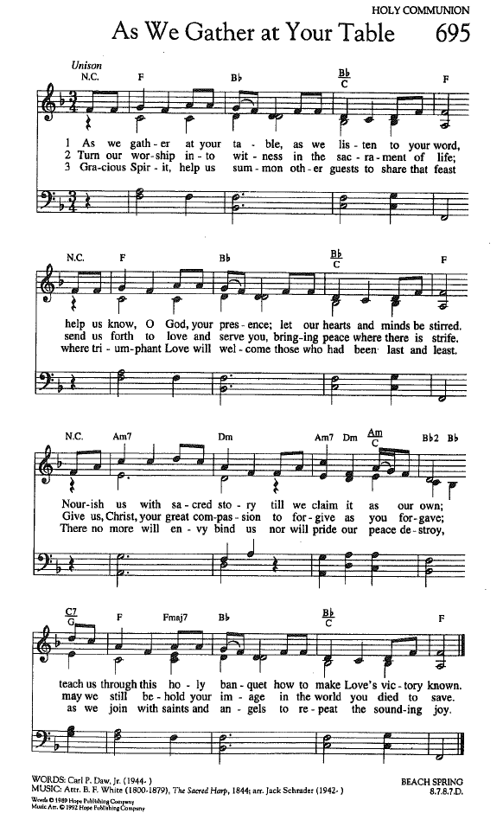
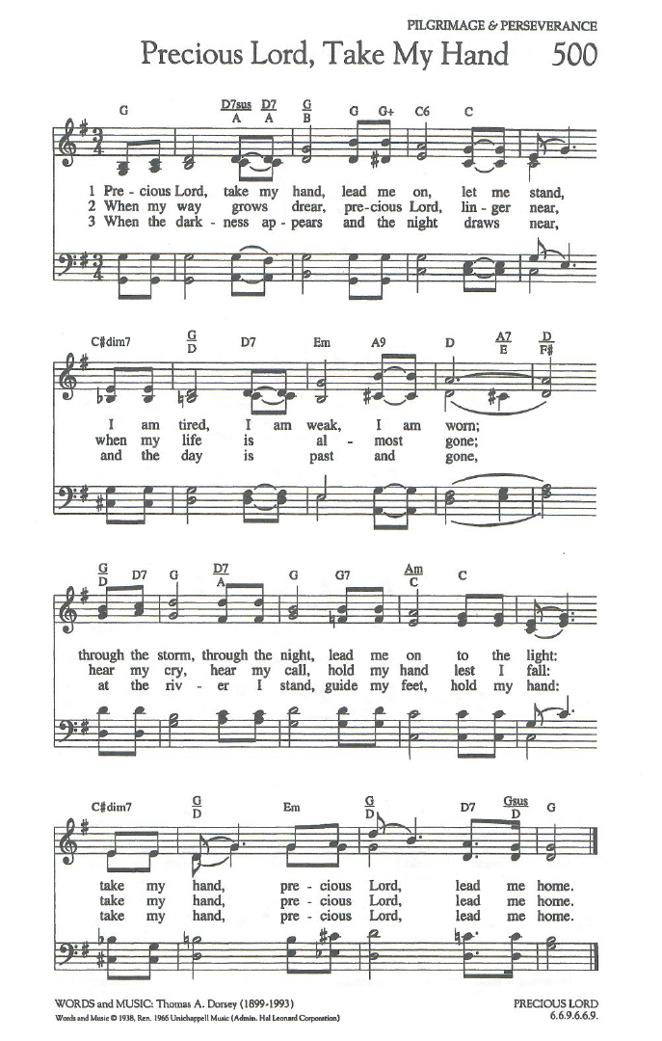

FOR YOUR CONSIDERATION

“The only justification for looking down on anyone is
that you’re going to stop and pick them up.”
Wynton Marsalis, American musician and composer

“I do not believe in demanding love. That should be
the gift of a free will. But simply to be kind - that is
not too much to ask of any of us.”
Josephine Lawrence, American novelist and journalist

“Jesus, the condescension of divinity, and the exaltation
of humanity.”
Phillips Brooks, American clergyman, author and hymn writer

ANNOUNCEMENTS
To Our Guests This Morning
If you are with us today for the first, or one of the first times, please let us know. Also, please take a moment to introduce yourself, or re-introduce yourself to Rev. Mark and others. Our hope is to provide you with the most graceful welcome and experience possible.
TODAY, SUNDAY, February 1 – The Sacrament of Communion
On this day, we celebrate the Sacrament of Communion together as a spiritual community.
NEXT SUNDAY, February 8 – Bulletin and Announcement Format Change
After several discussions with our Deacons, Council and Trustees, we will be implementing a change in how our Bulletins and Announcements are provided to you each Sunday.
As of next Sunday, February 8, our Bulletins will be reserved for Worship needs only. In addition, a much more limited number of copies of the Announcements will be offered separately. The number available will be adjusted according to the time of year and expected attendance.
This is being done for two related reasons. One is that the Announcements are already provided in both our weekly Saturday Worship eblasts and on our website. The other is that with those other means of communicating what’s going on at SCUCC well in place, it is neither efficient nor cost effective to offer a weekly Bulletin which reaches 16 and occasionally 20 pages.
As is the case with any church, while we know that not everyone will embrace this change, we hope that you will at least understand the reasoning for it. And as we move forward with it, we will remain open to further adjustments based on how things go with this one.

Church Office Hours
The Church Office is regularly open from 9 am-3 pm, Monday through Friday.
Mark is normally on campus Tuesday-Thursday pending pastoral visits or off-site meetings. Please feel free to just “drop by” or make an appointment directly with him by email: mark@sanibelucc.org or text/phone at 908-477-5426.
Mackenzie Albert, our Director of Music, is normally on campus each Wednesday and some Fridays. Please make an appointment by phone or text at 203-517-5427.

SPIRITUAL EXPLORATION
Our next unit begins on Tuesday evening, February 10!
An Unlikely Lent
Dates: Tuesdays, February 10, 17 and 24; March 3, 10 and 24
Times: 7:00-8:15 pm on Zoom * (Procedures are being put in place to allow us to offer this unit both on Zoom and in person as soon after it starts as possible.)
During this six-week unit which begins shortly before the start of Lent and ends shortly before Holy Week, we will explore, as author and Methodist pastor Rachel Billups describes them, “unlikely” characters who appear near and at the end of Jesus’ earthly story in the Gospels. We will discuss the role these characters - who we usually do not spend significant time with - play in that story, with an eye toward illuminating and deepening our own Lenten journey and spiritual life in general.

BIBLE STUDY
Bible Study will meet this FRIDAY, February 6 at 10:30 am on Zoom.
*Please note the change in the day for this week.
During each session, we explore the passages which will be part of that coming Sunday’s Worship. These meetings are discussion based, with Mark guiding a structured conversation based on participants’ questions, concerns and considerations of the text. The passage(s) to be looked at each week, as well as the necessary information for joining in, will be sent by email the day before.

MUSIC
The Church is very proud of the music programs we are able to present which are always free and open to all. However, many of these programs do involve expense to pay guest soloists and musicians. If you would be interested in sponsoring any or part of these programs and providing underwriting for them, please contact Music Director, Mackenzie Albert at 203-517-5427 about programs and costs.
The Green Team is Growing!
Are you interested in the stewardship of our natural world? Want to meet new friends? The Green Team invites you to join us! Simply put, the Green Team seeks to fulfill our SCUCC mission in nurturing God’s Creation. We share resources and help sponsor programs and speakers to raise awareness on how we are all intimately connected with our environment. Periodic planning meetings are online. For more information contact Linda Graf at 708-415-7020 or lgrafcnm@aol.com.

Shell Point Men’s Group FEBRUARY Luncheon
The Sanibel Congregational UCC Shell Point Men’s Group will next meet on Tuesday, February 10 at 11:45 am at the Palm Grill in the Woodlands Common. Please make reservations with Bruce Findley at bruce.findley@gmail.com.
Shell Point Women’s Group FEBRUARY Luncheon
The Sanibel Congregational UCC Shell Point Women’s Group will next meet on Friday, February 13 at 11:30 am at the Palm Grill in the Woodlands Common. Please make reservations with Susan Schmitt at sudischmitt@gmail.com.
SCUCC T-Shirts
Please check out our SCUCC t-shirts. They are available for sale in Fellowship Hall on Sundays after Worship. A $10 donation is suggested.
Like A Ride To Worship?
If you would like a ride to our Sunday Worship Celebration from Shell Point or Cypress Cove, please contact the Church Office at office@sanibelucc.org no later than noon on Thursday.
INTERESTED IN JOINING SCUCC???
If you are considering becoming a member of SCUCC, or would simply like to find out more about us, please let Rev. Mark know. After you and he discuss the expectations and, as the old commercial says, “the benefits of membership,” you and he can schedule a Sunday that works best for you to become an official part of the SCUCC community.

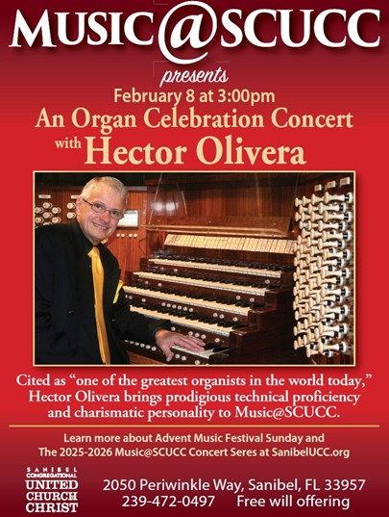
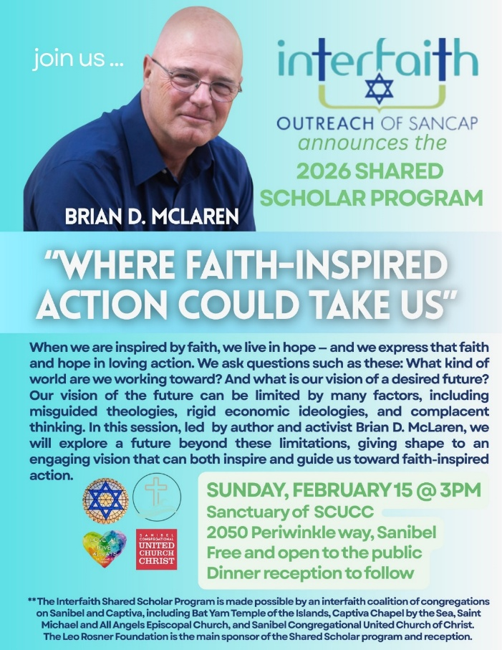
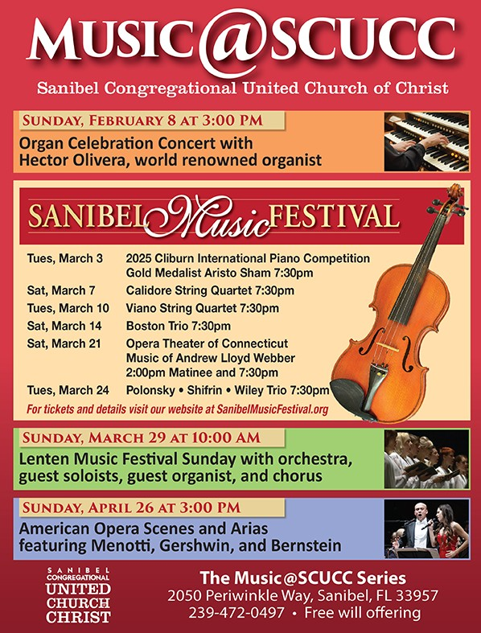
Assisting With Today’s Worship Celebration
Liturgist: Betsy Eidem
Ushers: Frank Palaia and Marcel Saghir
Ministers: All Members and Friends of SCUCC
Moderator: Frank Palaia; Vice Moderator: Norm Boyd
Parish Nurse: Linda Convertine, R.N., B.S.N.
Music Director: Mackenzie Albert
Church Administrator: Tammy Flatley
Financial Manager: Terri Czeczotka
Tech Team: Dr. Renee Rawe, Kirsten Smith, Maggie Voll
Missionaries:
Alex Maldonado-Lizardi & Xiomara Cintron-Garcia in Colombia
Senior Minister: Rev. Dr. Mark Boyea
Pastor Emeritus: Rev. Dr. Ran Niehoff
2050 Periwinkle Way, Sanibel, Florida 33957
Telephone: (239) 472-0497

Website: https://www.sanibelucc.org


Email: office@sanibelucc.org
You can scan a QR Code to make a donation through
PayPal or Venmo.



This Photo by Unknown Author is licensed under CC BY


