Sanibel Congregational United Church of Christ
Worship Celebration
January 18, 2026, 10:00 a.m.


Welcome Everyone!
If you are visiting with us, and you are looking for a spiritual
community…

where you will be loved, accepted, supported and affirmed
regardless of your age, class, ability, race, ethnicity, gender
identification or sexual orientation…where you will be
encouraged and challenged to reflect on your beliefs,
acknowledge your doubts, ask your questions, and grow in
your faith…where God’s desire for compassion, healing,
reconciliation, justice and joy is preached…where you are
given the opportunity to put your faith action through effective
outreach ministries…then we hope to get to know you as a new
friend.

No matter who you are, or where you are in your life journey…
You are welcome here!
An Open and Affirming / Creation Justice Congregation of the United Church of Christ
Seeking to love all people … growing in faith …
working toward God’s vision of justice, healing and joy.
Sanibel Congregational United Church of Christ
An Open and Affirming/Creation Justice Congregation
Worship Celebration
January 18, 2026, 10:00 a.m.

Welcome

Choral Introit Seek Ye First the Kingdom of God
The SCUCC Choir

Call to Worship

One: This is the day that God has blessed us with
All: Let us offer our best to God and each other in Worship.

*Hymn God of Grace and God of Glory #569 (on p. 6)

Opening Prayer (together) adapted, Rev. Dr. Martin Luther King, Jr.
O God, we thank You for the life, lessons and leadership of Jesus.

In response, may we love You with all our hearts, souls and minds, and love our neighbors as we love ourselves - even the neighbors we see as opponents or enemies. And we ask You, Lord, in these days, when the problems of the world and in our nation seem gigantic in scope and chaotic in detail, to be with us.

We ask You to be with us in our going out and in our coming in; in our rising up and in our lying down; in our moments of joy and in our moments of struggle.

We ask You to be with us until the day of Your ways dawns.

Amen.

Music Meditation Praise Ye the Lord Knowles

A Time of Prayer with Our Lord’s Prayer
(please use the wording most meaningful to you)

Invitation to Giving

Offertory Music All Creatures of Our God and King Hayes

*Presentation of Offering and Congregational Response
(To the tune of Praise God from Whom All Blessings Flow)
To God, all glorious heavenly light
To Christ, revealed in earthly sight
To God the Spirit, now we raise
Our joyful songs of thankful praise
Amen
*Prayer of Dedication (together)
God of all we have, do and are, You call us to use all of it to help You build a world where all people are fed, clothed, housed, and with the freedom and possibility to become all You created them to be. May these gifts be one of the ways we answer that call. And may those served by them find their spirits and lives lifted up by knowing that You - and we - are with them.

Amen.

Ministry of the Word 1 Samuel 3:1-18
(New Revised Standard Version Translation)

MINISTRY OF THE WORD
1 Samuel 3:1-18
Now the boy Samuel was ministering to the Lord under Eli. The word of the Lord was rare in those days; visions were not widespread.

At that time Eli, whose eyesight had begun to grow dim so that he could not see, was lying down in his room; the lamp of God had not yet gone out, and Samuel was lying down in the temple of the Lord, where the ark of God was. Then the Lord called, “Samuel! Samuel!” and he said, “Here I am!” and ran to Eli and said, “Here I am, for you called me.” But he said, “I did not call; lie down again.” So he went and lay down. The Lord called again, “Samuel!” Samuel got up and went to Eli and said, “Here I am, for you called me.” But he said, “I did not call, my son; lie down again.” Now Samuel did not yet know the Lord, and the word of the Lord had not yet been revealed to him. The Lord called Samuel again, a third time. And he got up and went to Eli and said, “Here I am, for you called me.” Then Eli perceived that the Lord was calling the boy. Therefore Eli said to Samuel, “Go, lie down, and if he calls you, you shall say, ‘Speak, Lord, for your servant is listening.’ ” So Samuel went and lay down in his place.

Now the Lord came and stood there, calling as before, “Samuel! Samuel!” And Samuel said, “Speak, for your servant is listening.” Then the Lord said to Samuel, “See, I am about to do something in Israel that will make both ears of anyone who hears of it tingle. On that day I will fulfill against Eli all that I have spoken concerning his house, from beginning to end. For I have told him that I am about to punish his house forever for the iniquity that he knew, because his sons were blaspheming God, and he did not restrain them. Therefore, I swear to the house of Eli that the iniquity of Eli’s house shall not be expiated by sacrifice or offering forever.”

Samuel lay there until morning; then he opened the doors of the house of the Lord. Samuel was afraid to tell the vision to Eli. But Eli called Samuel and said, “Samuel, my son.” He said, “Here I am.” Eli said, “What was it that he told you? Do not hide it from me. May God do so to you and more also, if you hide anything from me of all that he told you.” So Samuel told him everything and hid nothing from him. Then he said, “It is the Lord; let him do what seems good to him.”

Message Rev. Dr. Mark Boyea

Hymn Here I Am, Lord #559 (p. 7&8)
Blessing

Postlude Here I Am, Lord (improvisation)

*All who wish are welcome to stand.

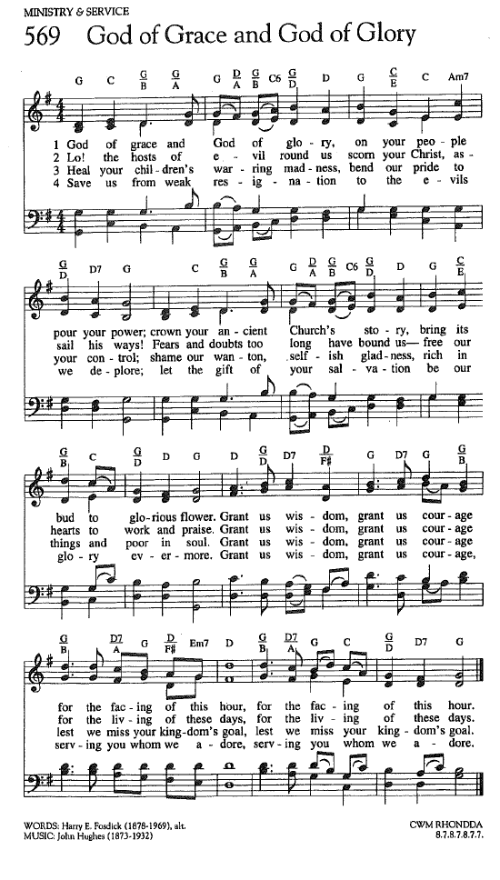
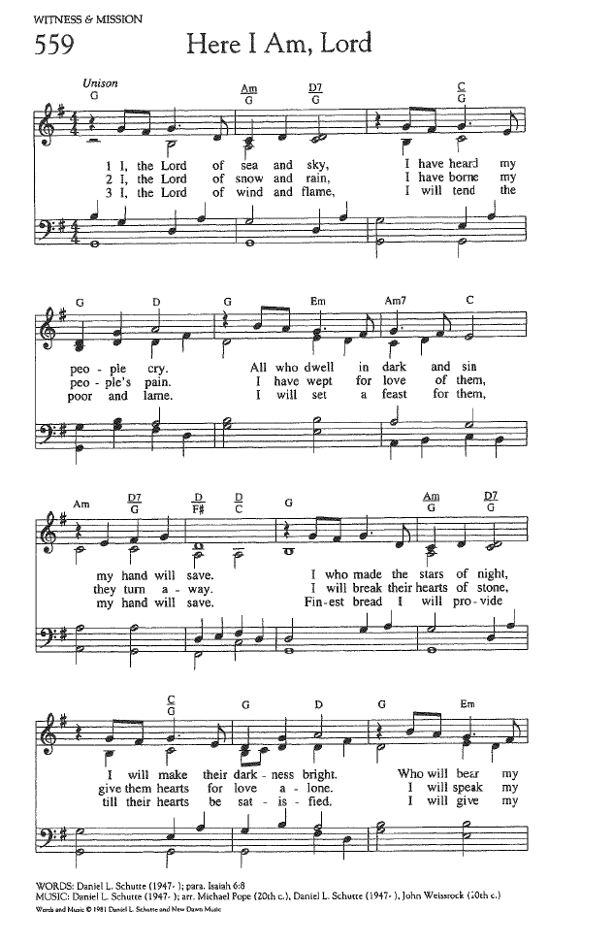

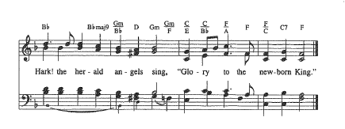
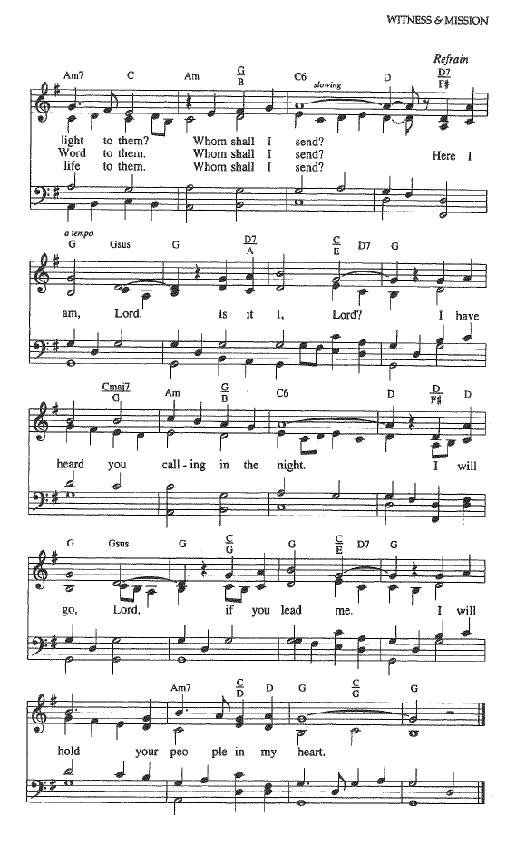

FOR YOUR CONSIDERATION
*All from Rev. Dr. Martin Luther King, Jr.

“Let us not seek to justify our thirst for freedom by
drinking from the cup of bitterness and hatred.”

“I am not interested in power for power’s sake, but
power that is moral, that is right and good.”

“Love is not emotional bash; it is not empty sentimentalism. It is the active outpouring of one’s whole being into the being of another.”

“There is some good in the worst of us and some evil in the best of us. When we discover this, we are less prone to hate our enemies.”

ANNOUNCEMENTS
To Our Guests This Morning
If you are with us today for the first, or one of the first times, please let us know. Also, please take a moment to introduce yourself, or re-introduce yourself to Rev. Mark and others. Our hope is to provide you with the most graceful welcome and experience possible.
NEXT SUNDAY, January 25 – Ask the Minister
Our Worship time next Sunday, January 25, will feature our bi-monthly
Ask the Minister segment.
Instead of a Message that morning, Mark will address as many of your biblical, theological, spiritual, and personal questions as time allows.
So get those questions in ahead of time to Mark at mark@sanibelucc.org, text them to 908-477-5426, or just come ready to ask them that morning.
ALSO NEXT SUNDAY, January 25 – Annual Meeting Sunday
The Annual Meeting of the congregation of SCUCC will be conducted at approximately 11:15 AM on Sunday, January 25, 2026 in the Sanctuary, in person and on Zoom.
Please make every effort to attend this time when we carry out our sacred covenant with each other in regard to the finances and governance of our spiritual community.

Floral Dedication This Morning
In loving memory of my brother, Vernon Dibeler,
who passed away suddenly last May

Dianne Higgins

Church Office Hours
The Church Office is regularly open from 9 am-3 pm, Monday through Friday.
Mark is normally on campus Tuesday-Thursday pending pastoral visits or off-site meetings. Please feel free to just “drop by” or make an appointment directly with him by email: mark@sanibelucc.org or text/phone at 908-477-5426.
Mackenzie Albert, our Director of Music, is normally on campus each Wednesday and some Fridays. Please make an appointment by phone or text at 203-517-5427.
~ Please note that the Church Office will be closed tomorrow, Monday, January 19, in observance of Rev. Dr. Martin Luther King, Jr. Day ~
SPIRITUAL EXPLORATION
This year’s “Advent Unit” has concluded.
Our next unit will begin in early February. The topic and schedule will be announced soon.

BIBLE STUDY
Bible Study WILL NOT meet this Thursday, January 22. It will resume on Thursday, January 29 at 10:30 am on Zoom.
During each session, we explore the passages which will be part of that coming Sunday’s Worship. These meetings are discussion based, with Mark guiding a structured conversation based on participants’ questions, concerns and considerations of the text. The passage(s) to be looked at each week, as well as the necessary information for joining in, will be sent by email the day before.
The Green Team is Growing!
Are you interested in the stewardship of our natural world? Want to meet new friends? The Green Team invites you to join us! Simply put, the Green Team seeks to fulfill our SCUCC mission in nurturing God’s Creation. We share resources and help sponsor programs and speakers to raise awareness on how we are all intimately connected with our environment. Periodic planning meetings are online. For more information contact Linda Graf at 708-415-7020 or lgrafcnm@aol.com.
“Knowing what’s right doesn’t mean much unless you do what’s right”
~ Theodore Roosevelt
Art Group on Tuesdays in Fellowship Hall
Calling all artists and all skill levels! Please join Carol Good and friends on Tuesday mornings, from 11:00 am to 2:00 pm in Fellowship Hall. Take time to paint, pick up some pointers and catch up with friends! You can also check the art displayed around Fellowship Hall, from our newest artist, Arlene Stigum.

Shell Point Men’s Group FEBRUARY Luncheon
The Sanibel Congregational UCC Shell Point Men’s Group will next meet on Tuesday, February 10 at 11:45 am at the Palm Grill in the Woodlands Common. Please make reservations with Bruce Findley at bruce.findley@gmail.com.
Shell Point Women’s Group FEBRUARY Luncheon
The Sanibel Congregational UCC Shell Point Women’s Group will next meet on Friday, February 13 at 11:30 am at the Palm Grill in the Woodlands Common. Please make reservations with Susan Schmitt at sudischmitt@gmail.com.
Reminder from the Mission & Benevolence Committee
This Wednesday, January 21st is the collaborative food drive for SCUCC and Bat Yam. Tables will be located under the covered portion of the driveway from 11:00 am to 1:00 pm. Please stop by and drop off non-perishable food items and bath and kitchen paper products.
SCUCC T-Shirts
Please check out our SCUCC t-shirts. They are available for sale in Fellowship Hall on Sundays after Worship. A $10 donation is suggested.

Like A Ride To Worship?
If you would like a ride to our Sunday Worship Celebration from Shell Point or Cypress Cove, please contact the Church Office at office@sanibelucc.org by noon on Thursday.

Ushers Needed
Please contact Barbara Challoner if you would like more information, or to be added to the contact list to be an Usher during our Worship Celebrations. Send an email to barbara@thechalloners.com.
INTERESTED IN JOINING SCUCC???
If you are considering becoming a member of SCUCC, or would simply like to find out more about us, please let Rev. Mark know. After you and he discuss the expectations and, as the old commercial says, “the benefits of membership,” you and he can schedule a Sunday that works best for you to become an official part of the SCUCC community.
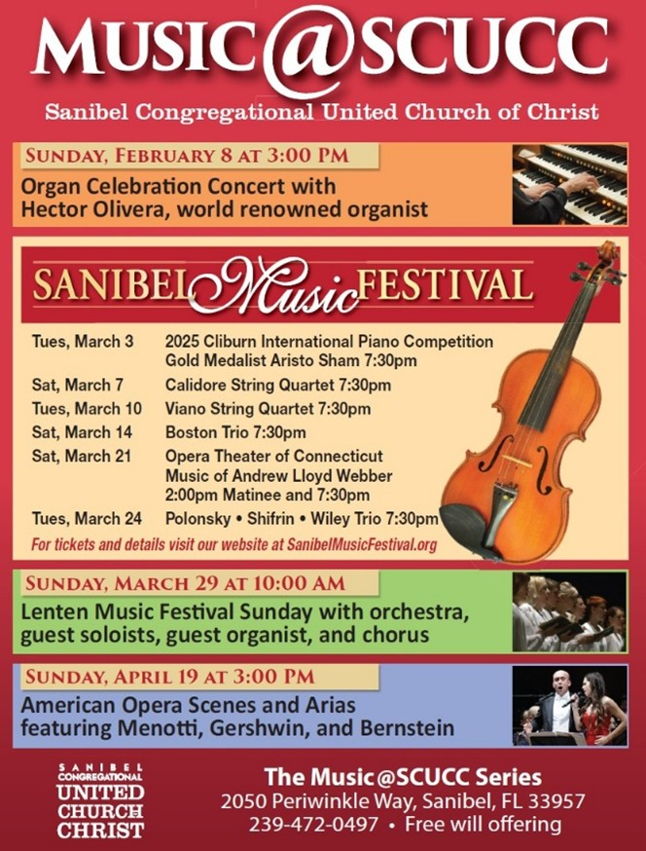
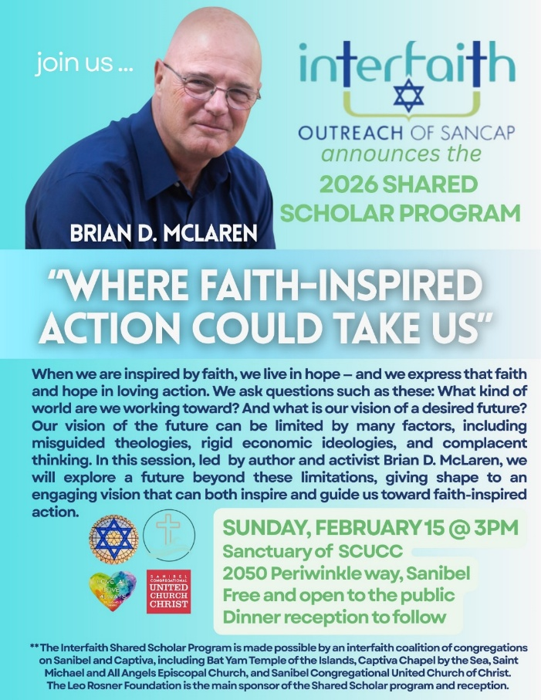
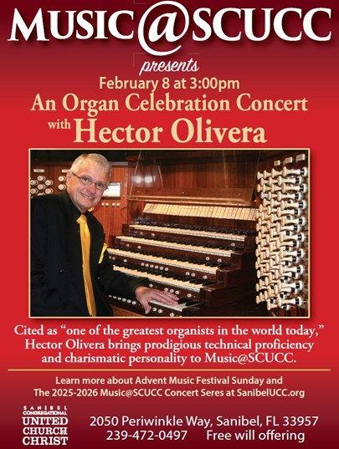
Assisting With Today’s Worship Celebration
Liturgist: Kathy Carter
Ushers: Neal and Sherry Halleran
Ministers: All Members and Friends of SCUCC
Moderator: Kathy Y. Carter; Vice Moderator: Frank Palaia
Parish Nurse: Linda Convertine, R.N., B.S.N.
Music Director: Mackenzie Albert
Church Administrator: Tammy Flatley
Financial Manager: Terri Czeczotka
Tech Team: Dr. Renee Rawe, Kirsten Smith, Maggie Voll
Missionaries:
Alex Maldonado-Lizardi & Xiomara Cintron-Garcia in Colombia
Senior Minister: Rev. Dr. Mark Boyea
Pastor Emeritus: Rev. Dr. Ran Niehoff
2050 Periwinkle Way, Sanibel, Florida 33957
Telephone: (239) 472-0497

Website: https://www.sanibelucc.org


Email: office@sanibelucc.org
You can scan a QR Code to make a donation through
PayPal or Venmo.



This Photo by Unknown Author is licensed under CC BY


