The Sanibel Light |  |  |  | August/SEPTEMBER 2023 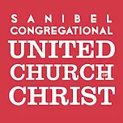Volume 55 Isue 8
In this issue
In Our Hearts, Minds and Spirits
Welcome to the newly renamed Deacon’s Bench
Hurricane Ian Recovery update
Healthy Happenings
Hot Days of summer
News from the garden |  | Seeking to love all people … growing in faith …  working toward God’s vision of justice, healing and joy.  Sanibel Congregational United Church of Christ

For Your Consideration

“I have come one step away from everything. And here I stay, far from everything, one step away.“ Antonio Porchia

The quote above is taken from a book titled Voices, a slim collection of aphorisms that reflect the complexity, struggles, joys and paradoxes of human existence. Here, author Antonio Porchia seems to be asking us to consider how often we come close to important achievements or breakthroughs during our lives, but don't take the one more step we need to get there - how close, yet so far, we remain.

Thankfully, Porchia doesn't turn this thought into one of those all too common “You can do it if you want to” platitudes. My sense is that he instead understands things are frequently not so simple. He recognizes that there are often times when we may be one step away but our circumstances make that step difficult if not impossible to take.

I wonder though, if rather than knowing we are one more step away and then choosing not to or being unable to take it, human existence is much more often characterized by not knowing we are one step away to begin with. I wonder too if it is ever really possible at all to know for certain that we are just one more step away from anything. Many times, I have thought I was one more step away from accomplishing or having something, only to have new obstacles or challenges arise. And history is littered with stories of those who, when they believed they were just one more step from certain discoveries, inventions or breakthroughs ended up still being far away, while conversely, others who thought they were far off instead turned out to be only one more step away.

In these days when we struggle as a state, nation, and world with serious and complex issues such as climate change and immigration. When we as a spiritual community continue the long and multi-faceted process of restoring and returning to our church campus. Or when we personally may be experiencing a complicated time of loss, health concerns, or transition, it can be difficult, if not overwhelming, to try and discern what to do next.

And while our faith, the Bible, our tradition, and our leader - Jesus - may not necessarily offer us any specific answers, they do consistently encourage and call us to do one thing.

Take the step we can.

Not the easiest step. Not the most convenient step. Not the step everyone else is taking. The step we can take. And we are encouraged and called to take that step knowing that God will help us keep moving in the direction we need to go. Knowing that as part of a spiritual community, we will walk with, lean on or be leaned on, even carry and be carried by each other all along the way as well.

It is the way I have consistently witnessed you and this congregation move through these past ten months, despite everything that has happened to us as a spiritual community and to so many individually. And it is the way we will continue to move in the days and months ahead, trusting that God will lead us where God needs us to go; to becoming who and what God needs us to be on the way to, and after, our return.

Thank you for being so faithful and inspiring.

Blessings,

Mark
Rev. Dr. Mark Boyea
Senior Minister

Worship Notes

On the first Sundays of June and July, we celebrated the Sacrament of Communion together as a spiritual community.

“Lay Sunday” on July 9 saw Kathy Carter and Lynda Swart lead Worship while Mark was on vacation, with Lynda delivering the morning’s Message based on Psalm 23. In addition, our latest “Ask the Minister” Sunday took place on July 16 with Mark once again addressing several insightful and thought-provoking questions from the congregation. And lastly, we were blessed with musical leadership from Dr. Albert, with guest singer/guitarist Steve Garrett on June 18, soloist Fred Nordstrom on July 2 and 16, and guest pianists Jameson Moore on July 23 and Sally Gillespy on July 30.

Coming in August and September will be the sharing of the Sacrament of Communion on Sunday, August 6 and Sunday, September 10, with guest preachers Brian Culbertson, Pastor of our host Refuge Church on August 27 and Rev. Dr. Sally Haynes on September 3 as Mark takes his traditional end of summer hiatus.

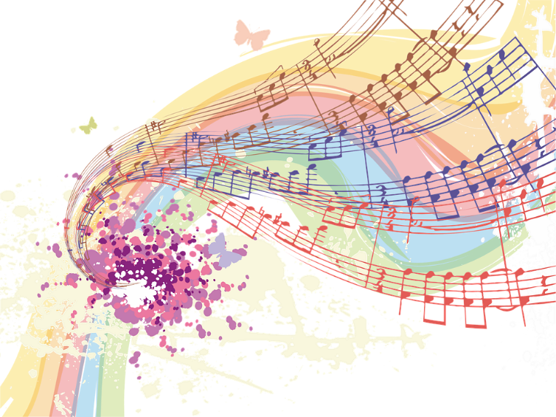

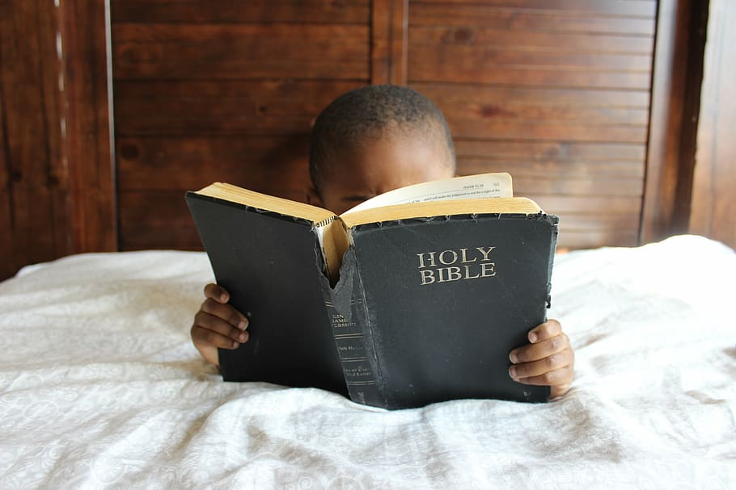  Bible Study is on break until Thursday, September 28 11 am on Zoom  Each week, we explore the Scripture passage(s) being used in Worship that coming Sunday. These sessions are largely “guided discussion” in approach, focusing on your questions and insights from reading the texts ahead of time, with Mark adding relevant context, detail and explanation as needed or wanted.  This approach allows for participants to engage with the Bible creatively, and with an with an eye toward how the texts speak to us in our time and lives. In addition, they are great prep for getting more out of the Sunday Messages!  We hope you will take the time to join in, and much gratitude to all who participated throughout the past 10 months, especially in the context of these post-Ian months. |  | Bible Study and Spiritual Exploration Opportunities
SPIRITUAL EXPLORATION UNITS

With the conclusion of our most recent unit on the Book of Job, our Spiritual Exploration programming is now on break until late September. At this time, our next topic and the schedule of sessions has yet to be determined. Stay tuned for updates over the coming weeks.

Enormous thanks to the many who participated in the 5 separate units we were able to offer this year over the past ten post-Ian months. These gatherings, along with the Bible Study sessions, contributed greatly to our remaining so spiritually engaged and vibrant as a congregation during these months of disruption and recovery.

Lastly, in line with the letter and spirit of our way of being in community, if you have any spiritual, biblical or theological topics you would like to add to the list of possible future units, please send them along to Mark at any time.

“In Our Hearts, Minds and Spirits”

THE RETURN OF THE (NEWLY RENAMED) DEACONS BENCH!

We are pleased to announce that the weekly listing of those we wish to hold in prayer for various reasons has returned.

Now named “In Our Hearts, Minds and Spirits”, it is planned to go out to our congregation on Friday of most weeks.

However, we need your help.

It is impossible for Mark and Linda Convertine, our Parish Nurse, to know of everyone who should or should not be listed. So please let Mark or Linda know of people who should be included or whose circumstances should at least be looked into for inclusion.

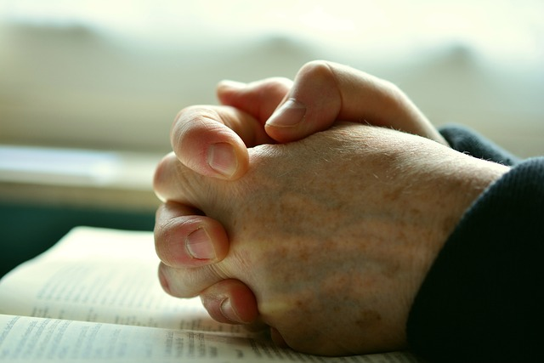

A Word from our Moderator
Ten months have gone by since we experienced a “sea change” in Southwest Florida, and we at SCUCC continue to show amazing resilience and spirit. I am also six months into my year-long term as Moderator of our church family, and I had hoped to spend more time doing “moderator” things - defined as refining the interactions of our various branches. It hasn’t turned out exactly like that, but instead I’ve worked and struggled to observe and communicate the many activities ongoing in our rebuilding process involving the staff, building and grounds. It has been such a team effort, and for that I am feeling grateful and exceedingly blessed.
Tom Lisle’s team of Trustees - featuring Tom, John McBroom, Ron Periard, and Frank Palaia, have new full-time jobs moving our reconstruction forward, and doing so amazingly well. Mark, Jenny, and Linda Convertine, along with great support from Kathy Monroe Carter and Judy Palaia (and others) get our sincere gratitude for keeping the office and outreach activities smooth and relevant. We are a healthy church family. Thank you.
I hope you are all able to attend Worship live, over the internet, or recorded, and appreciate them as much as I do. We are truly blessed.
I feel like my major role is to provide a rebuild update, so here it is:
SCUCC Rebuild Update
The rebuild team has been providing biweekly live updates at the Sunday services which are very comprehensive and helpful, in addition to allowing for Q and A. We have tried to anticipate questions and will continue to report as often as we have significant updates until we are back home!
* The Elevators continue to be top priority - they will enable us to use our own Fellowship Hall for Worship as soon as at least one is completed. While the contractor is optimistic about completion in September - October, we are being conservative in our projections. Is it appropriate to pray for elevator parts to arrive quickly?
* Fellowship Hall, with less damage and complexity, should be ready for occupancy by late Fall. Floors, ceiling, paint, and undamaged chairs and tables are in the plan.
* As Tom Lisle has been promising, any changes going forward need to be made using erasers, not sledgehammers, so details are being quickly finalized as construction proceeds.
* As suspected, there was hidden structural damage to the roof that is now being repaired at some additional cost, which we hope to be covered by insurance. The new metal roof material is due in August and will be installed shortly thereafter.
* Colors have been selected, and samples of the carpet, paint, and wood colors will be available as soon as we can get them. Unfortunately, computer renditions of the colors are so inaccurate they are not too helpful to share. There will be more “wood” color in the new palate. The 450-pound cross will be rehung, probably with a more natural wood stain.

* I’ve been told the grounds cleanup has been mostly completed, and now our member-gardeners are being invited to offer ideas for appropriate re-landscaping. We all know the city requires mostly native, resilient plantings. We are also actively looking into renewable energy options, and trying to make sure we are not precluding their future incorporation.
* While repairs are being made there are also improvements that add a bit to our costs but add a lot to upgrading our campus. New doors, modified pew orientation, improved choir loft and larger elevated altar platforms are just a few you will notice.
* Bat Yam continues to be included in our updates and discussions, as they are just as anxious to return “home” as we are.
* We have been blessed with a top-notch insurance intermediary “Jeb”, who is assisting in negotiating with our insurers to maximize our benefits. This has resulted in our progress being somewhat speedier than most non-single-family buildings on Sanibel. In addition, we have had great support from our initial remediator, Signal; our landscape clean-up crew, CSC; our elevator contractor; our architect, Amy Nowacki; and our local construction contractor, Stevens.
* The rebuild team meets twice each week and keeps stressing a few words: Patience, Hope, Patience, Teamwork, Patience, and Elevators. The goal is not just a repaired building, but a “new” facility in our old footprint. I’m confident this will come to fruition soon.

Diana Day, Moderator
Hurricane Ian Recovery at SCUCC

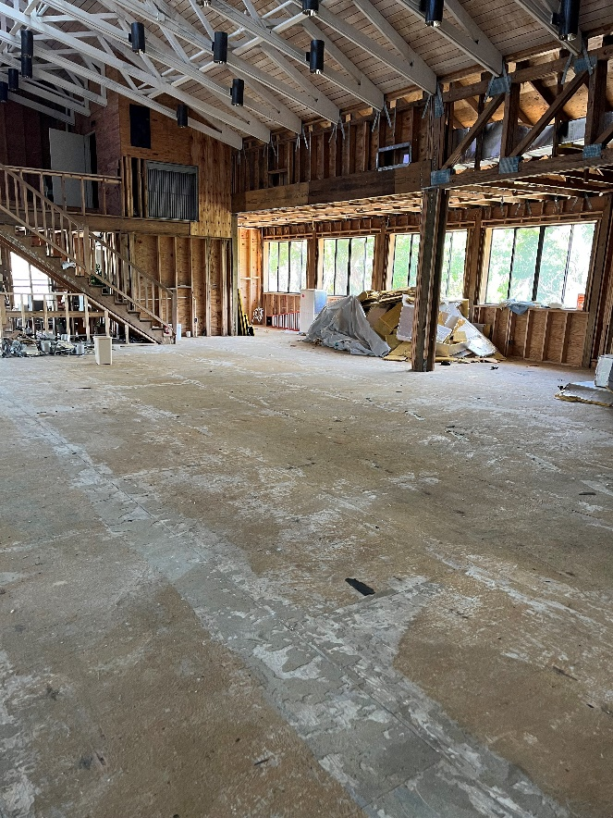
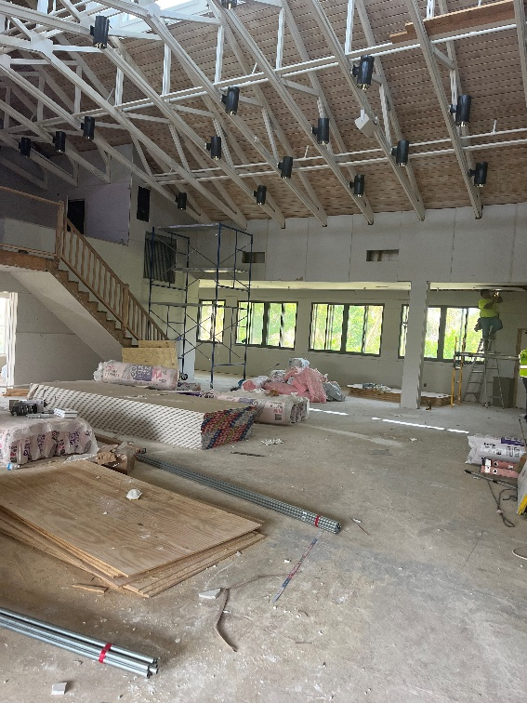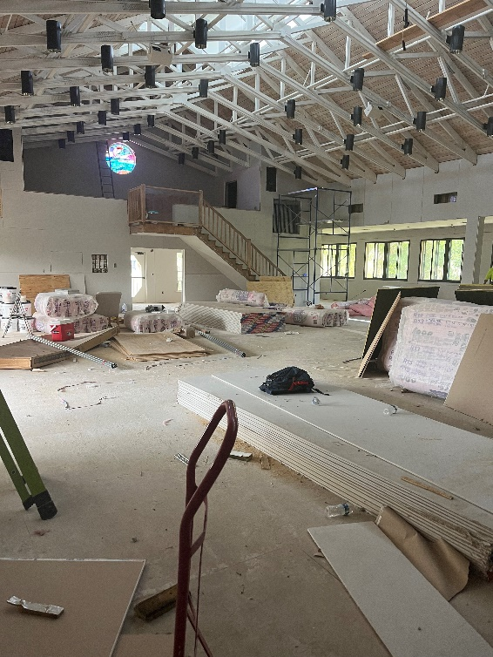
Healthy Happenings

It’s Hot Out There
Heat affects health in several ways.
Heat exhaustion, which can include dizziness, headaches, shaking and thirst, can affect anyone, and is not usually serious, providing the person cools down within 30 minutes.
The more serious concern is heatstroke, where the body's core temperature goes above 105 degrees Fahrenheit (40.6 degrees Celsius). It is a medical emergency and can lead to long-term organ damage and death. Symptoms include rapid breathing, confusion or seizures, and nausea. Heatstroke is a medical emergency and requires immediate professional intervention.
WHO IS AT RISK?
Some people are more vulnerable, including young babies and older people, as well as people who must stay active or are more exposed, such as those who are homeless.
Existing conditions, including respiratory and cardiovascular diseases, as well as diabetes, can also heighten risk and be exacerbated by heat. Globally, just under half a million deaths a year are estimated to be due to excess heat, according to a 2021 study in The Lancet, although data is lacking from many lower-income countries. As many as 61,000 people may have died in Europe during heatwaves last summer, with a repetition feared this season.
LESS OBVIOUS RISKS
Air pollution also poses a health risk, with serious potential effects from wildfire smoke including inflammation and tissue damage. Heat also can lead to low birthweight and premature birth for pregnant women and babies.
There are less obvious risks, too. Dr Vikki Thompson, Climate Scientist at the Royal Netherlands Meteorological Institute, said extreme heat often contributes to poorer mental health, as well as a rise in car crashes and drownings.
TIMING MATTERS
Experts say more deaths occur earlier in the summer when people's bodies have not had the chance to acclimatize.
Location matters, too; people are at higher risk in places where they are not acclimated to the heat. No matter the location people all around the world are at risk in extremely hot weather, particularly people who must continue to work in outside physical jobs.
"It is more important than ever that we put in place measures to limit the harm on our health," said Dr Modi Mwatsama, head of capacity at Welcome, a London-based global health charity. She said this ranges from providing shade and painting buildings white to investing in early-warning systems for climate-sensitive infectious diseases, like cholera.
WHAT YOU CAN DO
Public health agencies from Italy to the United States have issued advice on keeping cool, including avoiding exertion where possible and staying hydrated. Workers should think about having more breaks, wearing breathable fabrics, and of course, hydrating frequently.
"Heat waves are a silent and invisible killer. We don't often see the impact that they have had on human health until the mortality statistics are published many months later," said Professor Liz Stephens, a researcher in climate risk and resilience at Britain's University of Reading.
This summer has been unusually hot here in Florida, in the United States, and all over the world, with extreme heat advisories issued daily. It is very important to be cognizant of these conditions and protect yourselves and those vulnerable people around you. Stay cool and hydrated!
Caring for you and your health,
Linda Convertine, Parish Nurse

The Environment and SCUCC
Developments in Resilience for Sanibel
“The SanCap Citizens for a Resilient Future”, a coalition of concerned citizens and more than a dozen community organizations, is launching three new topical working groups to provide resources to local residents and businesses. The working groups include ‘Resilient Buildings,’ ‘Natural Environment/Landscaping,’ and ‘Communications.’
Each working group will be led by volunteers and one or more liaisons from the SanCap Citizens for a Resilient Future steering committee. The Resilient Building working group will be co-led by Kip Buntrock, a 50-year-plus resident of Sanibel with a background in condominium management, and Brian Wilson, a new Sanibel resident with a background in construction who moved here just after the storm to help the community rebuild. The steering committee liaisons will include Dr. Tom Bierma, a retired environmental health professor, and Erika Steiner, board member from Community Housing and Resources.
The Natural Environment/Landscapes working group will be led by volunteer Walter Cheatham, a Sanibel resident with a background in environmental education. Liaisons from the steering committee will include Dr. Carrie Schuman from Sanibel Captiva Conservation Foundation, and Sanibel resident and master gardener Mariana Pardo.
The Communications working group will be led by Maureen McGauran, owner of Beachwalker Marketing and Communications, a marketing consulting organization serving local businesses and nonprofits. The steering committee liaison will be Mark Heiman, who is a board member of the “Ding” Darling Wildlife Society. According to Heiman, the group is currently in the process of building a website and will be launching a Facebook group later this year.
“These new working groups will provide support to community members who are in the process of restoring or rebuilding their homes and businesses with a focus on resiliency,” said Dr. Carrie Schuman, coastal resilience manager at SCCF and co-chair of the SanCap Citizens for a Resilient Future steering committee. “That could include identifying best practices for hardening a building against future storms or flooding; technology to reduce energy usage, costs, and carbon footprint; or strategies to make landscapes more resilient.”
In addition to these three new working groups, the existing Sanibel-Captiva Renewable Energy Working Group will serve as the resilience coalition’s team to address energy resilience. According to the group’s co-founder and co-chair, Bob Moore, that includes evaluating how energy infrastructure can be enhanced to perform more effectively in the face of future storms, especially for emergency services, as well long-term planning to reduce energy demand and reduce, or ultimately eliminate, our reliance on fossil fuels to power our homes, businesses, and transportation. “Today clean energy like wind and solar are the cheapest forms of new energy generation in most of the world. Renewable energy makes good economic and good environmental sense,” Moore said.”
The church is fortunate to have Bob Moore helping research solar proposals for us.
Stay tuned!

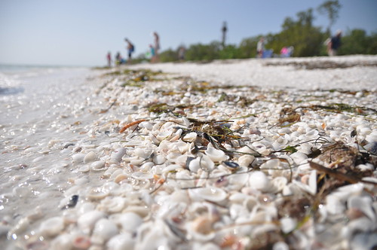
This Photo by Unknown Author is licensed undCC BY
Temple Bat Yam
Well, You Never Know!?!?
Rabbi Elchanan 'Sunny' Schnitzer
Bat Yam Temple of the Islands
During my first trip to Israel, over 30 years ago, I was sitting in a coffee shop in Jerusalem looking at three beggars across the street sitting on the curb, each with their alms cup, talking among themselves. One got up to leave and as he departed, he took two coins from his cup and placed one each in the cups of his friends. He then walked across the street and into the shop where I was sitting. Summoning my courage, I asked him in my, at that time, limited Hebrew, "Lama HaShekel B’Kos?” Why the coin in the cup?
He answered me in perfect British-accented English; “My dear young man, no one is exempt from the commandment of charity. It is a mitzvah (Divine commandment). It is not optional."
A few months later, I was walking to lunch in New York with a Christian friend, both of us seminary students. We passed a beggar on the street, a woman in rose-colored sunglasses. “Can either of you guys spare a quarter for a cup of coffee?” she said. I thought, “Where can you get a cup of coffee for a quarter?” Nevertheless, remembering the incident in Jerusalem a few months earlier, - I stuck my hand into my pocket.
I didn’t have any change. I never carry change. I like to travel light. All I had were two twenties and a five in my wallet. I gave her the five and we walked on.
My Christian friend said: “Your gift to that woman was very kind.” I replied: “It wasn’t kindness. As I learned from a poor man in the streets of Jerusalem, it’s an obligation.”
Somewhere within this story we can see a difference between the Christian concept of charity, which is based upon kindness, and the Jewish concept of tzedakah as outlined in Chapter 25 of the Book of Leviticus. It is all about the rights of the poor, the orphan, the widow, the immigrant - the justice they are due, the honor they are to be afforded, and the care that must be given to help lift them and their children from the cycle of poverty.
In our era where we tend to write a check to an organization and rarely give meaningful contributions directly to the needy, we seldom meet the people whose lives our tzedakah will directly influence. And it is, I believe, that distance that causes us to lose sight of tzedakah: the “justice,” which is, or ought to be, at the root of all our “righteous deeds.”
The Hebrew word tzedakah comes from the root word tzedek, which means, not charity, but “justice.” Tzedakah is justice in action. The beggar has a right to ask and we have a responsibility to give to them - not because we are, or ought to be, “kind”; nor because we feel guilty because we have achieved whatever we may have achieved. Giving tzedakah is the right thing to do, the righteous thing to do. From a Jewish perspective, it is as simple as that.
In the Jewish tradition there are countless stories about the prophet Elijah who goes about disguised as a homeless beggar on the street. In many of them, he is treated badly, and so the coming of the messianic age, which he will foretell, is delayed. In most of these tales, he is befriended by righteous souls who share whatever they might have and are then rewarded with what they truly need.
These are simple stories on the surface - treat the beggar like the herald of the messiah for you never know what good might come. Elijah comes in these stories as an agent for the righteous, and the giving of tzedakah is the simplest of tests. A “righteous soul,” a tzadik, gives tzedakah even when there may be no benefit in the giving. Each homeless beggar we encounter is Elijah asking us: “Are you a tzadik? Are you a righteous soul?”
The challenge we face in the modern age is to recognize this value, the righteousness of righteous deeds, even when there may be no immediate benefit for us. With each chance encounter with the needy, we stand in the presence of the Most High.
On the way out the door, my Christian friend and I passed the same woman again. “Hey”, she said again, “can you spare a quarter for a cup of coffee?” I smiled, but my friend said, “He just gave you five dollars.” “I know he did,” said the beggar, “I remember. But you haven’t given me anything today.”
She didn’t look like Elijah, but…

INTERESTED IN JOINING SCUCC???

Despite our ongoing displacement, energy, enthusiasm and participation on Sundays remains high, including the regular presence of visitors. In that regard, if you are considering becoming a member of SCUCC, please let Rev. Mark know. After you and he discuss the expectations and, as the old commercial says, “the benefits of membership”, you and he can schedule a Sunday that works best for you to become an official part of the SCUCC community.

SHELL POINT MEN’S GROUP
The Sanibel Congregational UCC Shell Point Men's Group will have its next two monthly luncheon meetings on Tuesday, August 8, and Tuesday, September 12 at noon at the Palm Grill in the Woodlands Commons. Please make reservations by August 4 and September 8 to Candy Atchison at JImAtch@aol.com or 561-714-4655.

SHELL POINT WOMEN’S GROUP

The Sanibel Congregational UCC Women’s Group will not meet over the rest of the summer. They will resume their gatherings in the fall. Stay tuned for that announcement.

OCTOBER 2023 SANIBEL LIGHT DEADLINE

Please keep in mind that the months of August and September make up the second of our two summer combined newsletters.

The deadline for submissions to the October 2023 edition of the Light is Friday, September 22.

Please send all submissions in Microsoft Word Format to Jenny Chacon, Church Administrator at jenny@sanibelucc.org

