Sanibel Congregational United Church of Christ
Worship Celebration
December 14, 2025, 10:00 a.m.


Welcome Everyone!
If you are visiting with us, and you are looking for a spiritual
community…

where you will be loved, accepted, supported and affirmed
regardless of your age, class, ability, race, ethnicity, gender
identification or sexual orientation…where you will be
encouraged and challenged to reflect on your beliefs,
acknowledge your doubts, ask your questions, and grow in
your faith…where God’s desire for compassion, healing,
reconciliation, justice and joy is preached…where you are
given the opportunity to put your faith in action through effective
outreach ministries…then we hope to get to know you as a new
friend.

No matter who you are, or where you are in your life journey…
You are welcome here!
An Open and Affirming / Creation Justice Congregation of the United Church of Christ
Seeking to love all people … growing in faith …
working toward God’s vision of justice, healing and joy.
Sanibel Congregational United Church of Christ
An Open and Affirming/Creation Justice Congregation
Worship Celebration
Third Sunday of Advent – “What ARE We Waiting For?”
ADVENT MUSIC FESTIVAL
December 14, 2025, 10:00 a.m.

Welcome
Lighting the Third Advent Candle – JOY
Carol Good and Paul Roth
Leader: Let us share these words from Psalm 96:
Let the heavens be glad, and let the Earth rejoice. Let the sea roar, and
all that fills it. Let the field exult, and everything in it. Then shall all
the trees of the forest sing for joy before God, for the Lord is coming.

Lighting of the Candle

Leader: With the lighting of the Candle of Joy, we proclaim the Joy God
offers us - a Joy so vibrant that it lights a path from the heavens to
earth and back. It is the Joy which Jesus, the One who is coming,
shows us the way to.

God’s Light brings Joy, and where there is Joy there is Light.

Hymn When in Our Music God Is Glorified #7 (on p. 6)

Opening Prayer (together)
Holy One, in this Advent time, You call us to open our hearts, minds and spirits to receive the Light which Jesus brings into our lives and Your world. You call us to let Hope in. You call us to let Peace in. You call us to let Joy in.
At times though, in the struggles of life, it can be harder to receive that Light than to shut it out. At times, it can be harder to embrace that Hope than to fall into despair. At times, it can be harder to believe in and work for Peace than to give up on it. At times, it can be harder to let Joy in than to be cynical or complacent.
Help us, O God, in these Advent days and beyond, to receive Jesus and all He offers us fully, reverently and gratefully. Help us to take hold of and trust in the promise of knowing Hope, Peace and Joy in and through Him - the promise of new and better life for us and all Your people.
Amen.
Invitation to Giving
Offertory Hymn In the Bleak Midwinter (v.1-3) #196 (on p. 7)
*Presentation of Offering and Congregational Response
(In the Bleak Midwinter, v.4, #196)
What can I give him, poor as I am?
If I were a shepherd, I would bring a lamb
If I were a wise one, I would do my part
What can I give him? Give him my heart.
*Prayer of Dedication (together)
O God, with the light of the Candle of Joy to lead the way, may these gifts help bring some measure of Your Joy to those served by them. May they find Joy in knowing they are not alone in whatever struggles they face. And may they know that You - and we - are with them.
Amen.

Ministry of the Word Psalm 150

(New Revised Standard Version Translation)
Ministry of the Word
Psalm 150

Praise the Lord! Praise God in his sanctuary; praise him in his mighty firmament!
Praise him for his mighty deeds; praise him according to his surpassing greatness!
Praise him with trumpet sound; praise him with lute and harp!
Praise him with tambourine and dance; praise him with strings and pipe!
Praise him with clanging cymbals; praise him with loud clashing cymbals!
Let everything that breathes praise the Lord!
Praise the Lord!”

CHRISTMAS ORATORIO

Oratorio de Noel Camille Saint-Saens
Mackenzie Albert, conductor

Blessing

*All who wish are welcome to stand.

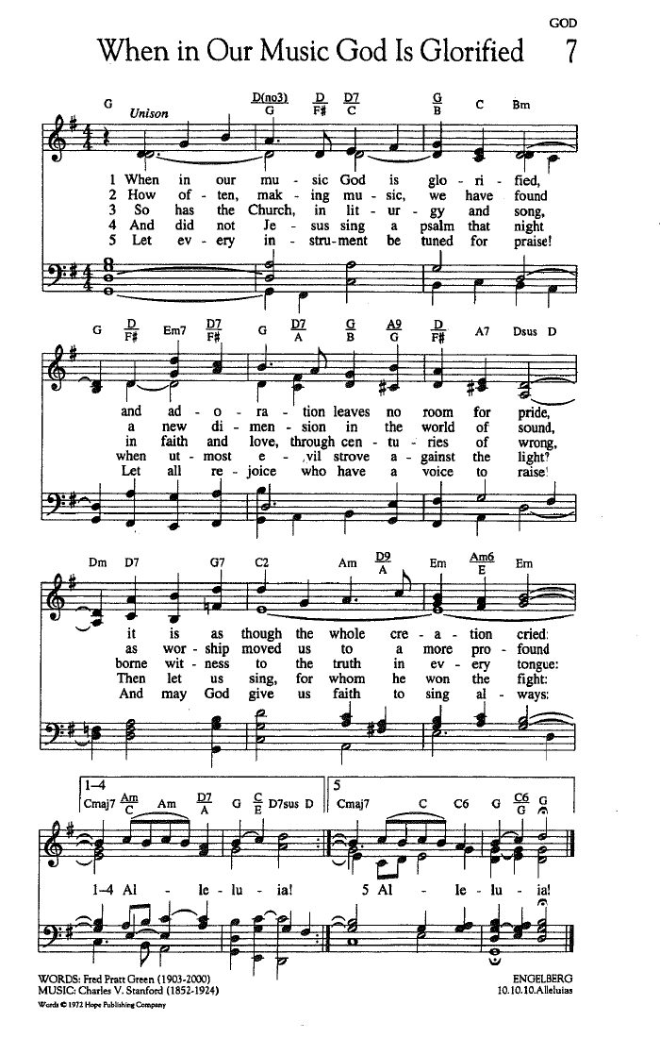

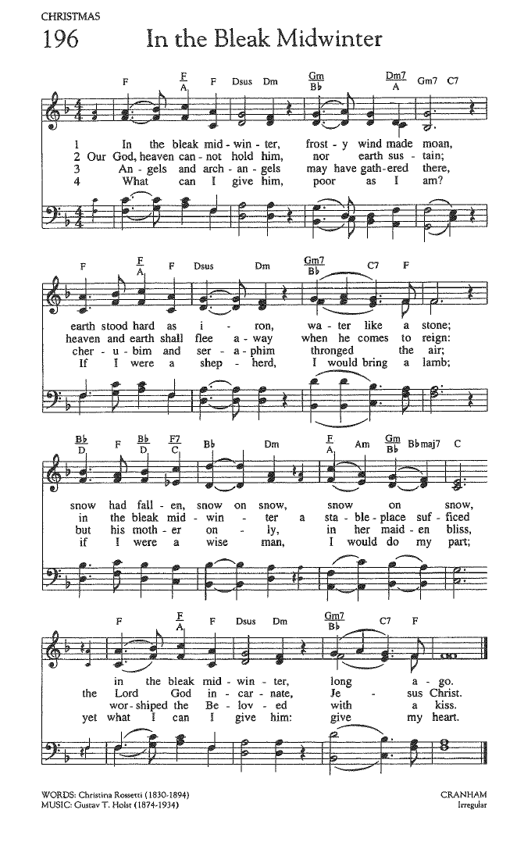

FOR YOUR CONSIDERATION

“I slept and dreamt that life was joy. I woke and saw
that life was service. I acted and behold, service was
joy.”
Rabindrath Tagore, Indian poet

“Joy is the most powerful revolutionary tool.”
Alice Walker, American novelist and poet

“Joy is the justice we give ourselves.”
J. Drew Lanham, American author and wildlife biologist


ANNOUNCEMENTS

To Our Guests This Morning
If you are with us today for the first, or one of the first times, please let us know. Also, please take a moment to introduce yourself, or re-introduce yourself to Rev. Mark and others, as we will do with you. Our hope is to provide you with the most graceful welcome possible.

TODAY, SUNDAY, December 14 – ADVENT MUSIC FESTIVAL!
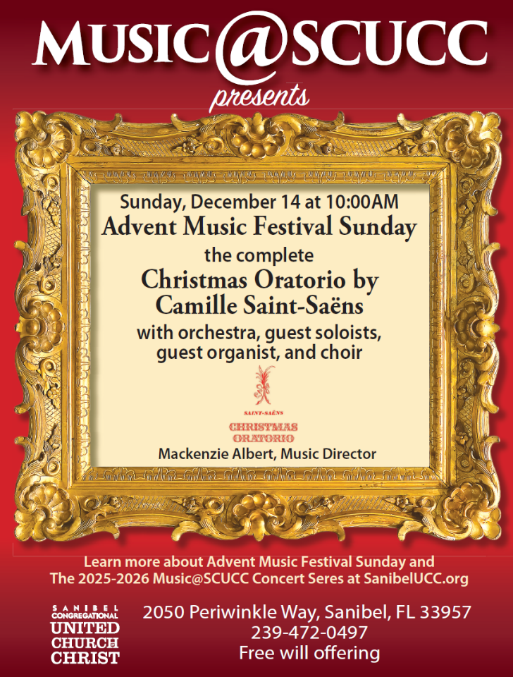

ADVENT DEVOTIONALS AVAILABLE!
In conjunction with Advent, hard copies of the Advent Daily Devotional, A Calendar of Devotions by Jan Turrentine, are available in the Narthex.
A number of digital copies are also available. If you would like one of those, please contact Mark and provide your preferred email address so he can send you one.
Office Hours
The Office is regularly open from 9 am-3 pm, Monday through Friday. Mackenzie Albert, our Director of Music, is normally on campus each Wednesday and some Fridays. Please make an appointment by phone or text at 203-517-5427.

*Please note: The Church Office will be CLOSED on Thursday, December 25 and Friday, December 26 in celebration of Christmas.
Our current SPIRITUAL EXPLORATION Unit CONCLUDES this Tuesday, December 16
“Letters From the Edge of the World: Part 2”
Tuesdays: December 16, 7:00-8:15 pm on Zoom
Back by popular demand!
After the success of Part One of this unit last Advent, we continue with more from Ruth Boling’s book, Season’s Greetings.
During our time together, we will explore more letters Boling imagined having been written by characters associated with the Christmas stories in the Gospels. Each week, we will review and discuss the content, context and spiritual concerns expressed in one or two of those letters, with an eye on gaining new insights regarding the meaning of Christmas for us in the Christian community and for the world. The information needed for you to join in, as well as any advance reading or other preparation, will be sent by email each Monday afternoon.
Bible Study Meets This Thursday!
Bible Study will meet this Thursday, December 18 for the final time in 2025 at 10:30 am on Zoom.
Each week, we explore the Scripture passage(s) being used in Worship that coming Sunday. The sessions are largely “guided discussion” in approach, focusing on your questions and insights from reading the text ahead of time, with Mark facilitating and adding relevant context and detail as needed or wanted.
This approach allows for participants to engage with the Bible creatively, and with an eye toward how the texts speak to us in our time and lives. In addition, they are great preparation for getting more out of the Sunday Messages!

The passage(s) to be looked at each Thursday, as well as the necessary information for joining in, will be sent by email each Wednesday afternoon.

Bible Study will resume on Thursday, January 15!
SHELL POINT CHRISTMAS COMMUNION CELEBRATION THIS THURSDAY, DECEMBER 18!
Our annual Shell Point Christmas Communion celebration will take place THIS Thursday, December 18 at 1 PM in the Chapel of the Village Church. It will be a time of prayer, hymns, special music, a brief Reflection from Mark, and, of course, the Sacrament of Communion. Joining Mark in leading this time will be McKenzie Albert and Linda Convertine, SCUCC Parish Nurse.
SCUCC/BAT YAM FOOD DRIVE
Our next collection will be this Wednesday, from 11:00 AM to 1:00 PM in the Church Parking Driveway. Please stop by and drop off non-perishable food items, as well as bath and kitchen paper products.
Mission Moment – The Christmas Fund
The Christmas Fund of the United Church of Christ supports the Veterans of the Cross and the Emergency Fund of The United Church of Christ. This fund has been caring for active and retired clergy and lay employees of the United Church of Christ for over 100 years, providing emergency grants, monthly supplementation of small annuities and health insurance premiums, as well as “Thank You” gift checks each December to lower income retirees.

Your gift to the Christmas Fund brings relief and hope to clergy and church employees who have dedicated their lives to serving our churches. It reminds them that they are not forgotten, that they are loved, and that their ministries are appreciated and remembered. Many served small congregations with low compensation, often being supplemented by “in-kind” gifts. Therefore, their pensions are also low.

The Mission and Benevolence Committee encourages you to give generously to the Christmas Fund.

Envelopes will be available in the Narthex, and will be collected with the Offering next Sunday, December 21. You may also donate directly on the United Church of Christ website.

Christmas Eve Beach Service Volunteers
As previously announced, the Christmas Eve Beach service we sponsor will return this year after several year’s absence on December 24 at 5 pm! Please help us make it as warm and welcoming as possible for the Sanibel community and its holiday guests. If you can give some time to volunteer in one of several ways, please check out the opportunities on the sign-up sheets in Fellowship Hall.

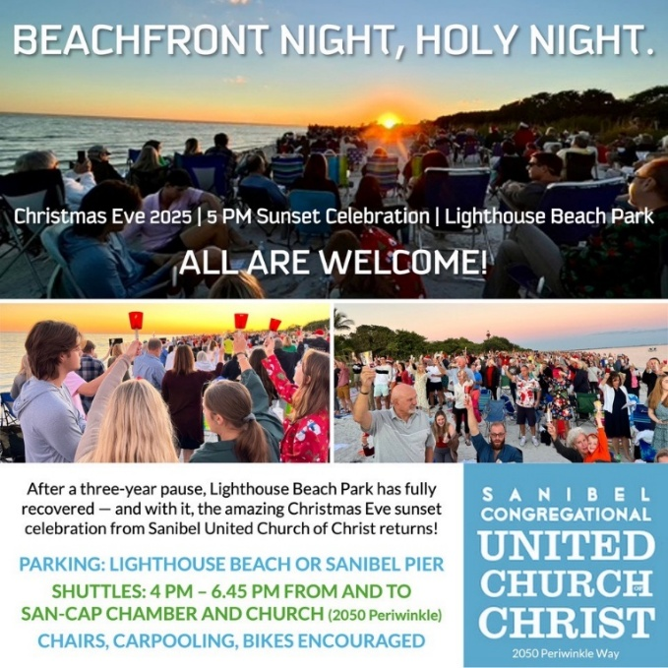

CHRISTMAS EVE at SCUCC
With the return of the Christmas Eve Beach Celebration, we will celebrate Christmas Eve as a SCUCC spiritual community at 9 pm in the Sanctuary.
We will join together for a time of readings from Luke’s Christmas story, inspiring music, the Sharing of Light, and a “Dramatic Reflection” from Mark.
SCUCC T-Shirts
Please check out our new SCUCC t-shirts. They will be available for sale in Fellowship Hall on Sundays after Worship. A $10 donation is suggested.
Like A Ride To Worship?
If you would like a ride to our Sunday Worship Celebration from Shell Point or Cypress Cove, please contact the Church Office at office@sanibelucc.org by noon on Thursday.
Shell Point Women’s Group JANUARY Luncheon
The Sanibel Congregational UCC Shell Point Women’s Group will next meet on Friday, January 9 at 11:30 am at the Palm Grill in the Woodlands Common. Please make reservations with Susan Schmitt at sudischmitt@gmail.com.
Shell Point Men’s Group JANUARY Luncheon
The Sanibel Congregational UCC Shell Point Men’s Group will next meet on Tuesday, January 13 at 11:45 am at the Palm Grill in the Woodlands Common. Please make reservations with Bruce Findley at bruce.findley@gmail.com.

INTERESTED IN JOINING SCUCC???
If you are considering becoming a member of SCUCC, or would simply like to find out more about us, please let Rev. Mark know. After you and he discuss the expectations and, as the old commercial says, “the benefits of membership,” you and he can schedule a Sunday that works best for you to become an official part of the SCUCC community.

Floral Dedication for Today’s Worship Celebration

With gratitude for our Family and Friends
Renny and Barbara Challoner

In Memory of Ric’s mother,
Elizabeth Sohn Walker Purdy

Ric & Jean Walker

Assisting With Today’s Worship Celebration
Liturgist: Betsy Eidem
Ushers: Ed and Sharon Hannon
Ministers: All Members and Friends of SCUCC
Moderator: Kathy Y. Carter; Vice Moderator: Frank Palaia
Parish Nurse: Linda Convertine, R.N., B.S.N.
Music Director: Mackenzie Albert
Church Administrator: Tammy Flatley
Financial Manager: Terri Czeczotka
Tech Team: Dr. Renee Rawe, Kirsten Smith, Maggie Voll
Missionaries:
Alex Maldonado-Lizardi & Xiomara Cintron-Garcia in Colombia
Senior Minister: Rev. Dr. Mark Boyea
Pastor Emeritus: Rev. Dr. Ran Niehoff
2050 Periwinkle Way, Sanibel, Florida 33957
Telephone: (239) 472-0497
Website: https://www.sanibelucc.org
Email: office@sanibelucc.org

Scan QR Code to make a donation through PayPal.




This Photo by Unknown Author is licensed under CC BY

