Sanibel Congregational United Church of Christ
Worship Celebration
May 17, 2026, 10:00 a.m.


Welcome Everyone!
If you are visiting with us, and you are looking for a spiritual
community…

where you will be loved, accepted, supported and affirmed
regardless of your age, class, ability, race, ethnicity, gender
identification or sexual orientation…where you will be
encouraged and challenged to reflect on your beliefs,
acknowledge your doubts, ask your questions, and grow in
your faith…where God’s desire for compassion, healing,
reconciliation, justice and joy is preached…where you are
given the opportunity to put your faith in action through effective
outreach ministries…then we hope to get to know you as a new
friend.

No matter who you are, or where you are in your life journey…
You are welcome here!
An Open and Affirming / Creation Justice Congregation of the United Church of Christ

Seeking to love all people … growing in faith …
working toward God’s vision of justice, healing and joy.
Sanibel Congregational United Church of Christ
An Open and Affirming/Creation Justice Congregation
Worship Celebration
Seventh Sunday of Easter
May 17, 2026, 10:00 a.m.

Welcome

Prelude This is the Day
Fred Nordstrom and Brandy Bilyeu, leaders

Call to Worship
One: God calls us to love our neighbor as ourselves;
All: the one who is happy and the one who is sad;
One: the one who is well and the one who is struggling;
All: the one who we understand and the one we don’t;
One: the one who is like us and the one who is not;
All: the one who is accepted, and the one who is not.
All: Let us come before God in Worship, trusting in God’s love for all.
Hymn God of Grace and God of Glory #569 (on p. 7)

Opening Prayer (together)
God of love and grace, You have called us to this time and place. You have called others in other times and places, and You continue to call the whole world into the embrace of Your love. Teach us to love the world as You do, even the people that we don't much like. In doing so, may we grow to resemble You more each day.
Amen.
Music Meditation How Great Thou Art
Brandi Bilyeu, soloist
A Time of Prayer with The Lord’s Prayer
2
(Please use the wording most meaningful to you.)
Invitation to Offering
Offertory Music Sweet Hour of Prayer arr. W. King
*Presentation of Offering and Congregational Response
Your name, we bless, O Risen Lord
And sing today with one accord
The life laid down, the life restored
Allelujah! Allelujah! Amen.

*Prayer of Dedication (together)
God of all we have, do and are, we offer back to You now this part of all You have blessed us with. May it be used to help make Your vision for the world a reality. And may those served by it know Your presence in their lives, giving them strength, courage and hope in the midst of their struggles.

Amen.
Ministry of the Word Jonah 3:1-5,10; 4:1-11
(New Revised Standard Version Translation)

MINISTRY OF THE WORD

Jonah 3:1-5,10; 4:1-11
The word of the Lord came to Jonah a second time, saying, “Get up, go to Nineveh, that great city, and proclaim to it the message that I tell you.”So Jonah set out and went to Nineveh, according to the word of the Lord.
Now Nineveh was an exceedingly large city, a three days’ walk across. Jonah began to go into the city, going a day’s walk. And he cried out, “Forty days more, and Nineveh shall be overthrown!” And the people of Nineveh believed God; they proclaimed a fast, and everyone, great and small, put on sackcloth. When God saw what they did, how they turned from their evil ways, God changed his mind about the calamity that he had said he would bring upon them, and he did not do it.
But this was very displeasing to Jonah, and he became angry. He prayed to the Lord and said, “O Lord! Is not this what I said while I was still in my own country? That is why I fled to Tarshish at the beginning, for I knew that you are a gracious and merciful God, slow to anger, abounding in steadfast love, and relenting from punishment. And now, O Lord, please take my life from me, for it is better for me to die than to live.” And the Lord said, “Is it right for you to be angry?”
Then Jonah went out of the city and sat down east of the city and made a booth for himself there. He sat under it in the shade, waiting to see what would become of the city.

The Lord God appointed a bush and made it come up over Jonah, to give shade over his head, to save him from his discomfort, so Jonah was very happy about the bush. But when dawn came up the next day, God appointed a worm that attacked the bush, so that it withered. When the sun rose, God prepared a sultry east wind, and the sun beat down on the head of Jonah so that he was faint and asked that he might die. He said, “It is better for me to die than to live.” But God said to Jonah, “Is it right for you to be angry about the bush?” And he said, “Yes, angry enough to die.”
Then the Lord said, “You are concerned about the bush, for which you did not labor and which you did not grow; it came into being in a night and perished in a night. And should I not be concerned about Nineveh, that great city, in which there are more than a hundred and twenty thousand persons who do not know their right hand from their left and also many animals?”

Message It’s Not Pie Rev. Dr. Sally Haynes
Hymn Here I Am. Lord #559 (on p. 8 & 9)
Blessing
Postlude Forward in His Name Boesiger

*All who wish are welcome to stand.

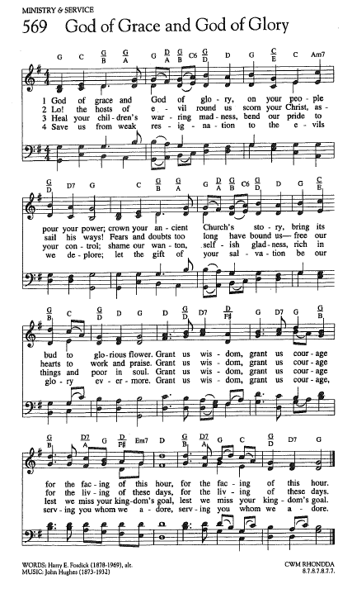
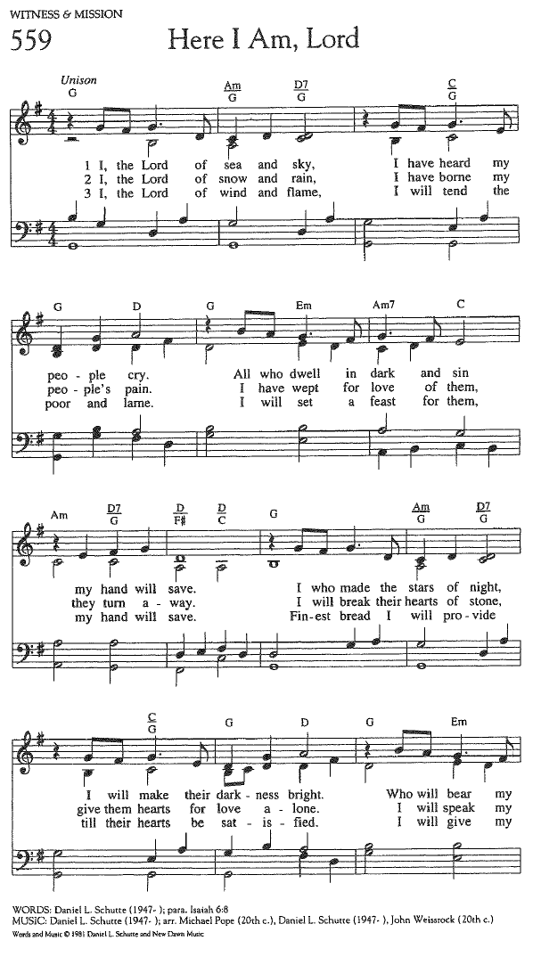
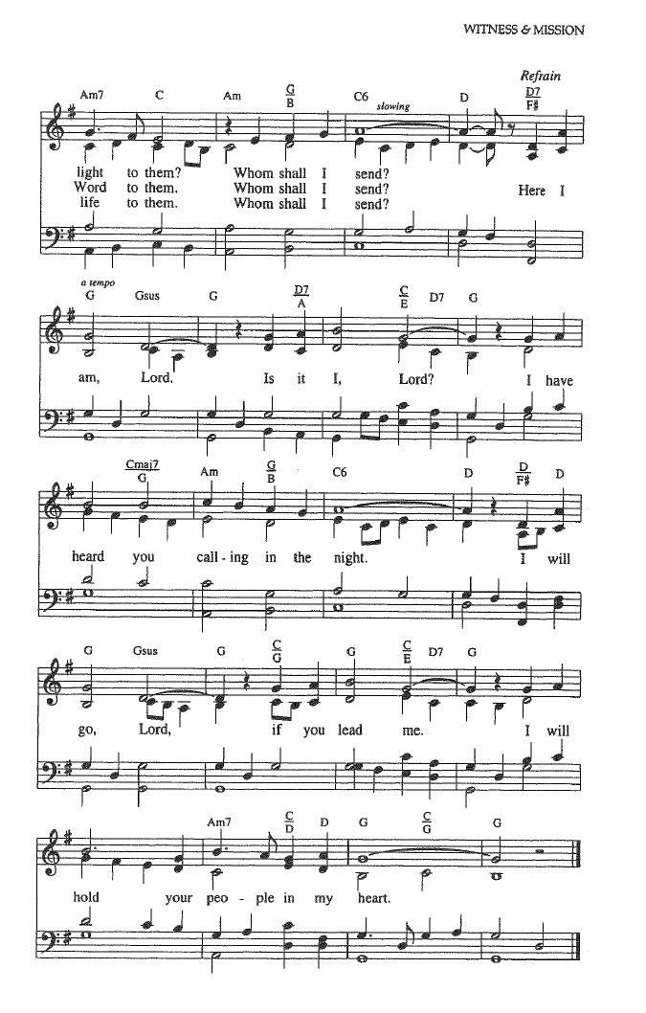

FOR YOUR CONSIDERATION

“Many people don’t understand the difference between a vocation and your own idea about something. A vocation is a call – one you don’t necessarily want.”
Dolores Hart, American Catholic nun

“Everybody’s not going to understand where
God has called you to go, but that is not an
excuse for you not to go there.”
Funke Felix Adejumo, Nigerian Bishop and writer

“Sometimes we want to withdraw from God in
order to escape God’s grasp. But God loves us
too much to allow us to fall. God holds us fast,
challenges us.”
Notker Wolf, German monk, author and musician

To Our Guests This Morning
If you are with us today for the first, or one of the first times, please let us know. Also, please take a moment to introduce yourself, or re-introduce yourself to Rev. Mark and each other. Our hope is to provide you with the most graceful welcome possible.


TODAY, Sunday, May 17 – Rev. Dr. Sally Haynes
As Mark is fulfilling a long-ago scheduled invitation to serve as guest preacher at one of our sister churches in Utah, our great friend Rev. Dr. Sally Haynes will once again lead Worship today. Dr. Haynes will also be with us a few times over the summer months while Mark is taking his usual vacation time during those months.
Office Hours
The Office is regularly open from 9 am-3 pm on Monday through Friday.
Mark is generally on campus Tuesday-Thursday pending pastoral visits or off-site meetings. Please feel free to just “drop by” or make an appointment directly with him by email: mark@sanibelucc.org or text/phone at 908-477-5426.
Mackenzie Albert, our Director of Music, is normally on campus each Wednesday and some Fridays. Please make an appointment by phone or text at 203-517-5427.

SPIRITUAL EXPLORATION
Our most recent unit has concluded. The topic and schedule for our next unit are still being determined. It is hoped that our next unit will start in late May.
BIBLE STUDY
Bible Study WILL NOT meet this Thursday. It will resume on Thursday, May 28 at 10:30 am on Zoom.

During each session, we explore the passages which will be part of that coming Sunday’s Worship. These meetings are discussion based, with Mark guiding a structured conversation based on participants’ questions, concerns and considerations of the text. The passage(s) to be looked at each week, as well as the necessary information for joining in, will be sent by email the day before.

Assisting With Today’s Worship Celebration
Liturgist: Jonathan Helmreich
Ushers: Neal and Sherry Halleran
Ministers: All Members and Friends of SCUCC
Moderator: Frank Palaia; Vice Moderator: Norm Boyd
Parish Nurse: Linda Convertine, R.N., B.S.N.
Music Director: Mackenzie Albert
Church Administrator: Tammy Flatley
Financial Manager: Terri Czeczotka
Tech Team: Dr. Renee Rawe, Kirsten Smith, Maggie Voll
Missionaries:
Alex Maldonado-Lizardi & Xiomara Cintron-Garcia in Colombia
Senior Minister: Rev. Dr. Mark Boyea
Pastors Emeriti: Rev. Dr. Ran Niehoff and Rev. Dr. John Danner

2050 Periwinkle Way, Sanibel, Florida 33957
Telephone: (239) 472-0497

Website: https://www.sanibelucc.org
Email: office@sanibelucc.org




You can scan a QR Code to make a donation through
PayPal or Venmo.

This Photo by Unknown Author is licensed under CC BY

