Sanibel Congregational United Church of Christ
Worship Celebration
October 4, 2026, 10:00 a.m.


Welcome Everyone!
If you are visiting with us, and you are looking for a spiritual
community…

where you will be loved, accepted, supported and affirmed
regardless of your age, class, ability, race, ethnicity, gender
identification or sexual orientation…where you will be
encouraged and challenged to reflect on your beliefs,
acknowledge your doubts, ask your questions, and grow in
your faith…where God’s desire for compassion, healing,
reconciliation, justice and joy is preached…where you are
given the opportunity to put your faith in action through effective outreach ministries…then we hope to get to know you as a new friend.

No matter who you are, or where you are in your life journey…
You are welcome here!
An Open and Affirming / Creation Justice Congregation of the United Church of Christ

Seeking to love all people … growing in faith …
working toward God’s vision of justice, healing and joy.
Sanibel Congregational United Church of Christ
An Open and Affirming/Creation Justice Congregation
Worship Celebration
October 4, 2026, 10:00 a.m.

Welcome
Prelude He Hideth My Soul Anderson
Call to Worship
One: God our Creator, we call You Father, Mother, Author of Life;
All: Draw us closer to You.
One: Christ our Savior, we call You the Son, the Messiah, the One who Saves;
All: Draw us closer to You, O Lord.
One: Holy Spirit, we call You the Advocate, the Inspirer, the Breath and Wind of God;
All: Draw us closer to You, O Spirit.
One: Holy, Holy, Holy, Lord God Almighty, Heaven and earth are full of Your glory;
All: May we love You more each day, O God.
Hymn My Hope is Built on Nothing Less #405 (on p. 6)

Opening Prayer (together)
We come together this day, Holy One, to hear You speak to us; to better understand Your call for our lives; to offer our gratitude. And to express our Love.
May we love You with all our hearts, minds and spirits. May we love You for forgiving our failings. May we love You for being an ever-present help in times of trouble. And may we love You for Your healing hand and constant grace.
Help us love You most by sharing that same forgiveness; ever-present help; healing hand; and grace to others.
Amen.

Music Meditation How Beautiful Paris

A Time of Prayer with The Lord’s Prayer
2
(Please use the wording most meaningful to you.)
Invitation to Offering
Offertory Music Rejoice, the Lord is King Wilson

*Presentation of Offering and Congregational Response
Praise God from whom all blessings flow
Praise God all creatures here below
Praise God for all that love has done
Creator, Christ and Spirit, One.
Amen.

Prayer of Dedication (together)
God of all our days, we thank You for loving us and calling us to be in relationship with You. Help us to keep loving You, and to live out that love by loving our neighbor. May these gifts be one way we express that love of neighbor, and may they be used to help them know that they are loved by You and us.
Amen.
Ministry of the Word Psalm 42:1-11
(New Revised Standard Version Translation)

MINISTRY OF THE WORD
Psalm 42:1-11
As a deer longs for flowing streams, so my soul longs for you, O God.
My soul thirsts for God, for the living God.
When shall I come and behold the face of God? My tears have been my food day and night, while people say to me continually, “Where is your God?”
These things I remember, as I pour out my soul: how I went with the throng and led them in procession to the house of God, with glad shouts and songs of thanksgiving, a multitude keeping festival.
Why are you cast down, O my soul, and why are you disquieted within me? Hope in God, for I shall again praise him, my help and my God.
My soul is cast down within me; therefore I remember you from the land of Jordan and of Hermon, from Mount Mizar. Deep calls to deep at the thunder of your torrents; all your waves and your billows have gone over me. By day the Lord commands his steadfast love, and at night his song is with me, a prayer to the God of my life.
I say to God, my rock, “Why have you forgotten me? Why must I walk about mournfully because the enemy oppresses me?” As with a deadly wound in my body, my adversaries taunt me, while they say to me continually, “Where is your God?”
Why are you cast down, O my soul, and why are you disquieted within me? Hope in God, for I shall again praise him, my help and my God.

Message Staying in Love with God Rev. Dr. Sally Haynes
Hymn The Gift of Love #397 (on p. 7 & 8)
Blessing
Postlude Improvisation on The Gift of Love

*All who wish are welcome to stand.

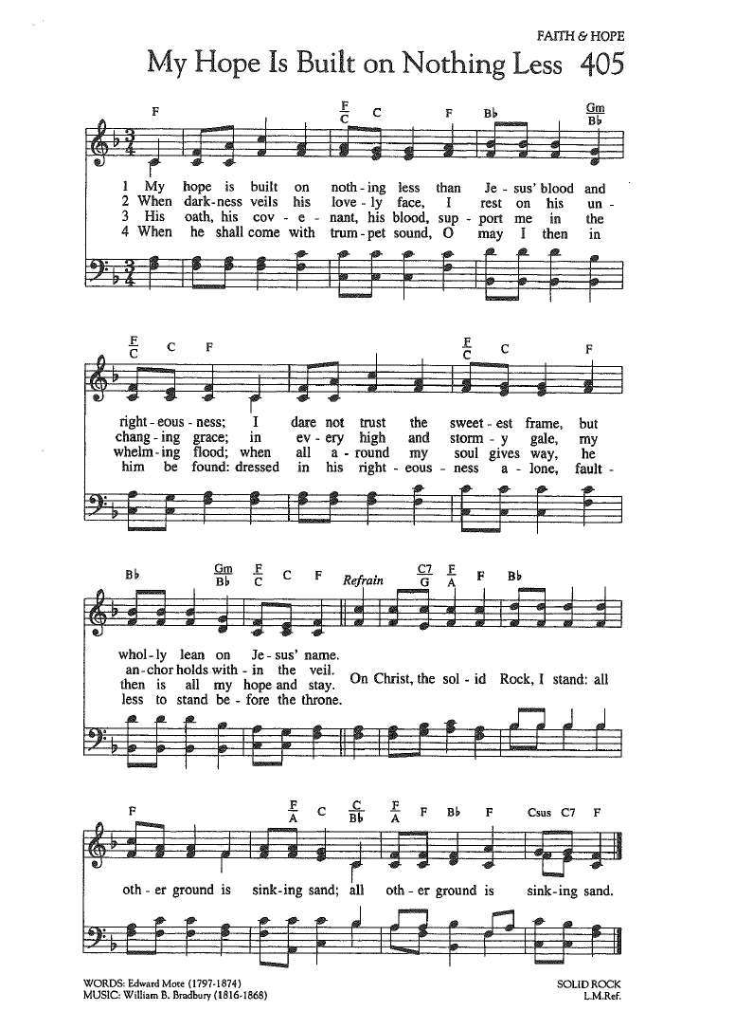
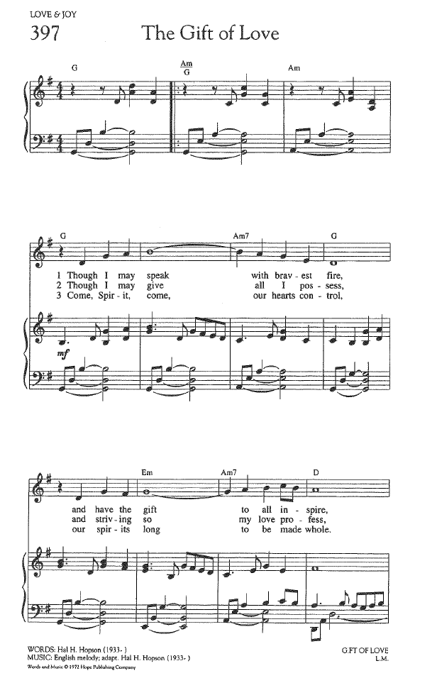
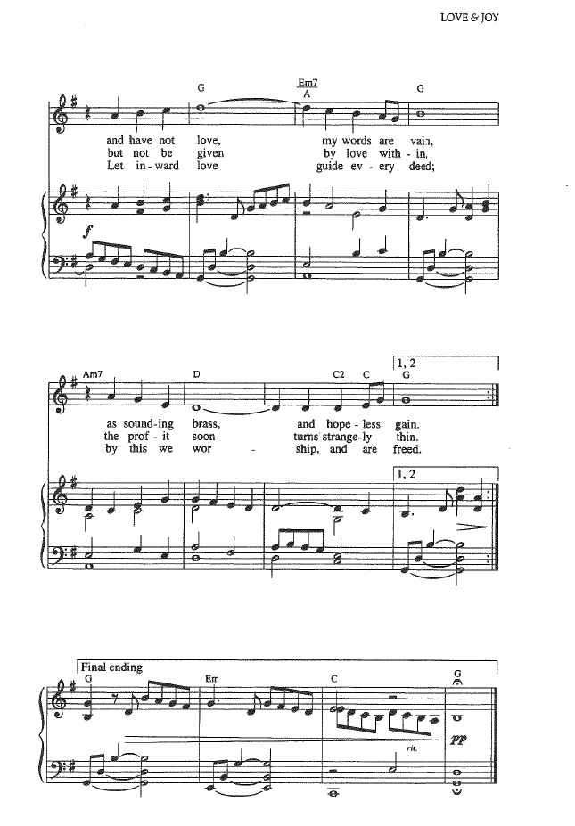

FOR YOUR CONSIDERATION

“Throw wide the gate of your heart, unlock your soul to God and offer God a welcome in your
mind, and you will see the treasures of peace
and the joy of grace.”
Ambrose of Milan, Roman theologian and bishop

“We cannot be sure we are loving God, but the
farther we advance in loving our neighbor, the
greater we will be loving God.”
Teresa of Avila, Spanish nun and mystic

“To love God is the greatest romance; to seek God
the greatest adventure; to find God the greatest
human achievement.”
Augustine of Hippo, Christian theologian and philosopher

To Our Guests This Morning
If you are with us today for the first, or one of the first times, please let us know. Also, please take a moment to introduce yourself, or re-introduce yourself to each other. Our hope is to provide you with the most graceful welcome possible.
TODAY, SUNDAY, October 4 – Rev. Dr. Sally Haynes
Today we welcome back Rev. Dr. Sally Haynes as Worship leader, as Mark is away this week for a family funeral and long-ago scheduled commitment.
TODAY’S FLORAL DEDICATION
The flowers for our Worship Celebration this morning
are in loving memory of Fred Nordstrom;
beloved family patriarch, choir member, and valued friend.
October 7, 1928 – August 18, 2026
A Memorial Celebration is planned for
January 9th, 2027 at 2 PM at SCUCC


SPIRITUAL EXPLORATION
Our first Spiritual Exploration Unit for Fall 2026 begins on TUESDAY, OCTOBER 13 at 7PM on ZOOM.
A,B,C,D,E,F,G… : Faith By the Letter (Part 1)
Tuesdays: October 13, 20 and 27; November 3 and 10
7:00-8:15PM on ZOOM
Based on the book, A Is For Alabaster by the renowned minister and theology professor Anna Carter Florence, this unit will be the first in a series that will occur intermittently over the next couple of years. Each week of this five-week unit will explore one story from the Hebrew Scriptures (Old Testament) and one from the New Testament that feature characters or themes that begin with a particular letter of the alphabet – beginning with the letter A and then proceeding in alphabetical order from there. As we do, we will discuss both our own and Carter Florence’s reflections on each story and its spiritual and theological themes.

BIBLE STUDY
Our first Bible Study session for Fall 2026 will take place on THURSDAY, OCTOBER 15 at 10:30AM on ZOOM.
The Bible Study Schedule for the remainder of October is:
Thursday, October 22
Thursday, October 29
Each week, we explore the Scripture passage(s) being used in Worship that coming Sunday. The sessions are largely “guided discussion” in approach, focusing on your questions and insights from reading the text ahead of time, with Mark facilitating and adding relevant context and detail as needed or wanted.
This approach allows for participants to engage with the Bible creatively, and with an eye toward how the texts speak to us in our time and lives. In addition, the sessions are great preparation for getting more out of the Sunday Messages!


Assisting With Today’s Worship Celebration
Liturgist: Betsy Eidem
Ushers: Frank and Judy Palaia
Ministers: All Members and Friends of SCUCC
Moderator: Frank Palaia; Vice Moderator: Norm Boyd
Parish Nurse: Linda Convertine, R.N., B.S.N.
Music Director: Mackenzie Albert
Church Administrator: Tammy Flatley
Financial Manager: Terri Czeczotka
Tech Team: Dr. Renee Rawe, Kirsten Smith
Missionaries:
Alex Maldonado-Lizardi & Xiomara Cintron-Garcia in Colombia
Senior Minister: Rev. Dr. Mark Boyea
Pastors Emeriti: Rev. Dr. Ran Niehoff and Rev. Dr. John Danner

2050 Periwinkle Way, Sanibel, Florida 33957
Telephone: (239) 472-0497

Website: https://www.sanibelucc.org
Email: office@sanibelucc.org




You can scan a QR Code to make a donation through
PayPal or Venmo.

This Photo by Unknown Author is licensed under CC BY

